Bumper Sticker Theology – Week 1
God Won’t Give You More Than You Can Handle

Message Big Idea: God will help you handle all you’ve been given.

Scripture: 1 Corinthians 10:13, James 1:17, Psalm 46:1-3, 1 Peter 5:7, John 16:33, Galatians 6:2
____________________

Introduction: Funny Bumper Stickers
If you’ve ever sat in gridlock on the Eisenhower during rush hour, then you know there aren’t very many good things about driving in heavy traffic. In fact, it can be down right painful! But the one thing that can make bad traffic feel bearable are bumper stickers! Sometimes they’re the saving grace to traffic, aren’t they?
Just the other day I was driving in bumper-to-bumper traffic, getting seriously frustrated, and just wanting to get home. Suddenly I saw this bumper sticker and it made my day. (Picture)“Nobody cares about your stick figure family”! Now maybe it was because I was having a really bad day, but I thought that was really funny! I thought about getting one for my car, but decided it’s probably not a good idea for a pastor’s car.

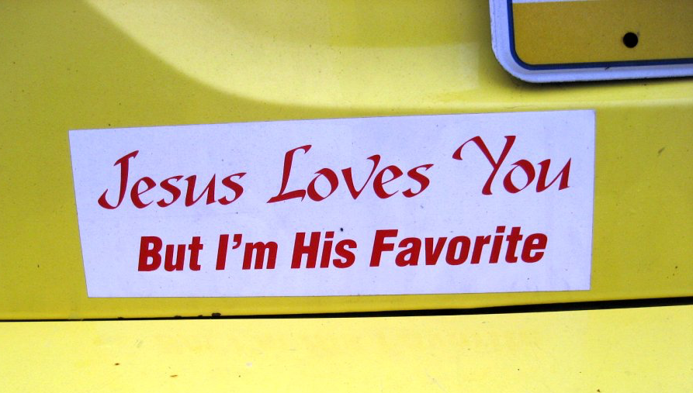
That experience got me thinking about some of the most ridiculous bumper stickers I’ve seen. I thought you might appreciate them too so let me share some of my favorites with you. Like this one: (Picture) “Jesus loves you, but I’m his favorite.” Are you really sure about that? Of all the people around, you’re Jesus’ favorite? Well I just so happen to know that can’t be right… because I’m his favorite!

Or how about this classic… (Picture) “I used to be cool.” Any other minivan drivers out there? I don’t know about you, but the older I get the more I can appreciate that one for sure! I’m not saying I'm not cool… I’m just less cool than I used to be.
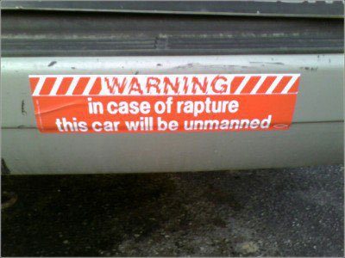
(If you can, a funny one you or someone you know used to have) But my favorite bumper sticker of all time is one that my mom actually had on her car when I was growing up. Have you ever seen this one? (Picture) “Warning: In case of rapture this car will be unmanned.” Little six-year-old Tammy actually thought this was cool! Although it also got my imagination racing about what would actually happen if a running car were unmanned. But now I just see this as a very awkward way to announce to the world that you’re a follower of Jesus. In fact, it’s a little bit like you’re rubbing the other person’s nose it!

I love reading bumper stickers. By nature they’re short, concise sayings that try to convey a clever or insightful thought.

Over time I’ve come to realize that whether they show up on bumper stickers or not, Christians also have their own collection of short, concise sayings. These are axioms that attempt to communicate some sort of spiritual wisdom in a memorable phrase. Sayings like:

- Everything happens for a reason, or…
- God helps those who help themselves, or…
- God is my co-pilot.

But the question we have to ask ourselves is: are all of those sayings actually true? Have we ever stopped to consider the theology behind them?

Series Intro
(Series Graphic) Well today we’re starting a brand new series called “Bumper Sticker Theology.” And each week during this series we’re going to take a closer look at one of these bumper sticker sayings and ask: “Is it Biblically sound or does it just sound Biblical?”
Most of these sayings have enough truth in them that they sound Biblical, but how do they match up with the larger arc of Biblical teaching? I believe it’s incredibly important to not take everything we see and hear as unquestioned truth, but instead we should carefully examine these sayings in light of Scripture.

And here’s why this is important:

- First, these statements lead people to conclusions about God… and some of those conclusions are untrue. And…
- Second, we may be unintentionally hurting people or pushing them away from God when we use these sayings.

So here’s the bumper sticker saying we’re going to tackle today: “God won’t give you more than you can handle.”

Why Do We Say It?
Sounds familiar, right? How many of you have heard this before? Yeah, there are a lot of us who have either said this or had it said to us. Have you ever stopped to think about why we say it?

Sometimes I think we say it as sort of a pep talk. We want to tell someone:

- “You got this!”
- “Hang in there!”
- “Don’t give up!”
- “God won’t give you more than you can handle.”

We genuinely want to help people muster up the courage to stand firm in whatever it is they’re facing.

Or maybe it’s a pep talk we give to ourselves. We think, “God won’t give me more than I can handle” as a way of mustering our own will to endure.

But let’s face it… Sometimes we say it because we just don’t know what to say to someone who is going through a difficult time. Saying, “That’s a bummer!” to that person doesn’t sound very encouraging. It sounds much more spiritual to say, “God won’t give you more than you can handle.” Besides, this saying along with, “I’ll pray for you,” is the quickest ways to get out of a conversation when you don’t know what else to say, right?

Why Does It “Feel” Right?
I also think there’s something about this bumper sticker saying that just feels right to us too, don’t you? It feeds right into our American value of self-reliance. Culturally, we love the idea of relying on our own power and resources to get us through any situation. We think we should be able to handle whatever comes our way. It’s sort of like we have a superhero complex. “I got this!” is our mantra.

I came across a Jerry Seinfeld clip that speaks to this. Guys, I’m going to pick on you for a minute, but this is so true…

Video: Jerry Seinfeld (https://www.youtube.com/watch?v=HksnkliM1mQ)

Let’s face it… we are self-reliant people, aren’t we? Our culture teaches us to rely on ourselves.

But think about this… If God only gives us what we could handle, would we even need him? If we buy into this idea of self-reliance, even as Christians we can end up living our lives as practical humanists…as if God isn’t necessary to our existence.

Why Does It Sound Biblical?
So where did this idea that “God won’t give you more than you can handle” come from?
Well it’s an interpretation of a passage in I Corinthians chapter 10 where the Apostle Paul is writing to new Christ-Followers in the city of Corinth. He tells them:

“No temptation has overtaken you except what is common to mankind. And God is faithful; he will not let you be tempted beyond what you can bear. But when you are tempted, he will also provide a way out so that you can endure it.” -I Corinthians 10:13

Maybe as we read that passage you can see a glimpse of how this bumper sticker saying developed. It at least sounds a little like that verse. Both carry the idea that God will protect you from being overwhelmed by something you’re facing.

Yet to understand the intended meaning of this verse, we have to look a little deeper. In original language of this passage, the Greek word for (highlight) “tempted” is peirasmos. Peirasmos can also be translated with the word “tested” so some believe this text could read, “…he will not let you be tested beyond what you can bear.”

However, that’s why it is critical to read a verse of Scripture in it’s context. We have to look at the context of the passage to understand Paul’s intended meaning.

You see, Paul is writing to new Christ-followers, many of whom had been pagans living in the city of Corinth. Corinth was a city filled with pagan temples where idol worship and temple prostitution were regular practices. There was a phrase used back in the day, “to live like a Corinthian,” and this phrase was synonymous with drunkenness and sexual license.

So Paul is encouraging these new Christ-followers to NOT go back to their old ways. This passage isn’t about God not giving you more burdens than you can handle; it’s about God helping you when you’re facing temptations to sin.

It’s a true statement to say that God won’t give you more than you can handle while you’re being tempted to do wrong. That’s the place where God will give you an escape. He will always provide a way out of that situation.

To apply this Scripture to the difficult circumstances we’re facing in life arises out of a bad interpretation of this Scripture. It would require us to rip this verse out of the context and away from Paul’s intended meaning.

The Danger
Yet, maybe you’re thinking to yourself, “So what? Is it really that big of a deal to let people believe a small ‘white lie’ about God?” Well the simple answer is: YES!! You see it’s dangerous for us to perpetuating this bumper sticker saying for 3 very important reasons:

#1 – It tells us lies about ourselves. When we’re overwhelmed by our circumstances, we can be hesitant to ask for help. We may even start to believe the lie, “I should be able to handle this on my own.”

(add) #2 – It tells us lies about each other. When we see someone else overwhelmed by their circumstances, we begin to expect them to handle it on their own. We hold them to the same unhealthy standard we’re holding ourselves to.

(add) #3 – It tells us lies about how to cope. When we’re overwhelmed by our circumstances and can’t live up to our own self-imposed expectations, we end up turning to unhealthy behaviors to cope.

- We self-medicate.
- We isolate ourselves from friends and loved ones.
- We become workaholics.
- Or we start to abuse substances that will only destroy us.

The Truth
Today, I want to tell you the truth and while at first it may sound bad, in reality this truth is actually freeing. And here it is: Sometimes you will face more than you can handle. (repeat)

Life is full of all sorts of twists and turns and sometimes we will face circumstances that knock us off our feet and leave us dizzy on the ground. Jesus, himself, warned us of this when he said:

“In this world you will have trouble…” -John 16:33

But just in case you’re worried that this message is going to end on a down note, let me assure you, that in the middle of these overwhelming circumstances there is hope. When we find our way back to God, the promise of Scripture isn’t that we’ll somehow escape hard times, but that when we go through hard times, we don’t have to go through them alone!

If you are stuck in the middle of difficult circumstances right now, let me remind you… You… are not… alone!

And you know what that means? It means when hard times come, it’s all right to admit, “I can’t handle this by myself. I need help.” It’s all right to lean on God and other Christ-followers to get you through whatever you’re going through. We don’t have to be superheroes because we have a hero who reigns supreme.

“God won’t give you more than you can handle” is a bumper sticker saying that is not true, but the truth we have is even better: “God will help you handle all you’ve been given.” (repeat) He will not leave you. He will never abandon you. He will see you through.

Depend on God
So what are we to do when we face something we can’t handle on our own?

Well, first, we Depend on God. We choose to trust him. And this isn’t just some blind trust; it’s trust based on centuries of evidence that God has always been there for his people.

(add Psalm 46:1) In the Old Testament, the Psalmist tells us that God is our ever-present help in times of trouble. That means he’ll never abandon us or leave us in difficulty, but that he’ll stand by us no matter what we have to endure.

(switch previous verse for 1 Peter 5:7) In the New Testament, we read that God cares about us and wants us to come to him with our burdens. Depending on God means taking our burdens to him.

God will help you handle all you’ve been given, so depend on him.

- Come to him in prayer.
- Come to him with tears.
- Come to him with anger.
- Come to him with pain.
- Come to him with your broken heart.

As we deal with hard times, he needs to be our very first “go to” no matter how daunting the circumstances may be. Nothing is too difficult for God. He is big enough to help you get through whatever you’re facing.

Depend on God Through Others
But there’s another thing we can do when we face something we can’t handle on our own: Depend on God Through Others. We are meant to live in community with one another. God uses us, as brothers and sisters in Christ, to help one another face our challenges.

One of the most important ways to live out that community is by being part of a Small Group. I know I’ve said it before, and I’m just going to keep on saying it because it’s that important: if you’re not part of a small group yet, then maybe it’s time to jump in!

What’s holding you back? Is it:

- Your schedule?
- Your convenience?
- Your pride?

It’s time to stop making excuses and join a group. Not because you have to in order to make God happy, but because we’re all meant to be connected in a community of Christ-followers who will help one another get through anything in life.

Now, maybe you think you’re off the hook because you’re already in a group… well not so fast Listen, doing life with people means more than just showing up. We don’t join a small group just to check a box off of a list, instead we join them to be real with each other and grow together. (Galatians 6:2) This means that we need to actually do what Scripture tells us and truly depend on one another.

I want to share a story with you about Matt and Debbie. Matt and Debbie are part of a Small Group at our Yorkville location and they faced a time when they truly needed to depend on God through their Small Group.

Written Matt & Debbie Story Here

Now I want to pause for a moment just to make sure I’m clear being clear about something. I believe that God can and will get us through anything in our lives and that he uses other Christ followers to help.

I also want to acknowledge that sometimes we need the help of a doctor, therapist, or recovery program to get through challenges too. Sometimes it’s not only appropriate, but it’s crucial for us to seek out Professional Resources to help navigate challenging seasons of life.

We need to resist the lie that “I should be able to handle things my own.” It’s not a sign of weakness to seek out help, but a sign of strength. It takes courage to know when you need help and as your church we want to walk through that journey with you. In fact, we want you to know that we provide contacts and references to trustworthy Professional Resources in our area to help you connect with someone who can help.

Conclusion
(“God will help you handle all you’ve been given.”) As we close this message, I want to remind us that the point of the cross is that we couldn’t handle everything on our own. In our brokenness and helplessness God sent Jesus so that we could find our way back to him. We were helpless to make a way on our own. There was nothing we could do to prove ourselves righteous before God. So Jesus became the righteousness we could never have provided.

Jesus didn’t just meet humanity in our helplessness 2,000 years ago; Jesus still comes to meet you and to meet me in our helplessness today. “God will help you handle all you’ve been given”… and he starts by helping us find our way back to him. So together let’s learn to depend on God and each other.

Communion Idea
Communion is a moment where we pause each week to celebrate the reality that Jesus meets us in our helplessness at the cross. Because of his love and sacrifice we were made right with God and have been made part of God’s family. No matter what we face in life we have a Savior who lived, suffered, died, and rose again and he can help us overcome whatever we’re going through.

Today as we take communion together, I want to challenge all of us to take a moment and thank God for healing our hopelessness. I also want to encourage us all to use this time to bring your burdens to God and take the first step in depending on him to get you through anything in life.

