Bumper Sticker Theology - Week 2
God Helps Those Who Help Themselves

Teachers:

This week we continue this great series, Bumper Sticker Theology. This week’s saying is “God helps those who help themselves.” It serves as a great opportunity for us to challenge our people toward a more compassionate way of thinking and living as we realize that God actually helps those who can’t help themselves and that includes us. He extended his love and grace to every one of us when there was nothing we could do on our own to earn it or deserve it.

We have some interesting research from Malcolm Gladwell’s book Outliers that reminds us that there are often reasons that we have nothing to do with that give us advantage or disadvantage in life.

We also have a video of Tom Ryan who is a Kids Hope Mentor. That leads into a very specific challenge where we ask people to consider three ways anyone can get involved with Kids Hope Mentoring.

I was reminded this past week of the responsibilty we have when it comes to teaching. Yes, it’s God at work through us, but it’s a huge opportunity and responsibility. So teach every week like it’s the last talk you will ever give!

Introduction: “Do It Myself!”
Little kids go through a lot of phases as they grow up.
- There’s the not yes, but “No!” phase
- Then the not yours, but (add) “Mine!” phase
- And of course, the I don’t want daddy, (add) “I only want Mommy!” phase…which, seems to last a very – long - time

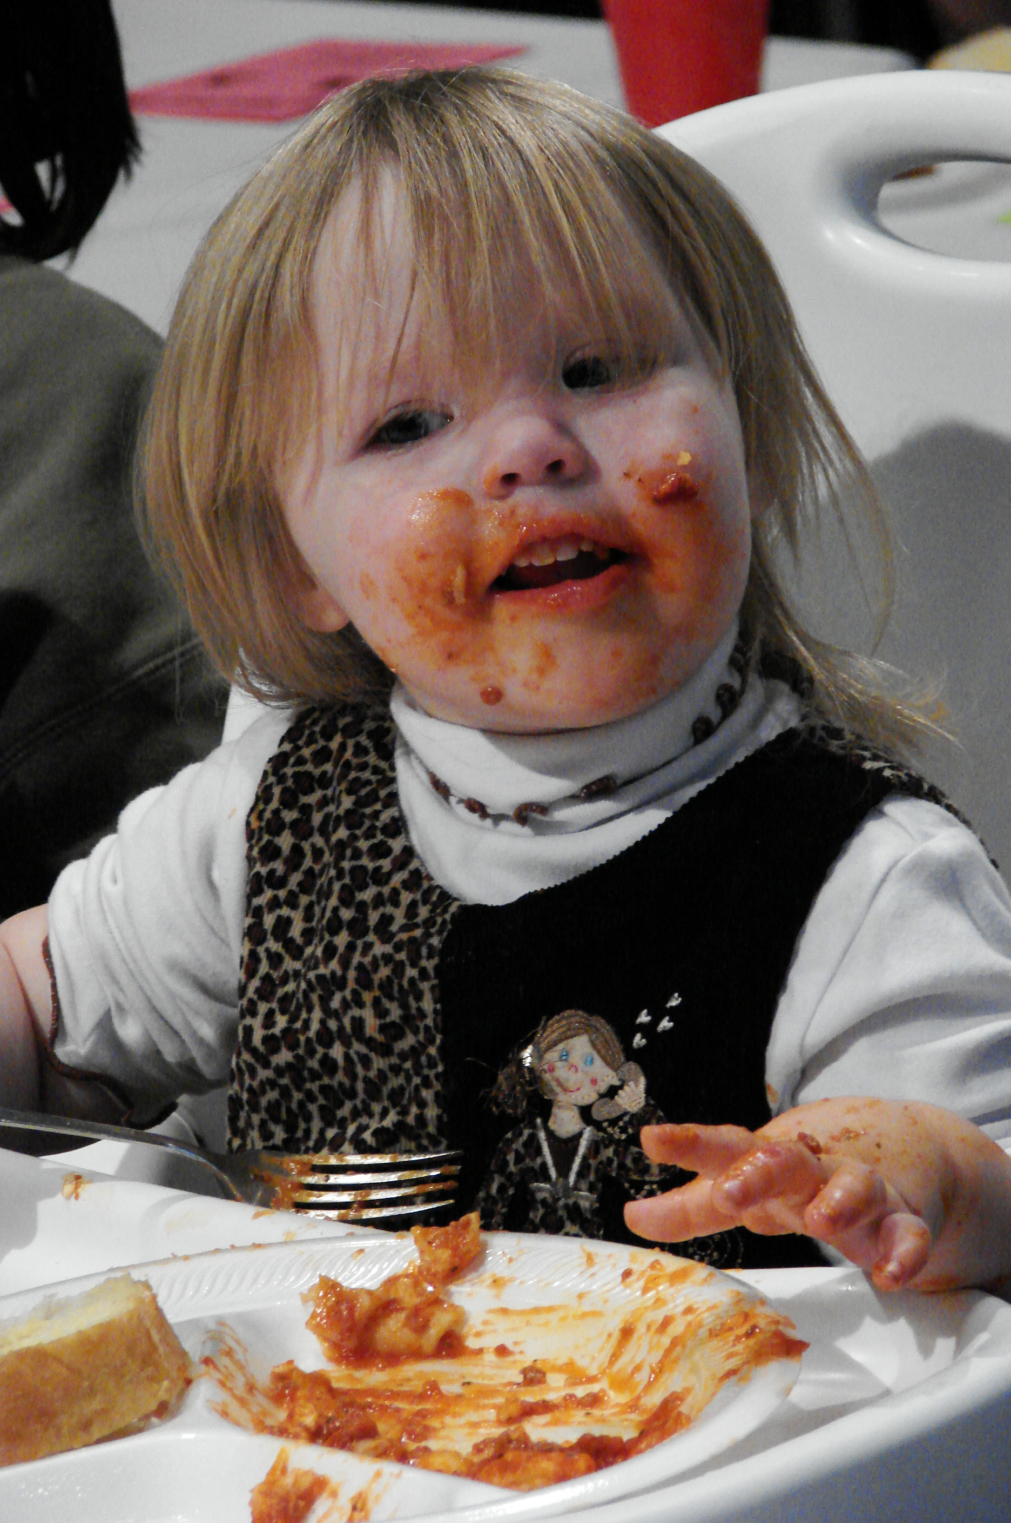
I enjoyed every phase of my kids’ growing up years, but I found special humor in the (new slide) “Do it myself!” phase. Anyone in the “Do it myself!” phase right now with your kids? As they move from being a toddler to a little kid, every child goes through this phase. They all want to prove they can do it themselves…
- (Picture) They want to dress themselves.
- (Add) They want to feed themselves.
- (Add) They even want to put makeup on ALL by themselves.
When our kids were little, and we wanted them to do something and they didn’t want to do it . . . like put on their shoes on or even pick up their toys. All I had to say was “Well, then Mommy or Daddy will have to help you.” And then they would say, “No. I can do it myself.” And they would do it right away. Their mother is a genius with that stuff!

If only that “do it myself” phase continued when it comes to paying for college.

This desire to “do it myself” starts very young; but the truth is, we continue to place a very high value on “doing it myself” even when we are all grown up!
- We want to make it vocationally – all by myself!
- We want to make it financially – all by myself!
It’s something quite uniquely American – we celebrate the stories of all the times we pulled ourselves up by our own bootstraps and made it happen – all by myself!

When the great French philosopher Alexis de Tocqueville came to America he noticed this “rugged individualism” and described Americans this way:

“…each of them withdrawn into himself is almost unaware of the fate of the rest. Mankind, for him, consists in his children and his personal friends. As for the rest of his fellow citizens, they are near enough, but he does not notice them. He touches them but feels nothing. He exists in and for himself…” (Alexis de Tocqueville)

And some of you are thinking, “Yep, sounds like somehting a Frenchmen would say!” (Ha!)

Bumper Sticker - “God helps those who help themselves”

And that brings us back to (Series slide) Bumper Sticker Theology. This series was born out of a realization that much of what is commonly thought to be good theology is not actually based on what we find in scripture. Often it’s just based on popular thinking; sayings sometimes found on a bumper sticker or maybe a Twitter feed. So every week we’re asking, “Is this saying Biblically sound or does this just sound Biblical?” And today’s Bumper Sticker Saying is this one: “God helps those who help themselves.”

I’m not going to embarrass any of us by asking for a show of hands, but the vast majority of Americans believe that “God helps those who help themselves” is in the Bible. We place such value on independence and doing it ourselves that when someone says this, we are all inclined to nod our heads thinking “Yea, that’s right. God helps those who help themselves!”

The Barna Research Group did a survey and found that 7 out of 10 of us think this is a quote from the Bible. And since we believe it’s in the Bible, with confidence we say: “Hey, God helps those who help themselves” – But let’s be real, there are plenty of sayings in scripture we DON’T quote, so why do we seem to want to say this, when it’s not even there?

- I think it may be because we like to believe we made it on our own! And if others would just do what we did – they would make it too. We often ignore how much help we’ve had and how blessed we are.

- Or at times I believe we say this so we don’t have to feel responsible for helping others. “God helps those who help themselves” lets us off the hook.

- Occassionaly, we say, “God helps those who help themselves” out of frustration with people we think are lazy or take advantage of the system.

The origins of this saying started way before there were bumper stickers or cars to put them on. We can go all the way back to Greek mythology in the 5th century B.C. There is a line in a story by Aesop where a character prays to the Greek God Hercules for help. Hercules responds with a charge to get to work because: “The gods help them that help themselves.” (Aesop, 5th century B.C.)

Credit for the phrase coming acroos the pond goes to Ben Franklin. (Saying on screen with “-Ben Franklin, 1736) “God helps those who help themselves” appeared in Franklin’s Poor Richard’s Almanac in 1736, and it’s been part of our thinking ever since.

That may explain why this saying seems so American, but why do so many Christians think it’s part of scripture? I’m not exactly sure, but it does sound somewhat similar to what the Apostle Paul wrote in a letter to the church in the city of Thessalonica. It reads like this:

“For even when we were with you, we gave you this rule: ‘The one who is unwilling to work shall not eat.’” (2 Thessalonians 3:10)

Now, f you were here last week, you may remember we said that to fully understand scripture, we need to understand the context in which he was writing. Back then, church communities had a kind of common fund that everyone shared and would have access to and use as needed. In this situation, they had some people who were slacking in their own work, not contributing to the common fund, and totally relying on the efforts of others. So Paul calls them out.

- Paul is NOT saying, “Everybody needs to go out and pull yourself up by your bootstraps and make it on your own!” No!
- Paul IS setting up some healthy boundaries here by saying, “It’s a good thing for us to help each other out when we are down – we should do that! But this is not an excuse for not working. -- If you don’t work when you could work, then you don’t eat!”

What Does the Bible Say? (Proverbs 31)

So, if scripture doesn’t say “God helps those who help themselves”; and God doesn’t expect me to “Do it all myself”, what does scripture say about WHO God helps and HOW he helps?

I think one of the best places to start is chapter 31 in the book of Proverbs. Proverbs is a book full of all sorts of wisdom. In this section, the writer is recounting the sage advice of his mother. When I was a kid one of the things my mom always said was, “If you can’t say anything nice, don’t . . . say anything at all.” So think of this chapter as one long, “My mom always said…”

In the first few lines of chapter 31 it says, “My mom always said… “
- “…good leaders don’t chase after women.”
- “…good leaders don’t drink too much.”
- “…good leaders don’t numb their feelings”

And then the writer gets to verses 8 and 9 and mom says this:
“Make sure you speak out on behalf of those who have no voice and defend all those who have been passed over. Make sure to open your mouth, judge fairly, and stand up for the rights of the afflicted and the poor.” (Proverbs 31:8-9)

Now there are lots of places in the Bible where we are told to “be still” or “be slow to speak,” but in this passage we are urged to speak up, to talk. Twice - in as many sentences, God urges us to say something, to speak out on behalf of those in need.

Jim Wallis, President and Founder of Sojourners, tells the story of the founding of his organization that speaks out for those who can’t speak out for themselves. He says:

“One of our first activities was to find every verse of scripture about the poor, wealth and poverty, and social justice. We found more than 2,000 texts that we then cut out of an old Bible. When we looked at the Bible without those verses we were left with a Bible full of holes...” (Jim Wallace, Founder of Sojourners)

Yes, a casual reading of the scripture makes it clear that God cares for those who are vulnerable. There are those around us who need an advocate; who need our voice. It may be because they don’t have a voice -- or it may be because they’re shouting as loud as they can - but no one is listening.

I’m reminded of a speaker we had at COMMUNITY a few years back who directed an amazing documentary titled, (picture) “Among the Discarded.” He spent a month living on Skid Row in Los Angeles with the homeless community. In this film he recounted that the most difficult thing to endure was the psychological effect of people walking by without any acknowledgment. The hardest part of that experience was being passed over and ignored over and over again. He said that within the first few days it was absolutely devastating!

Not only is the saying, “God helps those who help themselves” not true, I believe God is asking each of us to speak out, to open our mouth, and to stand up for those who can’t help themselves - the voiceless, the poor, and the oppressed. Why? Because they matter to him.

It’s also important to note that God is calling us to “judge fairly.” (highlight phrase) That means we’re supposed to look beyond just what we can see at face value. When we see someone struggling in poverty or experiencing homelessness, “judging fairly” means we don’t just see them as the sum total of what may have been some bad choices, but rather we seek to understand the influences that contribute to their situation.
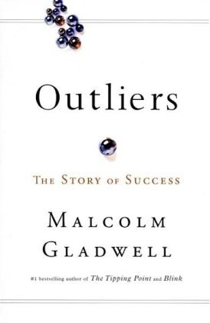
Here is what I mean. (Picture) In Malcolm Gladwell’s book Outliers, he tells a number of stories that all have one point: advantage is accumulated. Gladwell says: (add)

“…those who are successful in other words…are most likely to be given the kinds of special opportunities that lead to further success.” (Malcom Gladwell, Outliers)

One of my favorite examples in the book is from a study about how someone becomes a great hockey player in Canada. You’d think it’s skill, along with lots of hard work and effort, correct? Well, it turns out that in any elite group of hockey players in Canada:
- 40% of the players will have been born between January and March.
- 30% percent between April and June.
- 20% percent between July and September.
- 10% between October and December.

So you ask… Why? Why are 40% of all great hockey players born between January and March? Gladwell writes:

“The explanation for this is quite simple. It has nothing to do with astrology, nor is there anything magical about the first three months of the year. It’s simply that in Canada the eligibility cutoff for age-class hockey is January 1. A boy who turns ten on January 2 then could be playing alongside someone who doesn’t turn ten until the end of that year - and at that age, in preadolescence, a twelve month gap in age represents an enormous difference in physical maturity” (Malcom Gladwell, Outliers)

If you’re a boy born between January and March in Canada, and you want to be great at hockey, you have an advantage through no effort of your own. This example might seem silly, but if something as simple as the month in which you are born can be the difference in who becomes a successful hockey star or not; how much more might mental illness, socio-economics, or race increase or decrease access to what Gladwell calls, “…the special opportunities that lead to further success.”

Let’s look at some more outlier stats; -- how they might impact someone’s success; and then consider that there ARE indeed people who need our voice.

- How about this: 25% of our homeless population suffers from mental illness. How do you think that might mpact their ability to obtain stable housing?
- Would you judge those incarcerated less harshly if you knew that 60% of young men who had been in foster care in Illinois, Iowa and Wisconsin had been convicted of a crime.
- Might we see prostitutes differently if we knew 80% of those in prostitution were sexually assaulted as children.

Here is the deal: Judging fairly means we recognize there are factors beyond simply pulling ourselves up by our bootstraps that influence outcomes both positively and negatively. Judging fairly means we recognize we didn’t do it on our own and neither have others!

Truth: God Helps Those Who Can’t Help Themselves

Here is the true saying I hope we’ll all take away from today: God helps those who can’t help themselves. And you know how I know that statement is true? Because when I couldn’t help myself, God helped me. May I never forget: while I was far away from God, he came after me. When my relationship with him was broken and there was nothing I could do to repair it, God provided a way back.

The Apostle John states it so beautifully in his first letter:

“This is how we’ve come to understand and experience love: Christ sacrificed his life for us.” -(1 John 3:16 - The Message)

God helped us, when we couldn’t help ourselves. He sent Jesus to create a way for us to find our way back to him. He sent people into my life to point me towards him. He pursued me until I was found. This is how everyone of us have come know and experience God’s love: Christ gave up his life for you and for me.

God helped me, when I couldn’t help myself. And God helped you, when you couldn’t help yourself.

And because God helped us, John goes on to say:

“This is why we ought to live sacrificially for our fellow believers, and not just be out for ourselves. If you see some brother or sister in need and have the means to do something about it but turn a cold shoulder and do nothing, what happens to God’s love? It disappears. And you made it disappear. My dear children, let’s not just talk about love; let’s practice real love.” (1 John 3:17-18 - The Message)

Now, I don’t think John is saying that if we don’t help those in need, God’s love disappears from the world. And he’s not saying God won’t love us if we don’t help. What I think he’s saying is that it’s inconcievable for a Chris-follower to say we love God and be unwilling to help someone in need. And so if we don’t, the evidence of God’s love in our life will disappear. Often God helps those who can’t help themselves through his people –you and me. And when we help those who can’t help themselves God’s love becomes visible.

Kids Hope

So what does practicing real love look like? What does speaking out and giving a voice to those who don’t have a voice look like? One of the best examples I see at COMMUNITY is our (Logo) Kids Hope Mentoring program that Community 4:12 organizes in East Aurora, Joliet, and Chicago. The program pairs a student who faces systemic inequalities just because of the zip code they were born into with a mentor, a prayer partner, and a scholarship provider. The team practices love by being consistently present and casting hope of a better tomorrow.

Here’s Tom Ryan’s story of being a mentor at Brady Elementary School in Aurora.

Video Testimony – Tom Ryan

(Logo) That is a beautiful story of God’s love being visible through us? As I mentioned before Kids Hope is a team approach, and there are 3 ways you can get involved:

- There are Mentors like Tom, who meet weekly for an hour during the school day building a consistent and encouraging relationship with a student.
- There are Prayer Partners who pray for the student and provide support and accountability for the mentor.
- And there are Scholarship Providers who commit to cover the $15 monthly cost for each child.

I want to challenge you to step into one of these roles. You can go to www.community412.org and fill out a volunteer application to learn more about the Kids Hope OR you can check the Community 4:12 box on this connection card today.

Conclusion

It is childish to think that any of us can do life on our own, by ourselves. It’s not true that “God helps those who help themselves” – NO! God helps those who can’t help themselves. People like you and people like me.

And we can honor our God who helped us when we couldn’t help ourselves by helping others. So, let’s ALL determine:
- that we will use our voice for the voiceless,
- that we will judge fairly,
- and that we will stand up for the rights of the afflicted and the poor.
Let’s be agents of God’s love in a world that desperately needs him.

Communion Idea

There was a moment for me when I came to understand that I could NOT do it all on my own.

- In that moment I had to admit that I can NOT do this life on my own AND I can NOT make it into the next life on my own.
- Self, self, self…I can NOT do it myself.

That is when I discovered the grace of God; that God helps people like you and me, who can NOT do it on our own.

Communion is that moment; it is a moment when for the first time or once again we get to discover the grace of God by coming to him and admitting “I can’t do it on my own.”

In this piece of bread and in this cup Jesus comes to each of us and says, “I have come to help those who can’t help themselves”…me…you.

Alexis de Tocqueville. Democracy in America, New York: Anchor, 1969

