Bumper Sticker Theology - Week 2
God Helps Those Who Help Themselves

Message Big Idea: Through his people, God helps those who can’t help themselves.

Scripture: 2 Thessalonians 3:10, Proverbs 31:8-9, 1 John 3:16-18
____________________

Introduction: “Do It Myself!”
Little kids go through a lot of phases as they grow up.

- There’s the “No!” phase
- And the (add) “Mine!” phase
- And the (add) “I only want Mommy!” phase…which, seems to last a really long time

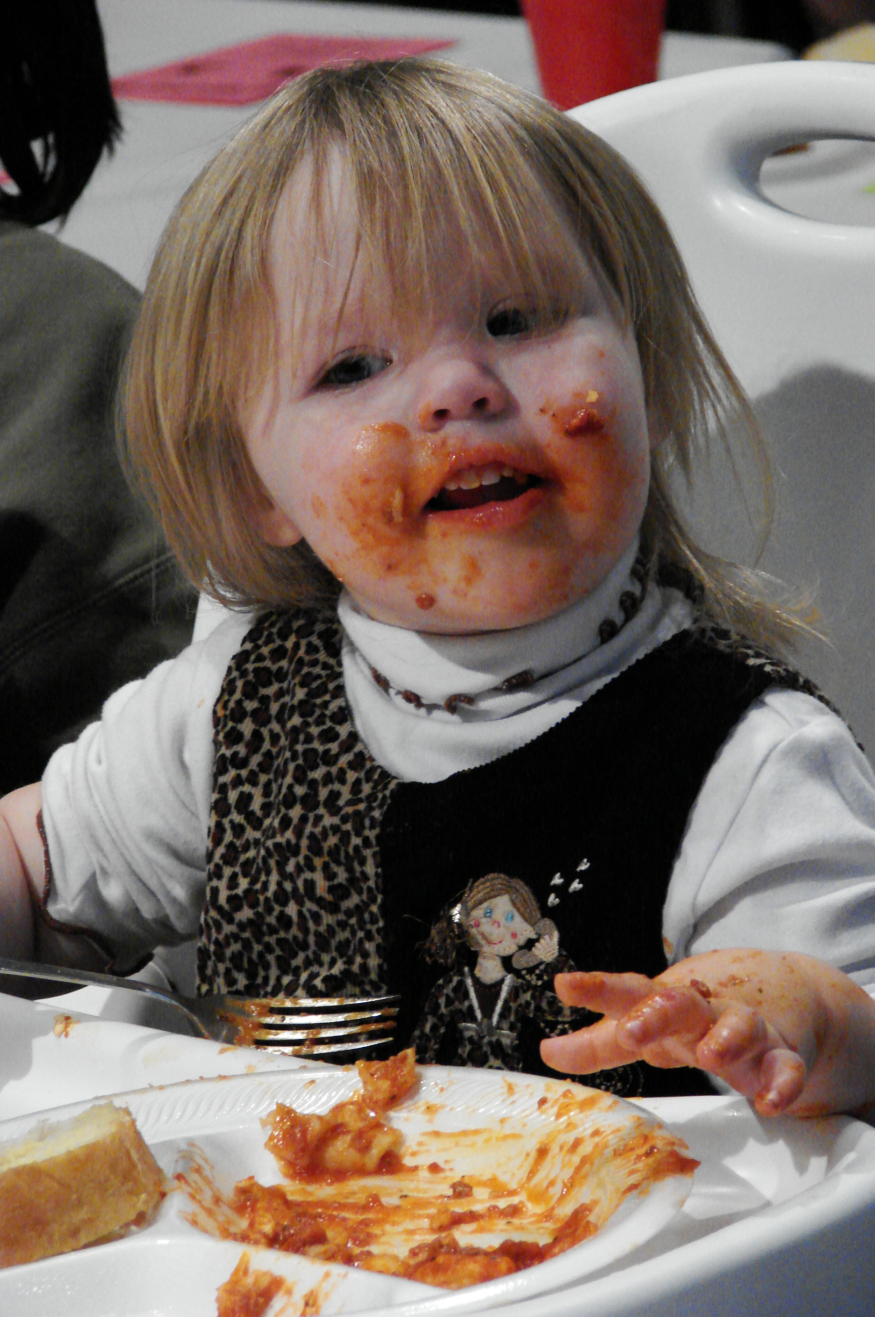
I’ve enjoyed every phase of my kids’ growing up years, but I found special humor in the (new slide) “Do it myself!” phase. Anyone in the “Do it myself!” phase right now with your kids? As they move from being a toddler to a little kid, every child goes through the “Do it myself!” phase. All of them want to prove they can do it themselves…

- (Picture) They want to dress themselves.
- (Add) They want to feed themselves.
- (Add) They even want to put makeup on ALL by themselves.
As we were working on this talk, our Lead Pastor, Dave Ferguson, told me a story about their youngest kid, Caleb. When Caleb was as toddler, it was getting late and Dave and his wife Sue were ready to go to bed, so they poked their heads into Caleb’s room. They could hear him saying something in his sleep; so they walked into his room and leaned over his bed and could hear him mumbling, “Self, self, self…I can do it myself.”

This desire to “do it myself” starts very young; but the truth is, we continue to place a very high value on “doing it myself” even when we are all grown up!

- We want to make it vocationally – all by myself!
- We want to make it financially – all by myself!
- And it’s something uniquely American – we celebrate the stories and we congratulate ourselves for all the times we pulled ourselves up by our own bootstraps and made it happen – all by myself!

When the great French philosopher Alexis de Tocqueville came to America to observe our culture, he noticed this “rugged individualism.” As an outsider, he described Americans this way:

“…each of them withdrawn into himself is almost unaware of the fate of the rest. Mankind, for him, consists in his children and his personal friends. As for the rest of his fellow citizens, they are near enough, but he does not notice them. He touches them but feels nothing. He exists in and for himself…” –Alexis de Tocqueville

Bumper Sticker - “God helps those who help themselves”
And that brings us back to the series we are in: (Series slide) Bumper Sticker Theology. This series was born out of a realization that much of what is commonly thought to be good theology is not actually based on what’s in the Bible after all. Sometimes it’s actually just based on popular thinking; colloquialisms likely to be found on a bumper sticker. So every week we’re asking, “Is this Biblically sound or does this just sound Biblical?” And today’s Bumper Sticker Saying: “God helps those who help themselves.”

Now, I’m not going to embarrass any of us by asking for a show of hands, but the vast majority of Americans belive that “God helps those who help themselves” is in the Bible. We place such a big value on independence and doing it ourselves that it when someone says this phrase, we are all inclined to nod with agreement!

The Barna Research Group did a survey and found that 7 out of 10 people think this is a quote from the Bible. 68% of Christians and 75% of Americans as a whole. And since we believe it’s in the Bible, we say it: “God helps those who help themselves” But why? Why do we even want to say it?

- I think sometimes we say the phrase because we somehow believe that we made it all on our own! And if others would just do what we did – they would be ok too. We completely ignore how much help we’ve had and how blessed we are.
- Or at times I believe we say this bumper sticker saying so that we don’t have to feel responsible for helping others. “God helps those who help themselves” lets us off the hook.
- Occassionaly, we say, “God helps those who help themselves” out of frustration with people who we believe are lazy and have take advantage of the system.

The origins of this saying started way before there were bumper stickers or cars to put them on. We have to go all the way back to Greek mythology in the 5th century B.C. There is a line in a story by Aesop where a character prays to the Greek God Hercules for help, and Hercules responds with a charge to get to work because: “The gods help them that help themselves.” –Aesop, 5th century B.C.

Credit for the phrase coming into the American consiousness has to be given to Ben Franklin. (Saying on screen with “-Ben Franklin, 1736) “God helps those who help themselves” first appeared in America in 1736 in Ben Franklin’s Poor Richard’s Almanac, and it’s been part of the American thinking ever since.

Now, that explains why it is in the American consciousness, but why do so many Christians think it’s also in the Bible? It does sound similar to what Paul says in 2 Thessalonians 3:6-12, particularly in verse 10 where he writes:

“For even when we were with you, we gave you this rule: ‘The one who is unwilling to work shall not eat.’” -2 Thessalonians 3:10

To understand what Paul is saying, we need to understand the context in which he was writing. Back then, church communities had a kind of common fund that everyone shared and would have access to and use as needed. In this situation, they had some people that were slacking in their own work, not contributing to the common fund and totally relying on the efforts of others. So Paul calls them out in this verse.

- Paul is NOT saying, “Everybody has to go out there and pull yourself up by your own bootstraps and make it all on your own!” No!
- Paul IS setting up some healthy boundaries by saying, “It’s a good thing for us to help each other out when we are down – we should do that! But this is not an excuse for not working. If you don’t work when you could work, then you don’t eat!”

What Does the Bible Say? (Proverbs 31)
So, if they Bible doesn’t say “God helps those who help themselves”; and God’s mandate is not about “Self, self, self, I will do it myself”, what does the Bible say about who God helps and how God helps?

I think one of the best places to start is chapter 31 in the book of Proverbs. The writer is recounting the sage advice of his mother. Think of the chapter as one long, “My mom always said…” In the first few lines of chapter 31 it says, “My mom always said… “

- “…good leaders don’t chase after women.”
- “…good leaders don’t drink too much.”
- “…good leaders don’t numb their feelings”

And then the writer gets to verses 8 and 9 and mom says this:

“Make sure you speak out on behalf of those who have no voice and defend all those who have been passed over.
“Make sure to open your mouth, judge fairly, and stand up for the rights of the afflicted and the poor.” -Proverbs 31:8-9

Now there are lots of places in the Bible where we are told to “be still” or “be slow to speak,” but in this passage we are urged to speak up, to talk. Twice in as many sentences, God urges us to say something, to speak out loud, to open our mouths about those in need.

Jim Wallis, the President and Founder of Sojourners, tells the story of the early days in the founding of his organization that speaks out for those who can’t speak out for themselves. He says:

“One of our first activities was to find every verse of scripture about the poor, wealth and poverty, and social justice. We found more than 2,000 texts that we then cut out of an old Bible. When we looked at the Bible without those verses we were left with a Bible full of holes...” -Jim Wallace, Founder of Sojourners

A casual reading of the Bible makes it clear that God cares for those who are vulnerable. There are those around us who need an advocate; who need our voice. It may be because they don’t have a voice or it may be because they’re shouting as loud as they can - but no one is listening.

I’m reminded of a speaker we had here at COMMUNITY a few years ago who had directed an amazing documentary titled, (picture) “Among the Discarded.” He’d spent a month living on Skid Row in Los Angeles with the homeless community. In this film he recounted that surprisingly the most difficult thing to endure was the psychological effect of people walking by without acknowledgment. The hardest part of that experience was being passed over, ignored, discarded over and over again. He said that within the first few days it was devastatingly impactful to his self esteem!

Not only is the saying, “God helps those who help themselves” not true, but I believe God is asking each of us to speak out, to open our mouth, to stand up for those who can’t help themselves - the voiceless, the passed over, the poor, the oppressed and the needy because they matter to him.

It’s also important to note God is calling us to “judge fairly.” That means we’re supposed to look beyond just what we can see at face value. When we see someone struggling in poverty or experiencing homelessness, “judging fairly” means we don’t just see them as the sum total of their bad choices but we work to understand the influences beyond their control that contribute to the situation.
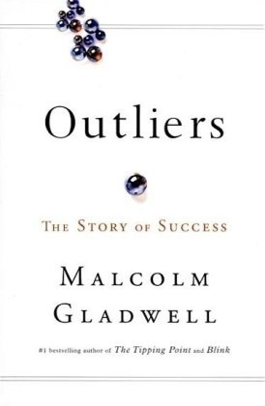
To demonstrate what I’m saying, let me share this illustration. (Picture) In Malcolm Gladwell’s book Outliers, he tells a number of stories that all have one thing in common: advantage is accumulated. Gladwell says: (add)

“…those who are successful in other words…are most likely to be given the kinds of special opportunities that lead to further success.” –Malcom Gladwell, Outliers

One of my favorite examples in the book is from a study about how someone becomes a great hockey player in Canada. It’s skill, right? Along with lots of hard work and effort, correct? Well, it turns out that in any elite group of hockey players:

- 40% of the players will have been born between January and March.
- 30% percent between April and June.
- 20% percent between July and September.
- 10% between October and December.

You have to ask yourself… Why? Why are 40% of all great hockey players born between January and March? Gladwell continues:

“The explanation for this is quite simple. It has nothing to do with astrology, nor is there anything magical about the first three months of the year. It’s simply that in Canada the eligibility cutoff for age-class hockey is January 1. A boy who turns ten on January 2 then could be playing alongside someone who doesn’t turn ten until the end of that year - and at that age, in preadolescence, a twelve month gap in age represents an enormous difference in physical maturity” –Malcom Gladwell, Outliers

If you’re a boy born between January and March in Canada, you have an advantage through no effort of your own. Now, this example might seem silly, but if something as simple as the month in which someone is born could be the difference in who becomes a successful hockey star or not; how much more might mental illness, socio-economic background, or race increase or decrease access to what Gladwell calls, “…the special opportunities that lead to further success.”

I want you to just think about some of these other outlier stats; how they might they impact someone’s success or not; and that perhaps there are people who need our voice.

- How might the fact that 25% of the homeless population suffers from mental illness influence their ability to obtain stable housing?
- Would we judge those incarcerated differently if we were aware of the 2010 University of Chicago study, which discovered 60% of young men who had been in foster care in Illinois, Iowa and Wisconsin. had been convicted of a crime.
- Might we see prostitutes differently if we knew 80% of those in prostitution were sexually assaulted as children.

Judging fairly means we recognize there are factors beyond simply pulling ourselves up by our own bootstraps that influence outcomes both positively and negatively. Judging fairly means we recognize we didn’t do it on our own and neither will others!

Truth: God Helps Those Who Can’t Help Themselves
Here is the true saying I hope we’ll all take away from today: God helps those who can’t help themselves. And you know how I know that statement is true? Because when I couldn’t help myself, God helped me. When you couldn’t help yourself, God helped you. Never forget: while you were far, far away from God, he came after you. When your relationship with him was broken and there was nothing you could do to repair it, God provided a way back. The Apostle John states it so beautifully in his first letter when he says:

“This is how we’ve come to understand and experience love: Christ sacrificed his life for us.” -1 John 3:16 (The Message)

God helped me, when I couldn’t help myself. He sent Jesus to create a way for me to find my way back to him. He sent people into my life to point me towards him. He pursued me until I was found. This is how we’ve come to understand and experience love: Christ sacrificed his life for us. God helped me, when I couldn’t help myself. God helped you, when you couldn’t help yourself.

And because God helped us, John goes on to say:

“This is why we ought to live sacrificially for our fellow believers, and not just be out for ourselves. If you see some brother or sister in need and have the means to do something about it but turn a cold shoulder and do nothing, what happens to God’s love? It disappears. And you made it disappear. My dear children, let’s not just talk about love; let’s practice real love. This is the only way we’ll know we’re living truly, living in God’s reality. -1 John 3:17-18 (The Message)

Now, I don’t think John is saying that if we don’t help those in need, God’s love disappears from the world. He’s not saying that God won’t love us if we don’t help. What I think he’s saying is if we are able and don’t allow God to use us to help those in need, the evidence of God’s love in our life will disappear. For often God helps those who can’t help themselves through his people – through you and me. When we help those who can’t help themselves God’s love becomes visible.

Kids Hope
So what does practicing real love look like? What does speaking out and giving a voice to those who don’t have a voice look like? One of the best examples I see at COMMUNITY is our (Logo) Kids Hope Mentoring program that Community 4:12 organizes in East Aurora, Joliet, and Chicago. The program pairs a student who faces systemic inequalities just because of the zip code they were born into with a mentor, a prayer partner, and a scholarship provider. The team practices love by being consistently present and casting hope of a better tomorrow. Here’s Tom Ryan’s story of being a mentor at Brady Elementary School in Aurora.

Video Testimony – Tom Ryan

(Logo) Isn’t that a beautiful story of God’s love being visible through us? As I mentioned before Kids Hope is a team approach and there are 3 ways you can get involved:

- There are Mentors like Tom, who meet weekly for an hour during the school day building a consistent and encouraging relationship with a student.
- There are Prayer Partners who pray for the student and provide support and accountability for the mentor.
- And there are Scholarship Providers who commit to cover the $15 monthly national programing cost for each child.

I’d like to challenge you to step into one of these roles. You can go to www.community412.org and fill out a volunteer application to learn more about the Kids Hope program OR you can check the Community 4:12 box on this connection card today.

Conclusion
It is childish to say, “Self, self, self…I can do it myself.” And it is childish to think that any of us can do it ourselves. It’s not true that “God helps those who help themselves” – NO! God helps those who can’t help themselves. People like you and me.

And we can honor this God who helped us when we couldn’t help ourselves by helping others. So, let’s ALL determine that we will use our voice for the voiceless, that we will judge fairly, that we will stand up for the rights of the afflicted and the poor. Let’s be agents of God’s love in a world that desperately needs him.

Communion Idea
There was a moment for me when I came to understand that I could NOT do it all on my own.

- In that moment I had to admit that I can NOT do this life on my own AND I can NOT make it into the next life on my own.
- Self, self, self…I can NOT do it myself.

That is when I discovered the grace of God; that God helps people like you and me, who can NOT do it on our own.

Communion is that moment; it is a moment when for the first time or once again we get to discover the grace of God by coming to him and admitting “I can’t do it on my own.”

In this piece of bread and in this cup Jesus comes to each of us and says, “I have come to help those who can’t help themselves”…me…you.

Alexis de Tocqueville. Democracy in America, New York: Anchor, 1969
George Barna, Boiling Point: How Coming Cultural Shifts will Change Your Life, Regal Books, 2001\, pg. 60.

