Turn the Page Week 6 – Captive to Courageous

Message Big Idea: “Turn the Page” by courageously living out my convictions.

Scripture: Daniel 6
________________________

Overview Video: The Exile (Recommended to start the message)

Captive in Another Culture
(Series Graphic) Over the last six weeks, we’ve been on a journey together called Turn the Page. We’ve been walking through the story of the Bible, and today we pick up the story as a remnant of the people of God have been carried off into exile to Babylon. In the book of Daniel, we find stories about what Daniel and some of his friends encountered during this time.

Now, there are people in our world today who still experience being forcibly removed from their homes and relocated to a completely foreign context, but very few of us can even comprehend that. Just imagine what this was like for the Israelites… Not only did they see their beloved Jerusalem destroyed, but now they find themselves in an unfamiliar place, surrounded by an unfamiliar culture, just wishing they could return home.

How many of you have ever traveled to a foreign country where you felt totally out of place? (Hands) Yeah, being in a foreign country can be disorienting because you don’t know the customs, you aren’t sure what to say or what to do, you…well, you can end up feeling like this guy…

Video: Elf Out of Place

(Elf picture) First rule of teaching… always figure out how to include an Elf clip at Christmas.

Seriously, though, what Daniel and his friends faced in Babylon was far more than just culture shock. The Babylonians wanted to immerse the Israelites in their culture so that they would pick up Babylonian ways and abandon the ways of God. The Israelites faced intense pressure and undoubtedly struggled with several distinct realities.

- First, they struggled with Isolation - They were far away from home. They rarely interacted with anyone who spoke their language or appreciated their cultural practices. For the most part, they were completely alone.

- They struggled with (add) Indoctrination - They were completely immersed in Babylonian culture and were constantly pressured to assimilate into it. In fact, these young Israelite men had to undergo 3 years of intense cultural training that was intended to rewire their brains to live out the Babylonian way of life.

- And, they struggled with (add) Identity – The Babylonians even forced the Israelites to take on new names. Now the thing is, a new name might not seem like a huge deal to us, but to ancient culture, names were central to their identity. A name defined who you were. (Daniel 1:6-7) And here, that key identifier is changed up on Daniel and his friends. They may have felt caught between two identities, and they had to decide which one they’d choose.

There was intense pressure to conform, and, for Daniel, this cultural pressure mounts to an unimaginable level as his commitment to God is directly challenged.

Daniel and the Lions Den
(Daniel 6:1-2 NLT) As we turn the page to Daniel chapter 6, Babylon has a new king, King Darius, and he decides to appoint others to help him rule his kingdom. Daniel, who had been in exile for a number of years at this point, has proved himself so capable that he is chosen for one of the three highest leadership positions. (Daniel 6:3 NLT) And he excels at it! The king is so pleased with Daniel’s leadership that he plans to place him over the entire empire!

Wow! Daniel is about to become the 2nd most powerful person in the world! This is great news for him and for all the people of God!

Yet, a lot of other people aren’t thrilled with this news. (Daniel 6:4 NLT) Daniel’s Babylonian co-workers are filled with jealousy. Though they were there to serve the king, their real loyalty is to themselves.

They begin an investigation to try to uncover some dirt on good ole Daniel, but they come up empty handed. They couldn’t find anything to criticize or condemn so they decide the only way to take him down is by being deceptive themselves. They conclude:

“Our only chance of finding grounds for accusing Daniel will be in connection with the rules of his religion.” -Daniel 6:5 NLT

You see, Daniel’s colleagues could see that it was his steadfast devotion to God that set him apart and so they attempt to turn his devotion into his vulnerability.

These top officials approach King Darius with a proposal for a new edict:

“We are all in agreement…that the king should make a law that will be strictly enforced. Give orders that for the next thirty days any person who prays to anyone, divine or human—except to you, Your Majesty—will be thrown into the den of lions.” –Daniel 6:7 NLT

Essentially, they propose a short term law that says, “Worship the king as god or die a horrible death.” Now, the new king doesn’t realize that he’s being taken advantage of by these schemers. Their idea appeals to his ego so he signs an irrevocable and unchangeable document that makes him a “god-king” for the next thirty days.

The trap is set. The officials have created a high stakes conflict of loyalties for Daniel. So how will he respond?

“…when Daniel learned that the law had been signed, he went home and knelt down as usual in his upstairs room, with its windows open toward Jerusalem. He prayed three times a day, just as he had always done, giving thanks to his God.” –Daniel 6:10 NLT

Amazingly, Daniel seems to be entirely un-intimidated by this law. His loyalties are first to God and then to king and country…never in reverse. So he continues to pray, (highlight) “just as he had always done.” He not only honors his loyalty to God internally, he makes no attempt to hide it externally!

I think if this were me I would have…Oh, I don’t know…SHUT THE WINDOWS!? Come on, man!

Daniel’s response was to pray openly to God because his identity was grounded completely in God. He knew who he was (or rather “whose” he was) and how he was called to live. He didn’t flaunt it, but he certainly didn’t hide his convictions. He did not waver in his steadfast devotion to God

He displays such remarkable courage and integrity. This may be one of the first peaceful, nonviolent protests in history.

And the officials think they have won!

“Then the officials went together to Daniel’s house and found him praying and asking for God’s help. So they went straight to the king and reminded him about his law. ‘Did you not sign a law that for the next thirty days any person who prays to anyone, divine or human—except to you, Your Majesty—will be thrown into the den of lions?’” –Daniel 6:11-12 NLT

The trap was perfectly set, and Daniel and King Darius are caught in it.

(Daniel 6:14 NLT) The king was deeply troubled and tried to think of a way to save Daniel. But not even the king himself could stop what had been set in motion. According to Persian law, once a law was made, it could not be changed. There was no turning back. And so the king acts in loyalty to the law.

As the story unfolds… actually - it’s such an amazing story, I’m just going to read it to you.

“So at last the king gave orders for Daniel to be arrested and thrown into the den of lions. The king said to him, ‘May your God, whom you serve so faithfully, rescue you.’

A stone was brought and placed over the mouth of the den. The king sealed the stone with his own royal seal and the seals of his nobles, so that no one could rescue Daniel. Then the king returned to his palace and spent the night fasting. He refused his usual entertainment and couldn’t sleep at all that night.

Very early the next morning, the king got up and hurried out to the lions’ den. When he got there, he called out in anguish, ‘Daniel, servant of the living God! Was your God, whom you serve so faithfully, able to rescue you from the lions?’

Daniel answered, ‘Long live the king! My God sent his angel to shut the lions’ mouths so that they would not hurt me, for I have been found innocent in his sight. And I have not wronged you, Your Majesty.’

The king was overjoyed and ordered that Daniel be lifted from the den. Not a scratch was found on him, for he had trusted in his God.” –Daniel 6:16-23 NLT

In the end, only God can deliver us. He is the one worthy of our loyalty.

The king’s loyalty to the law betrayed him…leaving him sleepless, full of anxiety, and unable to do what he knew to be right.

And the officials? Their primary loyalty to themselves ends up costing them their lives (as graphically described later in the chapter).

But Daniel? Daniel trusted God. His loyalty to God gave him courage in impossible circumstances.

I mean think about it… If Daniel had acted to save his own skin, he would have betrayed God and lost the opportunity to prove God’s faithfulness. As it was, this public display of God’s faithfulness ends up sending shockwaves through the entire Babylonian Empire! Just look at the incredible reversal of the story at the end of chapter 6:

“Then King Darius sent this message to the people of every race and nation and language throughout the world:
‘Peace and prosperity to you!
I decree that everyone throughout my kingdom should tremble with fear before the God of Daniel.
For he is the living God,
and he will endure forever.
His kingdom will never be destroyed,
and his rule will never end.’” –Daniel 6:25-26 NLT
Daniel’s loyalty to and trust in God led not to just his own deliverance, but to the king recognizing and declaring God as the living God to every race, nation, and language throughout the world!

When we have the courage to remain loyal to God in the face of fear and consequence, it has the power to change the world around us.
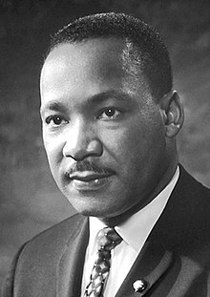
Story: MLK Jr.
In modern history, there is perhaps no better example of this than (Picture) Martin Luther King Jr.

The racial world he grew up in, and the one we live in today, are very different. Racism remains in many forms in America and around the world. In fact, the last few years have brought a disheartening setback, as advocates of white supremacy have been emboldened to act out.

But in the days of MLK’s youth in the south, it was worse. The segregation was almost absolute, its manifestations utterly degrading, and the defense of it rang out not only from street mobs, but also from the halls of political power.

- In 1954, seventeen states required segregated public schools.
- (Either add or new slide) In 1956, 85% of all white southerners rejected the statement, “White students and Negro students should go to the same schools.”
- (Either add or new slide) In 1963, 82% of all white southerners opposed a federal law that would give “all persons, Negros as well as white, the right to be served in public places such as hotels, restaurants, and similar establishments.”

The result of those statistics was an unjust, unsafe, condescending, unwelcoming, demeaning, and humiliating world for blacks.
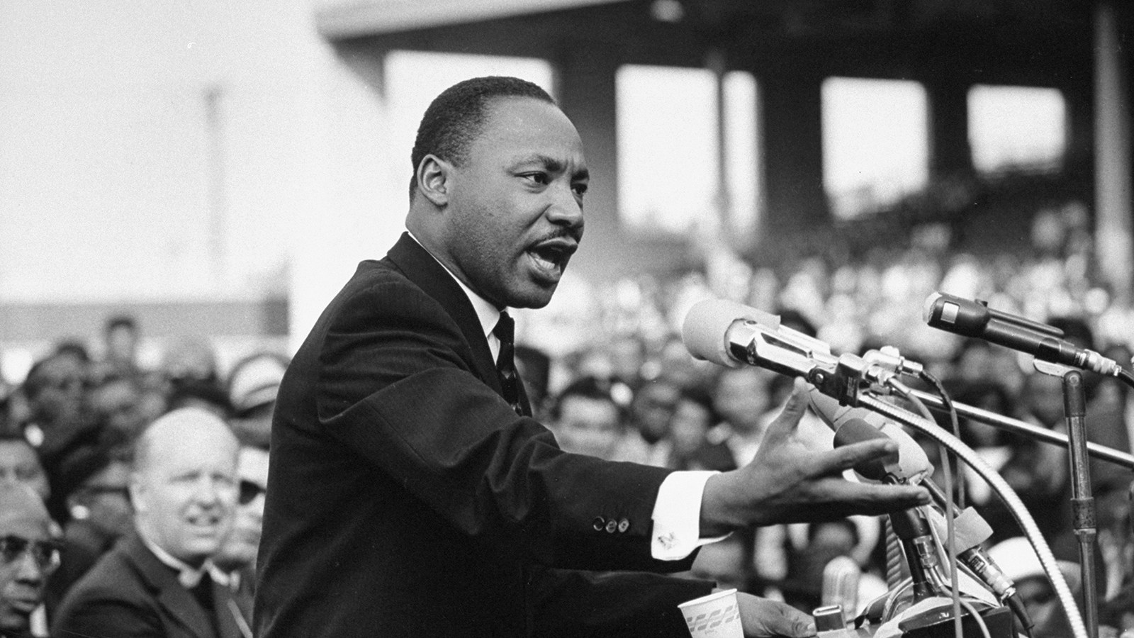
Have you ever paused to ask yourself what separate water fountains and separate restrooms could possibly mean except, “You are unclean — like lepers in a modern society”? It was an appalling world.

Enter (Picture) Martin Luther King Jr.

MLK gave his life to change the world. And toward the end, he was increasingly aware that “the movement” would cost him his life. The night before he was assassinated outside his room at the Lorraine Motel, he preached at the Bishop Charles Mason Temple.

His message came to be called “I’ve Been to the Mountaintop,” and his sermon ended with these words:

“We’ve got some difficult days ahead. But it really doesn’t matter with me now, because I’ve been to the mountaintop. And I don’t mind. Like anybody, I would like to live a long life — longevity has its place. But I’m not concerned about that now. I just want to do God’s will. And He’s allowed me to go up to the mountain. And I’ve looked over, and I’ve seen the Promised Land. I may not get there with you. But I want you to know tonight, that we, as a people, will get to the Promised Land. And so I’m happy tonight; I’m not worried about anything; I’m not fearing any man. Mine eyes have seen the glory of the coming of the Lord.” –Martin Luther King Jr.

Less than 24 hours later he was dead.

For a brief window of time, MLK was able to use his voice to restrain violence and overcome hate. He, like Daniel, kindled a kind of fire that no fire hoses could put out, and a kind of courage that no dogs could defeat.

MLK was captive in an unjust and inhumane culture…and he, like Daniel, had the courage to live according his faith in God, regardless of consequence.

And our world is forever changed as a result.

Courageous faith in the living God is an unstoppable force. An unstoppable force that is available to ALL who steadfastly remain loyal to God.

Modern Captives
As followers of Jesus, the reality is that we, too, live captive in another culture. Maybe we wouldn’t think of it in those terms, but if we take a step back and examine our world, there are things all around us that challenge our loyalty to God. And, like Daniel and his friends in Babylon, we may struggle with several distinct realities.

- Sometimes we face Isolation. Sure, we’re confident in our faith when we’re here together in this room, but when we’re away from the support of our Christian community, we can feel alone in our convictions.
- We can also feel the pressure of (add) Indoctrination. Every day every one of us is immersed in a culture whose messages and values are in direct conflict with the Word of God.
- And all of this can leave us confused about our (add) Identity. We have hundreds of voices coming at us from all different directions trying to tell us who we are.

The thing is, if we’re not careful, we can end up conforming to the beliefs, values, and practices of our culture, instead of staying true to the way of life God’s called us to live. If we aren’t intentional about living as “the people of God,” then before we know it, we’ll find ourselves lost in another culture.

The key to living courageously… like Daniel … is to ground our identity in God. To know who we are… or better said “whose” we are. We are God’s people, called to live according to his wisdom given to us by his Spirit and in his Word. When we stay loyal to him, putting our faith in him, we’ll find the courage to live as he’s called us to live.

Challenge: Take Courage
So what does this mean practically? How do I begin to live the way God’s called me to live?

First, I have to Recognize the places where my loyalty to God is being tested. Ask yourself:

- What pressures am I facing?
- What in my life is leading me away from God instead of toward him?
- Where am I being tempted to compromise in my commitment to him?

If we are not paying attention, we will mindlessly adopt the values and assimilate into the ways of our culture. We have to measure those values by Word of God. We have to examine those ways in light of the ways of God.

Once we recognize the places where our loyalty to God is being tested, we then make the choice, just like Daniel, to Courageously live out my convictions.

This could take many forms. It might mean there is…

- (add under above heading) A word I need to speak. I may need to speak out against an injustice. Perhaps I may need to say, “I’m sorry, I’m not going to be a part of that,” in a particular situation. At times this may mean speaking the truth in love to another person.

- Living courageously could be about An action I need to take. This might mean walking alongside the marginalized and forgotten. It could be about getting out of the house and involved in the community. It’s about imitating the ways of Jesus in a world that is desperate for his hope, joy, and healing.

- Courageous living can also be about A stand I need to make. This is about remaining faithful to God when the pressure to conform is fierce. It may involve sacrifice and rejection. It’s about being committed to doing God’s will no matter the consequences.

Understand, courageous living isn’t fearless living. It’s OK to be afraid. Courage isn’t the absence of fear. In fact, the exact opposite is true. As Oliver Wendell Holmes, the American writer and poet once said:

“Courage is about doing what you're afraid to do. There can be no courage unless you're scared." — Oliver Wendell Holmes.

Conclusion
Friends, we can have courage because God is always faithful. (Hold Bible) As we continue to turn the pages of this book, we find story after story of God coming through for his people. Daniel’s story is meant to remind us that we follow a faithful God who can free us from fear and help us live courageously.

No matter what we face in life, no matter how big the pressures mount around us, we can live courageously because we follow a courageous Savior. Jesus is deserving of our devotion. Jesus is deserving of our loyalty. Jesus is deserving of our everything.

Communion Idea
Leads into creative moment planned by Arts Catalyst based on this prayer by Mother Teresa: https://www.catholicnewsagency.com/resources/prayers/prayers-to-saints/mother-teresas-description-of-jesus

Follow the creative moment with…

Today we remember this Jesus who is deserving of our everything by receiving Communion. The bread representing his body, the cup representing his blood. He took a stand and went to the cross all so that you and I would no longer be captive to this world of sin but could live victoriously in his power. Let’s remember him as we receive the elements.

