Explore God – Week 2 – Is There a God?

Message Big Idea: When we are open to the possibility of God’s existence, we’ll discover there are many indicators of his presence.

Scripture: Psalm 19:1, 1 John 4:8, John 1:14
_______________

Introduction: Letters to God
The notion of God or the idea of God is almost impossible to avoid…
- His name is printed on the currency we once used to pay for stuff. (You remember what paper money looks like, don’t you?) On it we find the words: “In God we trust.”
- The pledge of allegience that most of us memorized when we were kids includes this phrase: “One nation under God.”
- (90% of Americans believe in a higher power. 56% of Americans believe in the God of the Bible. (Footnote this source on the screen: Dalia Fahmy, "Key findings about Americans’ belief in God" at http://www.pewresearch.org/fact-tank/2018/04/25/key-findings-about-americans-belief-in-god/.)) Almost 90% of Americans say they believe in some kind of god. With over half saying they believe in God as described in the Bible.

So I think we can all agree that almost everyone thinks about God or in one way or another believes in God. Even if we conclude that we do not believe, my hunch is that we still give the notion of God at least some thought from time to time.

And it’s not just adults who wrestle with the idea of God. Little kids think about God too, and sometimes their thoughts lead them to write letters to God. We were able to intercept some of these letters, and here are a few of my favorites: (In kid handwriting on separate slides)

- God, I bet it’s very hard for you to love all of everybody in the whole world. There are only four people in our family and I can never do it. - Your friend, Frank
- Or how about this letter from Lucy: Dear God, Are you really invisible, or is that just a trick? - Lucy
- And here is my favorite: “Dear God, Maybe Cain and Abel would not kill each other so much if they had their own rooms. It works with my brother.” - Love, Larry

We can laugh at these letters from children whose questions will likely go unanswered; but if we’re honest, what can make God less than believable to us as adults are the questions we have that often go unanswered.

Maybe there is a nagging question you carry with you that leaves a few too many lingering doubts as to whether or not God is real.

Series Recap
If you have been with us over the past several weeks, you know that we are joining with hundreds of churches in Chicagoland on a 7-week journey called (Series Graphic) “Explore God.” And if this is your first-time here, we are so glad you came.

We want you to know that during these 7 weeks, we’re digging into 7 big questions many people have about God and faith. And our desire for these seven weeks is not to convince anyone of anything or to remove all your doubts, we just want to invite everyone to explore these questions together.

And today’s question is one that we may think we have a quick answer to, but I wonder if we’ve given it as much thought as we think we have. The question is this: “Is there a God?”

Belief in God
As I mentioned earlier, 90% of Americans believe in some kind of higher power with over half of people survyed saying they believe in the God described in Scripture. Only 1 in 10 say they don’t believe in a higher power of any kind.

Sometimes those who deny the existence of God believe that educated people don’t believe, but many of history’s most influential intellectuals are convinced – they absolutely believe in the existence of God.

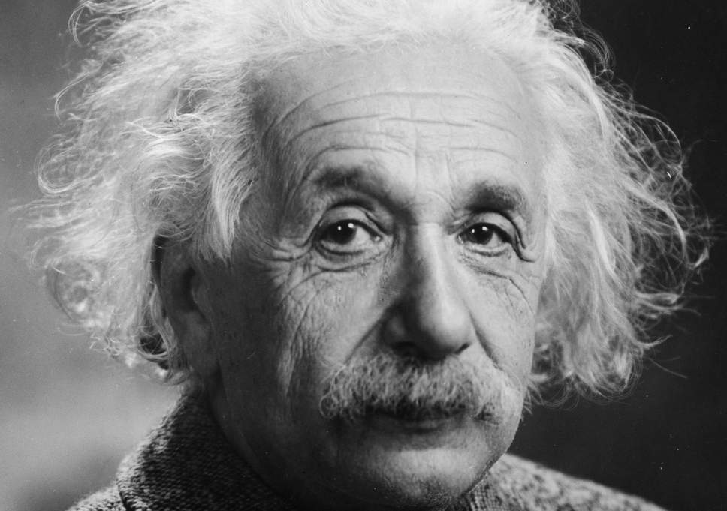
Albert Einstein (picture with quote), one of the most highly recognized and revered scientists of the twentieth century, was quoted as saying “Everyone who is seriously committed to the cultivation of science becomes convinced that in all the laws of the universe is manifest a spirit vastly superior to man, and to which we with our powers must feel humble.” –Albert Einstein

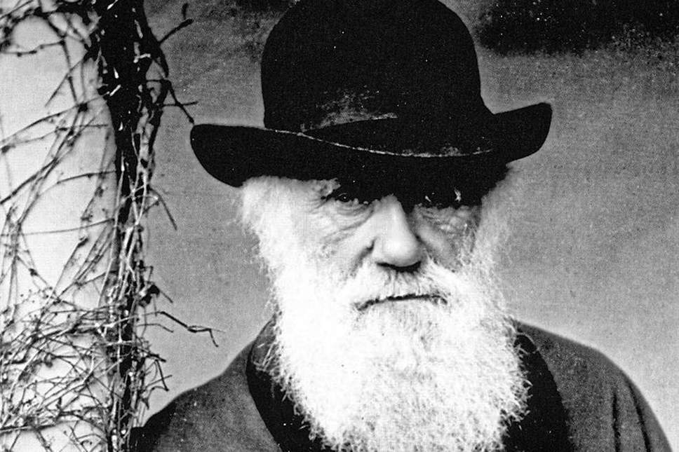
It may be surprising to know that the English naturalist and geologist, Charles Darwin (picture with quote) believed in God and believed there could be a relationship between faith and science. He said: “I have never denied the existence of God. I think the theory of evolution is fully compatible with faith in God. I think the greatest argument for the existence in God is the impossibility of demonstrating and understanding that the immense universe, sublime above all measure, and man were the result of chance.” –Charles Darwin
Perhaps not quite as well-known, Francis Collins (picture) is an American physician-geneticist who discovered the genes associated with a number of diseases and led the Human Genome Project. He is director of the National Institutes of Health (NIH) in Bethesda, Maryland, and here is how he describes his faith…

Video: Alpha Testmony – Francis Collins https://www.youtube.com/watch?v=Pl-fhLjz2Ac (Improved Option adds 3-4 minutes to talk)

(“Is there a God?”) The bottom line is this: You do not need to check your brain at the door, and you are not intellectually inept if you believe in the existence of God.

Crisis of Belief
Now we could go on talking about famous, smart people who believe in God. We could talk about arguments for the existence of God, and whether or not they “work” or are convincing one way or another; but at the end of the day, after all the evidence and the reasons, it has to go deeper than intellectual engagement. The question “Is there a God?” has to make sense in your experience, and sometimes you can find yourself grappling with this question in a way you didn’t expect for reasons you don’t anticipate.

(Tell your own story of doubt or there is a alternative story at the end of this manuscript)
I (Jon H) remember a few years ago my wife and I had been stabbed in the back by some very good friends that were a part of our church. They hurt us and left the church, which hurt and confused a lot of people, but it was personally crushing for me. For months I couldn’t shake the deep feelings of rejection I was feeling, and I honestly started feeling like a failure. I would pray, and call out to God, asking for God to bring healing to my pain, but there was no answer, only hurt. Well, that year I came to church on Easter Sunday, the high holy day of the Christian calendar. I walked into the back of the auditorium from the lobby and the band was rocking, singing about the resurrection, but the message of hope and felt so foreign and impossible to me in my mind and in my heart. And I stood there taking it in, and then I said outloud to myself, “I don’t believe this anymore.” What do you do when you’re the pastor and you don’t believe the central event of your faith on the biggest Sunday of the year?

Now I could give you sophisticated philosophical and theological reasons for belief in God and why it’s reasonable intellectually; I had a master’s degree in philosophy and theology, but in that moment, none of that mattered. God didn’t seem real to me. I started wondering: “Maybe God doesn’t exist?”

Perhaps you know what I am talking about:

- For some of you God, seemed so real at one point in your life, but someone or something came along and devestated you, and now God feels like a distant relative living on the other side of the planet.

- Or maybe you’ve been a part of a church, and you got burned by a friend, or a small group, or a staff member, and you’ve thought, “If that’s what God’s people are like, I’d rather have nothing to do with them.”

- Or maybe every version of God’s people you see on display seems so narrow-minded, petty, and arrogant, that you want nothing to do with the God of such repugnant people.

If that’s been your experience or something similar, I don't blame you for feeling the way you do. But I’ll also confess that my experience is broader than just that Easter morning. There are other moments in my life that point the other direction – moments of wonder that take my breathe away – moments that seem to point me in some way to God.

Signposts
I call these moments signposts. They point towards God. They don’t make an airtight case for the existence of God. I don't think there is a easy set of evidence for or against the existence of God, no matter what Youtube says. Rather, these signposts nudge us toward God. They resonate deeply within us. They point to something bigger than ourselves.

For example, one signpost that points beyond ourselves is the experience of Beauty.

N.T. Wright, in his book Simply Christian, says, (add) “We must acknowledge that beauty, whether in the natural order or within human creation, is sometimes so powerful that it evokes our very deepest feelings of awe, wonder, gratitude, and reverence.” –N.T. Wright

We’ve all experienced these moments. If we are willing to pause long enough to take in the world around us, we are struck by the awe and wonder of it all. Last summer my family (Jon H) went up to Door County, and we watched the sunset at Peninsula State Park. (Picture) We sat on the rock beach and watched the waves pound the shore and the sun sink into the lake. It stirred something in me, and I took pictures. I’ve experienced this same stirring when reading poetry or a grand piece of writing or eating a fantastic meal. We use words like sublime, divine, or transcendent to describe our experience.

This has led many to think that beauty points us to a divine artist, a mind who has created and orchestrated a good, ordered, and beautiful world. One poem from the Old Testament reads this way:

“The heavens declare the glory of God; the skies proclaim the work of his hands.” –Psalm 19:1

Beauty calls us out of ourselves to something bigger, and it also resonates deeply within us. The Christian story proclaims that at the heart of the universe is the Beautiful One.

A second signpost that points beyond ourselves is our longing for Justice.

Travel to the nearest playground and you’ll hear children caling out, “That’s not fair!” because a sense of fairness and justice is part of being human. We feel a longing for the world to be put right. We all know the world is not as it should be. There is plenty that puts the beauty of God at risk. Like a child with a broken leg, our world needs to be set right, to be fixed, the bone needs to be set and given time to heal.

You’ve undoubtedly experienced this desire for justice if you’ve:

- Been to a third world country and seen people living in extreme poverty. A few years ago I was in a city in Mexico, and we went to the “Cardboard City” where people lived in the garbage dump of the world. Their homes we made of billboards and scrap metal. Their sewer was an open ditch, and their kids ran naked through the dirty streets. In that moment I didn’t have words, except to say, “This isn’t the way the world is supposed to be!”

- Maybe you’ve felt this longing for justice when you’ve turned on the TV and heard about a shooting or a stabbing, or systematic violence committed against a people group because of their gender or their ethnicity or their political or religious views. It’s not right, and we feel in our bones, someone needs to do something!

C.S. Lewis, one of the great Christian thinkers of the 20th century said, (add) “Human beings, all over the earth, have this curious idea that they ought to behave in a certain way, and cannot really get rid of it.” –C.S. Lewis

He believed there are moral facts in the universe – that every civilization believes betraying a friend or lying to a family member goes against a moral virtue. And, Lewis concludes, that this moral order points to a “source of morality” – to God. A God who is concerned with justice and wants his people to be concerned with fairness.

Now I know some of you may be thinking, “Christians have done their fair share of horrible acts in the world,” and you’d be right. All of us have the capacity for great evil no matter what we believe, but we also have the capacity for good, and followers of Jesus have and still make waves in the world for fairness and justice.

One last signpost pointing beyond ourselves is our desire for Relationships.

We all long to be in healthy, meaningful relationships. Even when relationships are difficult and we feel like swearing off the people around us, we still want someone there in that moment to have pity on us. We are made for relationships, and our experience of relationships points again toward God.

- Maybe you’ve experienced this at the birth of a child.
- Or on a wedding day
- Or sitting around a table with some good friends where you connect beyond surface level conversation to talk about your hopes and fears.

The other night I was wrestling with my eight year old boy, and in that moment, it’s like nothing else matters in the world. This little child is so precious and full of dignity and life. He’s not just a collection of chemicals and brain synapses; he’s a glorious human being capable of giving and receiving love.

Relationships point back towards a God who is the definition of love. The earliest Christ-followers believed this is what Jesus revealed about God. That… “God is love.” -1 John 4:8

Creative Moment: Treble and Bass
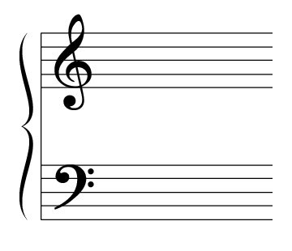
Whether you believe in God or not, we likely all have those moments where something just resonates deeply within us. Beauty, justice, relationships - when we see these things lived out, or better yet - when we experience them ourselves, there's something in our gut that knows, "There's something powerful going on there."

It's a little bit like this. (Picture) In music, there is treble, which are tones of high frequency. The symbol on the top of a music chart is treble. The counterpart to treble is bass – the lower, deeper tones. It’s the symbol on the bottom.

Treble is something you hear, but bass is something you feel.

Improved Option: Illustrate this by having a bass guitar play a treble note and then a bass note.

Have you ever been to a concert and the bass was cranked all the way to 11?

Here’s the truth… In our culture, we're surrounded by a lot of "treble" - social media, advertising, and entertainment - things fighting for our attention. Amidst that sea of noise, I think a lot of us, deep down, long for a bass note - something that resonates deep within us.

The presence of the divine resonates within us like a bass note. God is not merely something to learn about or even just talk about, but someone to experience, deep down. This longing, whether we recognize it or not, is in all of us.

Challenge: Pascal’s Wager as a Community
Let me say again that in this series we are not really trying to convince you, we are simply inviting you to join us, as together we explore these important quesitons about life and faith. But I want to push you just a little bit because I believe this is the most important journey or exploration you will ever undertake.

Last week we introduced you to Pascal’s Wager. The seventeenth-century mathematician Blaise Pascal had one of the greatest intellects in the history of Western civilization. He grew up knowing about God, but NOT earnestly following him. Then, in a profound middle-of-the-night experience with God, he had a change of heart. That experience ignited Pascal’s passion to help others find their way back to God.

Pascal began to challenge his fellow intellectuals to a wager on God. He would dare them to step into a belief about God and see if it didn’t change their lives. Pascal explained his wager this way: “Make a bet that there is a God who loves you. If you are right you have everything to gain, and if you are wrong you have nothing to lose. Make a bet that God is real.”

Last week we challenged everyone of us to individually pray a prayer. To pray, “God if you are real, make yourself real to me.” That’s Pascal’s Wager.

But today, I want to challenge everyone to something slightly different. The journey of life is not meant to be taken individually so take this journey with us, a community of fellow pilgrims who are on a similar exploration simply seeking to find our way back to God. Join us every week for the next five weeks. Consider joining a small group where you can go deeper, ask questions, and be encouraged by other fellow explorers. And for sure don’t miss next week as we ask the question: “Why does God allow pain and suffering?”

But during this next week, let’s continue to pray this prayer, but with one slight modification. Let’s pray: “God if you are real, make yourself real to US.”

The journey we are on is a journey we are meant to take together.

Conclusion and Communion Idea
I’m going to ask the band to come up and begin to prepare us for our communion time. Communion is a tremendous reminder of lengths to which this God would go to make himself real to us. His one and only son, Jesus, became so real he left heaven to become one of us. One of his closest friends and followers, John, put it like this:

“The Word became flesh and blood, and moved into the neighborhood.” -John 1:14 The Message

Jesus lived with and among us. He saw life like we see it. He felt feelings like we feel them. He cried tears like we cry them. And then he willingly sacrificed his life – experiencing untold pain and suffering in order to give us the hope of grace, forgiveness, and an eternity with him that begins the moment we put our trust in him.

Then to make sure we wouldn’t forget him and to keep on making himself real, he put his spirit inside each of us who choose to follow him and asked us to remember him by participating in a very real and simple meal each week we call Communion.

In a moment we will celebrate Communion together as a community, but before we do I want us to prayerfully say these words to God together: (together) “God if you are real, make yourself real to us.” Let’s say it one more time: “God if you are real, make yourself real to us.”

May everyone of us feel the bass notes of his presence with us this week.

Let’s pray.

Alternative story option: I thought of a story I once heard about a woman named Agnes. From the time she was a young girl, Agnes believed. Not just believed—she was passionate about following God. She wanted to do great things for God. She knew Jesus was with her and had an undeniable sense of his calling on her life. She left her home, became a missionary, committed everything to God. And then God left her. At least, that is how it felt to her. “Where is my faith?” she wondered. “Deep down there is nothing but emptiness and darkness,” she wrote. “My God, how painful is this unknown pain.”On the outside she continued to work, to serve, to smile. She chose to trust Jesus and walk by faith even though she struggled to feel it. This inner darkness and dryness and pain over the absence of God continued on, year after year, with one brief respite, for nearly fifty years. Such was the secret pain of Agnes, who you probably know better by another name…Mother Teresa.

