Explore God Week 6 – Is the Bible Reliable?

Message Big Idea: The Bible can be shown to be a reliable document, accurately recorded and transmitted through history, and relevant to life in the 21st century.

Scripture: X
______________________

Introduction: Reliability
(Series Graphic) Good morning! I thought we’d begin this morning with a little game I’ve entitled, “Is it Reliable?” Here’s how the game works. I’m going to show you a brief clip of someone trusting, wisely or unwisely, in the reliability of an object and then we’ll all vote whether or not we think the object itself will be reliable. Are you ready to play? Let’s give this a go…roll the first clip!

Reliable Fails 1a – Two people, one rope swing. I don’t know, what do you think? Will the rope be reliable? Thumbs up if you think it will be reliable. OK, Thumbs down if you think it won’t. Well, let’s see how this turns out.

Reliable Fails 1b – Definitely not reliable! OK, let’s try the next one.

Reliable Fails 2a – Now, that looks like a helpful product. Made of steel. That could be useful in painting high areas. What do you think? Thumbs up for reliable. Thumbs down for not reliable. Let’s see how this one turns out.

Reliable Fails 2b – Oooo… something tells me that hurt. Definitely not reliable! OK, one last one. How about when our Naperville Teaching Pastor, Ian Simkins, decides to use a hammock as a teaching illustration.

Reliable Fails 3a – Who says the hammock will be reliable? (Thumbs up) I think you’re catching on… Who says not reliable? (Thumbs down) Let’s see what happens to poor Ian.

Reliable Fails 3b

(“Is It Reliable?”) Well, it looks like we were 0-3 with these examples today. How many of you guessed all three right? Why don’t you give yourself a hand!

I show you these because we all long for reliability in our lives.

- A car that will start in the morning.
- A furnace that will work during a polar vortex.
- A relationship you can trust.
- A community you can count on.
None of us want to put our trust in someone or something that isn’t reliable. Now, hammocks and ladders are one thing, but what about the Bible? Is the Bible actually reliable?

Series Recap
(Series Graphic) For the last month or so we’ve joined together with hundreds of Chicago-land churches in a series called Explore God where we’ve been wrestling with seven big questions that many of us struggle with – myself included. This series is called “Explore God” because our goal is not to convince you to believe a certain way but to invite all of us to explore these big questions together. And today’s big question? “Is the Bible Reliable?”

What is the Bible?
Well, answering this question requires that we first understand what the Bible actually is. It’s critical for us to understand that the Bible isn’t a book that arrived in complete form at one point in history.

- It wasn’t hand delivered from heaven by a bunch of cherubs.
- It’s not an owner’s manual.
- It’s not a legal contract.

When we open the Bible and read it, we are eavesdropping on an ancient spiritual journey. We have to understand that to understand the Bible.
The Bible is a collection of…

- 66 books
- Written by 40 authors
- Over a period of more than a thousand years
- In 3 different languages
- On 3 different continents

It’s kind of like a mix-tape with something for every occasion. There is poetry, history, narrative, letters, and allegory. There are stories of love, heroism, and cowardice. Words of instruction, encouragement, and correction. Like mix-tapes, the Bible tells a story – and it's the story of all of us.

The Reliability of the Bible: Historical Criticism
So that’s what the Bible is, but is it reliable? It’s a big question. In the time we have we can’t cover everything so let’s hone in on the New Testament and specifically the Gospels…the first four books of the New Testament that tell the story of Jesus. How can we believe that the information we have about Jesus is trustworthy?

Let’s start by using the tools of historical criticism. Now, “Historical Criticism” doesn’t mean we’re going to get critical about history, no the term refers to the practice of investigating the origins of ancient texts. If we want to know whether a text is reliable, we first want to know where it came from. So let’s look at the Gospels.

First of all, the Gospels, Matthew, Mark, Luke, and John, can be understood as a kind of “Ancient Biography”. Each of the four Gospel writers set out to write an account of a real person, Jesus. In the Gospels, we have four portraits of Jesus painted by four different authors from eyewitness accounts.

- (add) Matthew was an eyewitness to Jesus’ life and teaching.
- (add) Mark got his information from Peter, another eyewitness.
- (add) Luke, a historian, thoroughly researched his Gospel from eyewitness accounts.
- (add) John was an eyewitness and recorded what he saw and heard.

Just to give you some perspective, Alexander the Great – you’ve heard of him? We have 1 account of his life written 400 years after he died, and still not many people have a hard time believing in his military conquests. For Jesus, we have 4 accounts written by eyewitnesses within a generation of his time on earth.

Another question historical criticism asks is: “Are the documents we have today trustworthy?” Now, when I say “Trustworthy” I’m asking if we have a lot of evidence that the Gospels are true representations of what was originally written about Jesus by these eyewitnesses in the first century. Is what has been handed down to us what was originally written or did later editors change the text?

The way you determine whether or not ancient literature is trustworthy is to first ask: (add) How many years passed between the original work and the earliest copy?

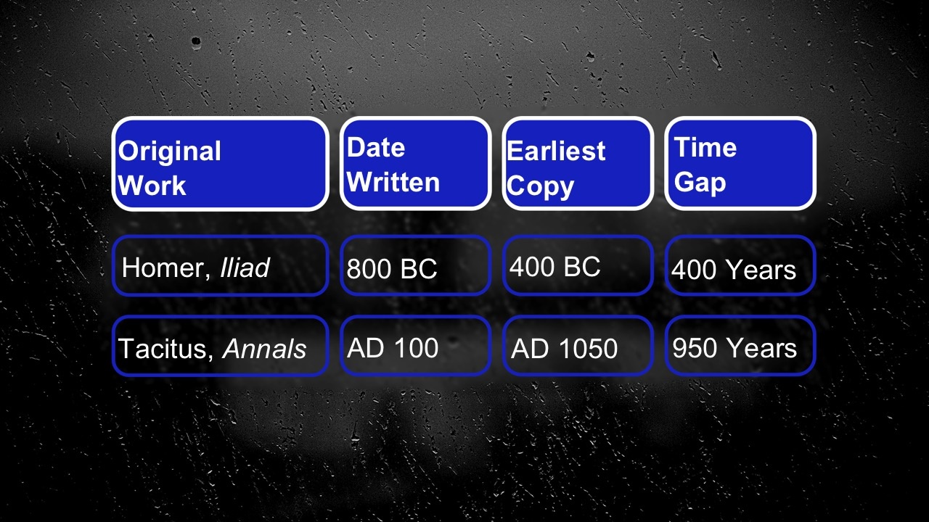
Today, English versions of classic literature are reproduced from copies called “manuscripts.” The original writings, known as “autographs,” were lost many years ago. If the gap between the autograph and earliest manuscript is wide, there is a greater likelihood that the text could have been altered, but if the gap is small the likelihood of the text changing is lessened.

To put this in perspective, let’s consider how the New Testament stacks up to other classic, ancient literature. (Note: these original pictures are from Reasons Week 2 PPT)

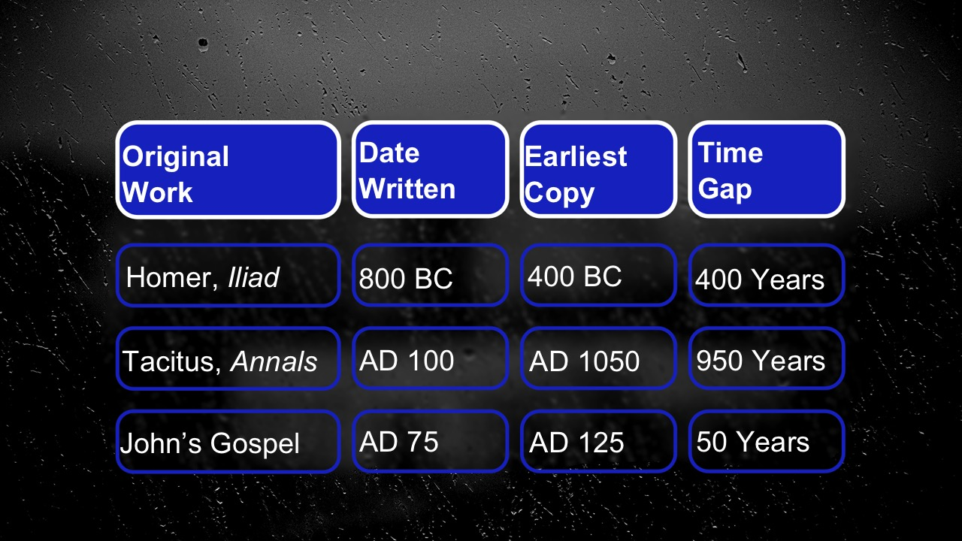
(Picture) For example, Homer’s Iliad was written in 800 BC, but the earliest copy we have is from 400 years later in 400 BC. Tacitus’ Annals has a 950-year gap between the original writing and the earliest copy!

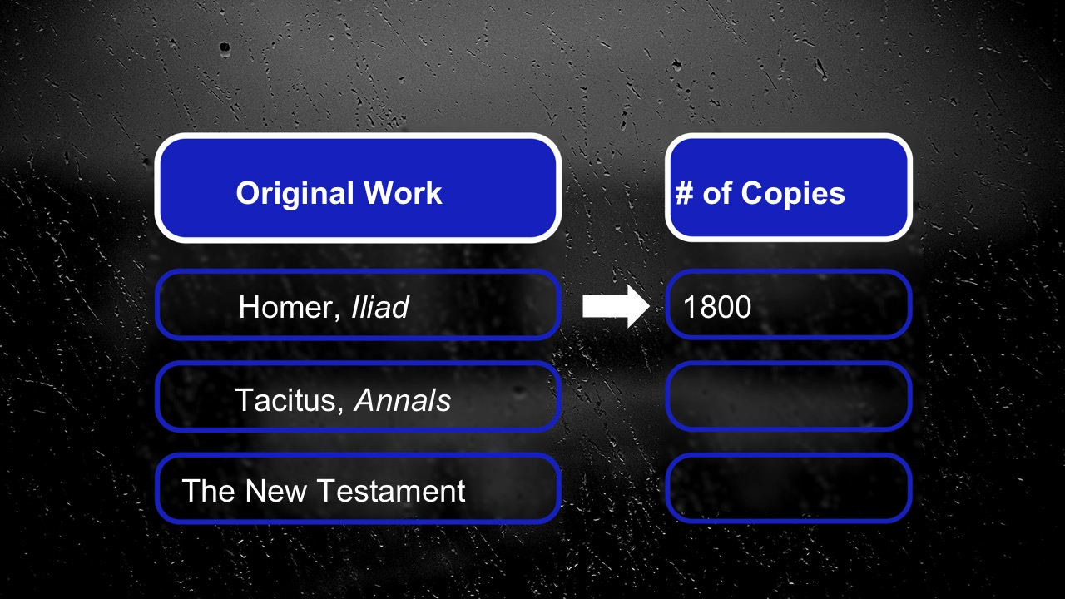
In contrast… (Picture) The oldest fragment of the Gospels was discovered in Egypt in 1920. It’s from John’s Gospel and is dated around AD 125. John’s Gospel was written somewhere around 70-80 AD…so only 50 years difference between the original autograph and the earliest copy.

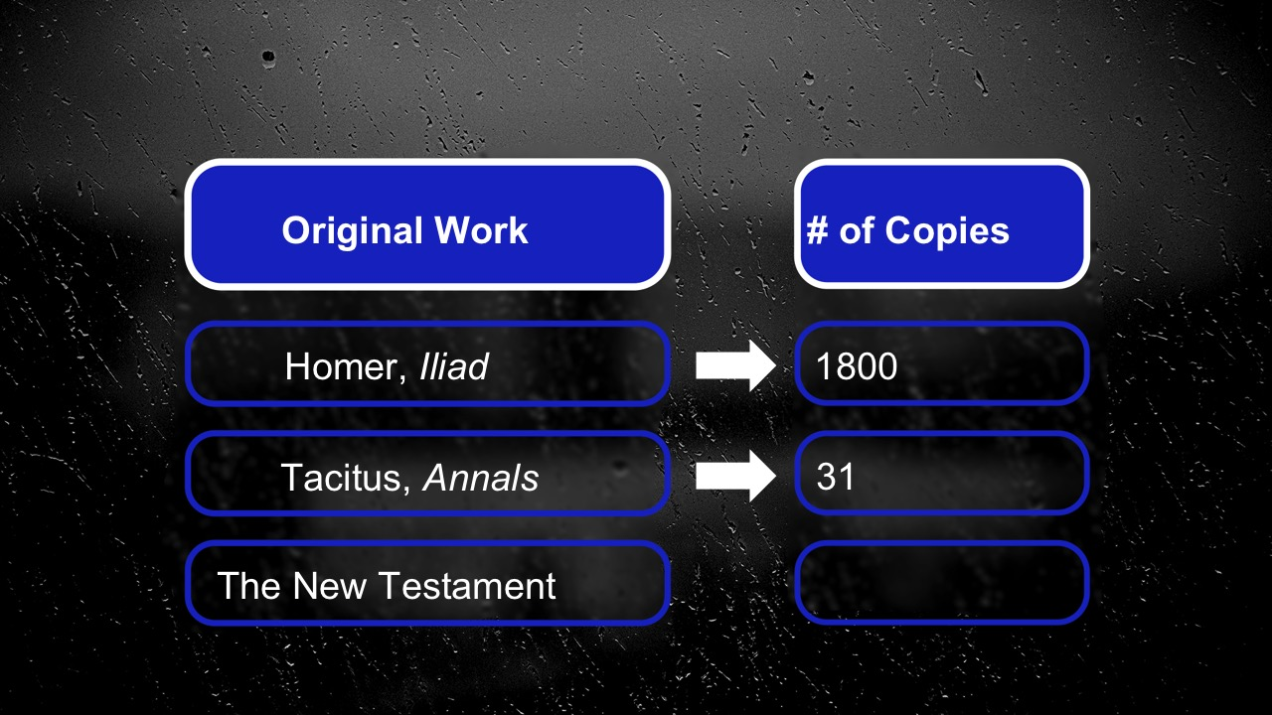
A second “trustworthy” factor is to consider how many copies of the document or manuscript exist. The more copies you have, the more you can check to see if the various copies have drastic differences.

(Picture) For our three works, there are over 1800 copies of the Iliad, which seems good. (Picture) But just 31 copies of Annals, not a lot. And for the New Testament? (Picture) We have 6000 manuscripts and more continue to be discovered!
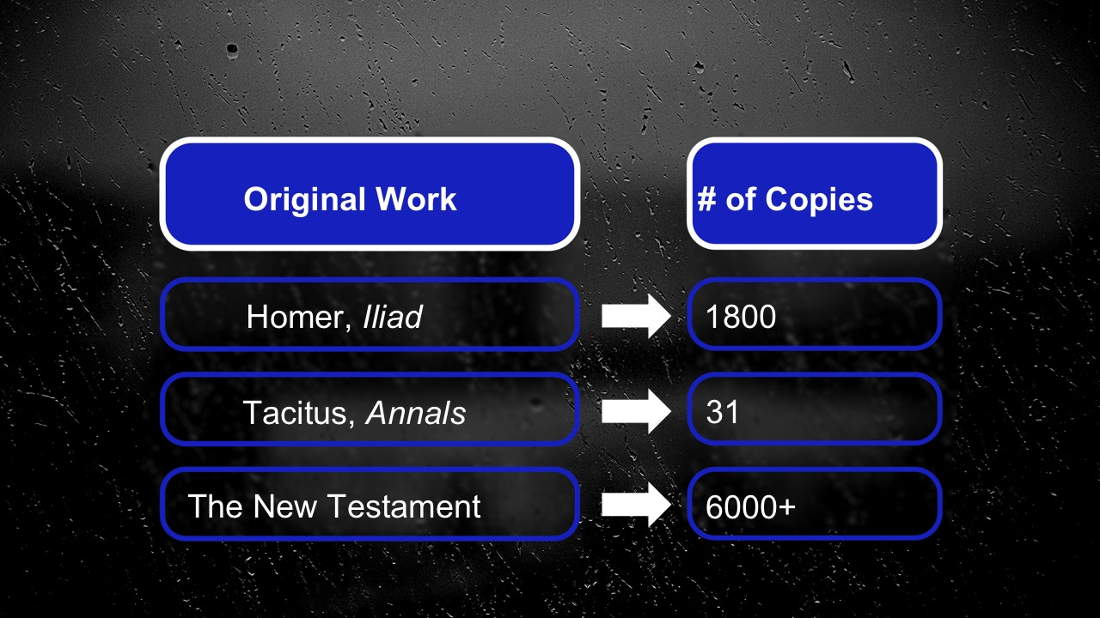
All of this tells us that by the principles of historical criticism, the four Gospels we have in our Bible are reliable eyewitness accounts of the life and teachings of Jesus.

The Reliability of the Bible: God-Breathed
Now, that is all very interesting stuff, but there is something else we don’t want to miss when it comes to the Bible. There is another sense in which the Bible is reliable that is even more important to our conversation. It is summed up in one of the strongest and most well known statements we find in the Bible about the Bible. The Apostle Paul writes:

“God has breathed life into all Scripture…” –2 Timothy 3:16a (NIrV)

Paul says God breathed life into all Scripture. Some translations of the Bible say that Scripture is “God-breathed.” It has the breath of God in it. So, what does that actually mean?

It might be helpful to envision the Bible as an old castle. Maybe you’ve visited one in Europe or some other part of the world; they’re amazing to behold. They feel vast and ancient, but they also seem rather cold and lifeless. But what if you came across a castle where a family still lived in it? It makes the castle live and breathe in a way not possible if it were just a museum. In the same way, this ancient collection of stories, poems, laws, and letters is alive, it’s breathing. God meets us in the Scriptures and invites us to experience him and be transformed by him.

This idea that the Bible is God-breathed is also called “inspired.” Author NT Wright writes about this concept saying:

“Inspiration is a shorthand for the belief that by his Spirit God guided the very different writers and editors so that the books they produced were the books God intended his people to have.” –NT Wright

A lot of people have found the Bible to be reliable because they have picked it up, read it, and experience life in it. They experience God through the words of the Bible.

The Reliability of the Bible: Practically Speaking
Which brings us to an important point about the reliability of the Bible. Often when we ask, “Is the Bible Reliable?” what we’re really asking is… “What is the Bible reliable for?” What is its purpose? What can I use it for?

Lots of people want to use the Bible to advance their own agenda. Maybe you know someone like this…

Video: John Crist – Lady Who Has a Bible Verse for Every Situation https://www.youtube.com/watch?v=hzEL4h1vq7o

(“What is the Bible reliable for?”) Ok, so that’s an extreme example, but we’ve all probably known people who quote the Bible to support their particular opinion or political affiliation. To be honest, it’s really easy to fall into the trap of using the Bible as a way to attack people who don’t think or believe or act the way you do. Not surprisingly, when we use the Bible this way, we often end up pushing people away from Jesus. And let me just say, if that’s happened to you, I’m deeply sorry.

What is God’s intended use for the Bible? Let’s go back to the Apostle Paul. After reminding us that…

“God has breathed life into all Scripture. He goes on to say…

(Add) “It is useful for teaching us what is true. It is useful for correcting our mistakes. It is useful for making our lives whole again. It is useful for training us to do what is right. By using Scripture, the servant of God can be completely prepared to do every good thing.” –2 Timothy 3:16-17 (NIrV)

God desires for these pages to transform our lives from the inside out. These words are useful for:

- Teaching.
- Correcting.
- Training.
- Making our lives whole.

The Bible isn’t just a collection of words on a page; it’s a vehicle through which God works in our hearts. We don't read Scripture for the sake of Scripture. We don’t even read it merely for our cognitive growth. We read it because it is there we experience the breath of God moving in our lives.

Over and over again, I have experienced God using the words in this book to impact my life (Make these bullet points personal to your story.)

- When I was betrayed by my best friend, I wrestled with the difficult words of Jesus, “forgive us our sins, just as you forgive us,” and found healing and life and reconciliation.
- When I’ve taken in the majesty of the beauty of creation, I hear the echo of Psalm 18 – “The heavens declare the glory of God; the skies proclaim the work of his hands. Day after day they pour forth speech; night after night they reveal knowledge.” And I feel my soul lifted up.
- When my grandfather passed away I read Psalm 34 – “The Lord is close to the brokenhearted, and saves those who are crushed in spirit.” And I found comfort and peace.

Theologian Peter Enns puts it this way:

“The Bible doesn’t say, ‘Look at me!’ It says, ‘Look through me.’” –Peter Enns

When we look through the Bible, we encounter the God of the Bible. When we look through the Bible, we discover Jesus. In fact, Jesus himself said:

“You study the Scriptures diligently because you think that in them you have eternal life. These are the very Scriptures that testify about me…” –John 5:39

Ultimately, the Bible points to Jesus! When we ask, “What is the Bible reliable for?” the most important answer is that it leads us to Jesus.

Challenge: Test the Reliability of the Bible
If you really want to know if the Bible is reliable, my challenge to you today is simple: test it. In John 7:17, Jesus says:

“Anyone who chooses to do the will of God will find out whether my teaching comes from God or whether I speak on my own.” –John 7:17

In essence he’s saying, “Do you want to find out whether my teaching is really from God? Do you want to see what it could do in your life? Live it out.”

Here, Jesus is daring us to trust him by trusting God’s Word.

Understand, what we find in Scripture isn't as much a set of beliefs as it is a way of being in the world – a way of living as we were created to live. The way to discover if this way is truly reliable is to actually try it. Test it. Live it out. Can we trust Jesus when he says:

- It is better to give than to receive.
- To love your enemies.
- The first will be last, and the last will be first.

So if you want to find out if the Bible is reliable, I want to issue this Challenge: Read it and Live it out.

Start reading Scripture on a daily basis, respond to what you learn, and see what happens in your life. See if the Bible proves to be reliable.

Here are some steps to get started:

(add as a bullet point) First, Find a Bible Reading Program. There are so many to choose from. (Graphic) COMMUNITY Bible Reading Plan is one to try. If you subscribe to our reading plan, we will send you Bible readings Monday through Friday. Most often, these readings correspond to the Big Idea we’re talking about each week on Sundays. Right now we are in the middle of reading the book of Matthew to explore God by coming to know Jesus.

You can also download the (Picture) YouVersion Bible app on your phone and check out all kinds of reading plans or even listen to one. Then you’ll also have a Bible with you everywhere you go!

As you read, ask God to show you how you can apply what you are reading to your life, and then live it out. Of course, that can be hard to do on your own and that’s why I want to give you a second encouragement…

(Previous slide and add this as a second bullet point) Read the Bible in Community. It can be great to listen or read the Bible individually, but it’s also extremely valuable to read the Bible with others. That’s why we encourage everyone to be in a Small Group. In a Small Group, you can dig into the Scriptures together, you can ask questions, you can search for answers. In a Small Group, we can help one another discover how God wants to use this book to transform our lives. And then we can encourage and challenge one another to live out what God reveals to us.

Our goal is for every person to be in a Small Group. We think it is that important! So if you’re not yet in a Small Group, stop the Welcome table table or fill out a Communication Card, and we’ll help you find a place where you can read the Bible in community.

Conclusion
If you are starting out on a spiritual journey, have some questions, or are skeptical about the reliability of the Bible, you are not alone. In fact, we welcome a thoughtful approach to faith and life and hope you find our community a safe place to ask questions. We are a community seeking to know the God of the Bible, and want you to know this a community where we are open to wrestling with challenging questions. Pastor William Sloane Coffin once said:

“It is a mistake to look to the Bible to close a discussion; the Bible seeks to open one.” –William Sloane Coffin

Let’s open the Bible and continue to explore God together. Let’s try the teachings of Jesus, and see if they not only prove reliable; let’s see if we encounter the God of the Bible in the process. These words are meant to lead us to Jesus. If we earnestly engage them, we will find him.

Communion Idea
On the last night of Jesus’ life, he made time to have dinner with his friends. He knew what the next day would bring, but relationships were the most important thing in his life and he wanted to have a few more conversations.

At that dinner, he took a piece of bread and broke it, telling his friends that “This is my body, which is for you; do this in remembrance of me.” And in the same way, when we participate in communion, we’re remembering Jesus’ gift of life and on-going conversation around hope, love, and joy.

Later in that same dinner, he took the cup and said, “This cup is the new covenant in my blood; do this, whenever you drink it, in remembrance of me.”

When we take communion, we’re celebrating that we get to join into the on-going conversation. We celebrate that we aren’t alone, that we’re given the Holy Spirit and the Bible to guide our life and relationships.

The table is set, will you come to the table?

Redacted from Josh McDowell, God-Breathed: The Undeniable Power and Reliability of Scripture (Uhrichsville, OH: Barbour Publishing, Inc, 2015), 165.

