Relationship Goals – Week 2 – Conflict Goals

Message Big Idea: Conflict is inevitable, how we respond is our choice. Conflict is not something to avoid; it’s an opportunity to follow Jesus the peacemaker.

Scripture:
____________________

Introduction: Sitcom Conflicts

Video: Sitcom Conflict Montage (Run the video and go right into the following script.)

(Series Graphic) So funny! Quick show of hands:

- Who here experienced some sort of relational conflict in the last 2 weeks? Maybe it was with a friend or co-worker or family member? Maybe with your husband or wife or signficant other? Whether it was a big or small conflict, you would say “Yes, I have had relational conflict in the last 2 weeks?”
- How about in the last week?
- What about in the last 2-3 days?
- Anyone willing to admit you got into a conflict just this morning before you got here? No, put your hands down. That’s a little too fresh!

The truth is, some of you walked in here today weighed down by something that has put distance between you and a person you love. And, unlike the conflicts we see in sitcoms, it is no laughing matter. Relational conflict can be one of the most stressful and difficult things we face.

Series Recap
We are in week 2 of our Relationship Goals series. The most important thing in life are relationships. Our relationship with God and our relationships with others. We all long for strong, stable, solid relationships.
Each week of this series we are examining an aspect of relationships that can help us achieve our relationship goals. And this week, we want to talk about Conflict Goals.

My conflict goal is 7. I want to get into about 7 conflicts this week. Ok, so that’s not what we mean by a conflict goal. The reality is conflict is inevitable. So it is not something to avoid or ignore BUT it is not something we should plow our way through without a goal or strategy.

So today, we’re going to establish a conflict goal!

Before we take a closer look at how we individually navigate conflict, let’s remember that Jesus had something to say about our conflict goals. Some of Jesus most famous words are these:

“Blessed are the peacemakers.” -Matthew 5:9

The apostle Paul echoed these words when he wrote to Christ-followers in Rome saying:

(add) “If it is possible, as far as it depends on you, live at peace with everyone.” -Romans 12:18

You can’t read the New Testament or look at the life of Jesus and come to any other conclusion – Followers of Jesus are to be peacemakers.

And yet, that’s much easier said than done! Most of us struggle with this in our relationships. So how can we establish a conflict goal?

Conflict Scale
Let’s start by getting honest about our willingess to address conflict.

(Picture) Let me put this scale up on the screen, and I want you to think honestly about where you would place yourself.

All the way on the left is “Conflict Avoidant.” You might be on this side of the scale if right about now you wish you hadn’t come to church today! You’re thinking, “I wish they’d talk about tithing…anything but conflict!”

Now, over here on the right side of the line, there are people we’ll call “Conflict Assertive.” You’re thinking, “Conflict Goals? Bring. It. On.” Alright, you need to calm down.

Where on this line would you place yourself? We all sit at different places. Some of the difference is because of our temperaments, but a lot has to do with how conflict was handled in our families growing up.

For example, I (Sharie) grew up in a house where conflict was addressed quickly and boldly and loudly. If I have a conflict, I want to address it now and I have no problem addressing it.

Where would you place yourself? We’re going to come back to this in a few minutes, but first, let’s take a closer look at the source of conflict. Why does it happen? Where does it come from?

The Source of Conflict
Life brings all sorts of conflicts our way.

We all experience trivial annoyances like…

- The obnoxious driver who cut you off in traffic, or even worse - cuts you off, then drives in front of you 15 miles per hour below the speed limit.
- Or that co-worker who has the most annoying-sounding voice on the planet. As soon as they begin to talk it’s like fingernails on the chalkboard.

While we can make light of this kind of conflict, the reality is that there is more serious conflict that usually comes from a much deeper place. And something we all have to do in order to navigate conflict in a healthy way is to recognize the source of conflict.

We are all born with deep longings, and we are all raised by humans. Even those of us who were fortunate to grow up in relatively stable homes with parents who loved us very much, grew up in flawed families. Every family has its own dysfunction. Can I get an “Amen?”

Combine that with the fact that the most well intentioned parents will make mistakes, and the result is that we’ve all been wounded – every single one of us. And so our past experiences color our interpretations of current interactions. We enter into all relationships with what some have called Wound-based filters.

In my home (JF), growing up we placed a very high value on working hard. I wouldn’t say my parents had unreasonable expectations; they just wanted us to work and work hard. I remember a season where I was between part-time jobs in college, and whenever I mentioned that I wasn’t able to buy something because I didn’t have any money, my Mom or Dad would sing this jingle, “Get a job, sha-nah-nah-nah-nah-nah-nah-nah-na.” It was the most annoying thing ever.

While I was working on this talk, I decided to Google that and discovered that there was a hit song in the 50’s by a group called The Silhouettes. I had no idea. The title of the song? You guessed it - “Get a Job.” (Specific to Jon - Here is what it sounds like.” https://www.youtube.com/watch?v=nbGthv-dJp4 )

So if you want to quickly push my buttons, question how hard I work. That jingle will come to mind, and I will immediately get super defensive. And even though I know I am extremely sensitive to that topic, it still triggers me today and it can quickly lead to conflict.

We also have (add) Expectations. We have unspoken expectations. We have unreasonable expectations. Un-agreed upon expectations. And when our expectations are not met, we have conflict.

Next time you find yourself in conflict with someone, ask yourself: Am I reacting from a past wound? Do I have expectations that aren’t being met? Have I expressed these expectation? Were they agreed upon?

Unhealthy Conflict Strategies
Once we recognize where the conflict is coming from, we’re ready to start working through it with the other person. Now remember conflict is inevitable, it’s going to happen, there is no avoiding it. It is important for us to have goals so that when a conflict does arise, we have a strategy for how we will respond. And there are healthy ways and unhealthy ways to respond to conflict.
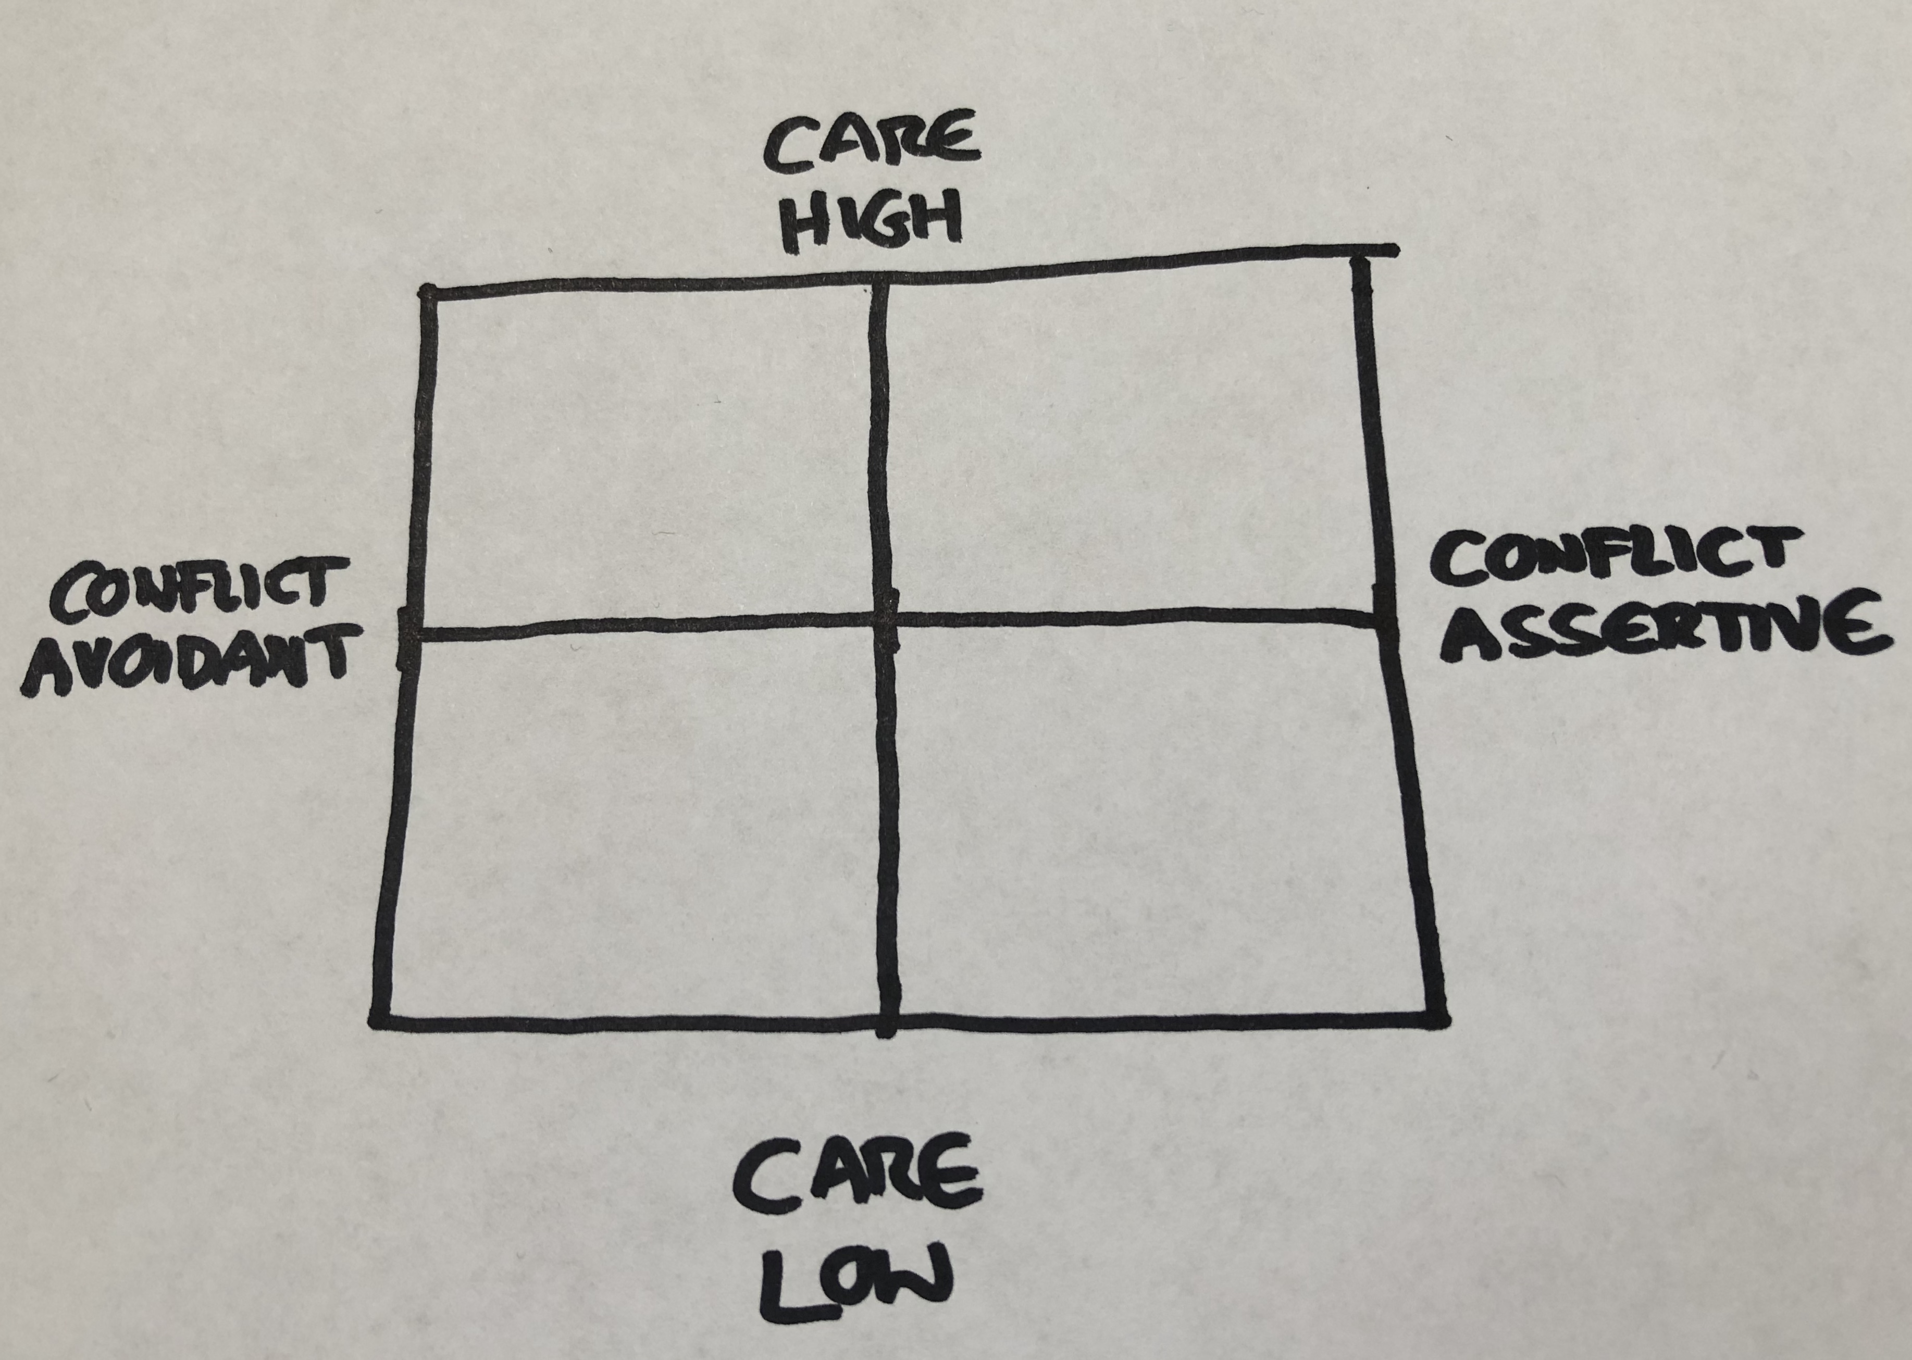
To dig into this, let’s return to our (scale picture from before) conflict scale. Did everyone figure out where you are on this conflict scale? Alright, now I’m going to add another dimension to it. (4-quadrant picture)

The horizontal axis continues to measure our willingness to address conflict. The new vertical axis measures our love or how much we care.

Let’s talk about each quadrant in this diagram. (Build the diagram until all 4 Quadrants are filled in with names)

We could call the person who is in the upper left quadrant the (upper left) Peacekeeper. The peacekeeper is full of love, but not willing to address conflict. Often the peacekeeper thinks he or she is doing the right thing by not rocking the boat, but the result isn’t peace at all – it’s false peace. It can take the form of the silent treatment, living in denial, walking away, passive-aggressive comments, or being dishonest. This is an unhealthy way to address conflict.

If you are a peacemaker, your heart is probably in the right place. You care about the relationship, but you need a better strategy for addressing conflict.

Jesus is our best model when it comes to healthy conflict, and what we learn from him is he didn’t avoid conflict. He confronted crowds, the disciples, the Romans, those buying and selling in the temple, and the religious leaders. Jesus didn’t settle for being a peacekeeper. He didn’t accept false peace.

In fact, these are the kinds of things Jesus said about conflict:

“If you enter your place of worship and, about to make an offering, you suddenly remember a grudge a friend has against you, abandon your offering, leave immediately, go to this friend and make things right.” Matthew 5:23-24 The Message

Jesus takes conflict so seriously that he basically says if you come to church and you remember there is something between you and another person, leave and go address that conflict first!

Peacekeepers, when you feel someone is pushing your buttons, when you get that little rise in your blood pressure and an uneasiness in your gut. When you begin to ruminate over what was said or what happened. You have got yourself a conflict! And it needs to be addressed.

We’ll talk about how to address it in just a minute, but first let me speak to those of you who are in this lower right quadrant. We’re going to call this one the (lower right) Bully. The bully has no trouble with conflict. When someone triggers a bully, they address it head on, but that’s not the unhealthy part. The unhealthy part is that a bully addresses conflict low on care, low on love. The bully attacks the person instead of the problem. He or she might lecture, blame, criticize, make threats, name-call, or shout with rage.

In case you are wondering, this is not the way of Jesus.

The apostle Paul shares an important piece of wisdom in his letter to the Ephesian church that is important for bullies to remember. We are to…

“…speak the truth in love…” -Ephesians 4:15

If you recognize that you have bully tendencies, let me first assure you that it is a good thing that you want to address conflict. The challenge for you is to learn to address that conflict with the right heart and the right words. We’ll help you with that in a second.

But before we move on to the healthy strategy for addressing conflict, let me address this quadrant in the lower right. If you find yourself in this quadrant, I’m not going to give you a name like the peacekeeper or the bully, I’m just going to describe what it feels like to be in this quadrant…and that is (lower left) Apathy. You find yourself low on love, and you lack a willingness to address conflict. Maybe things have gotten to the point in a relationship where you feel like giving up. You’ve stopped giving any effort. Your heart feels indifferent.

That is a really hard place to be, but I do want to encourage you today… relationships are worth fighting for. A marriage is worth fighting for. Family relationships are worth fighting for. Friendships are worth fighting for. If you have found yourself in this quadrant, it might be time to invite a third party such as a trusted spiritual mentor or counselor to help. This is not a healthy place to live. Don’t settle for Apathy.

Healthy Conflict Strategies
No matter which unhealthy quadrant you have a tendency to fall into, let’s talk about the healthy quadrant we all can set our sights to move to.

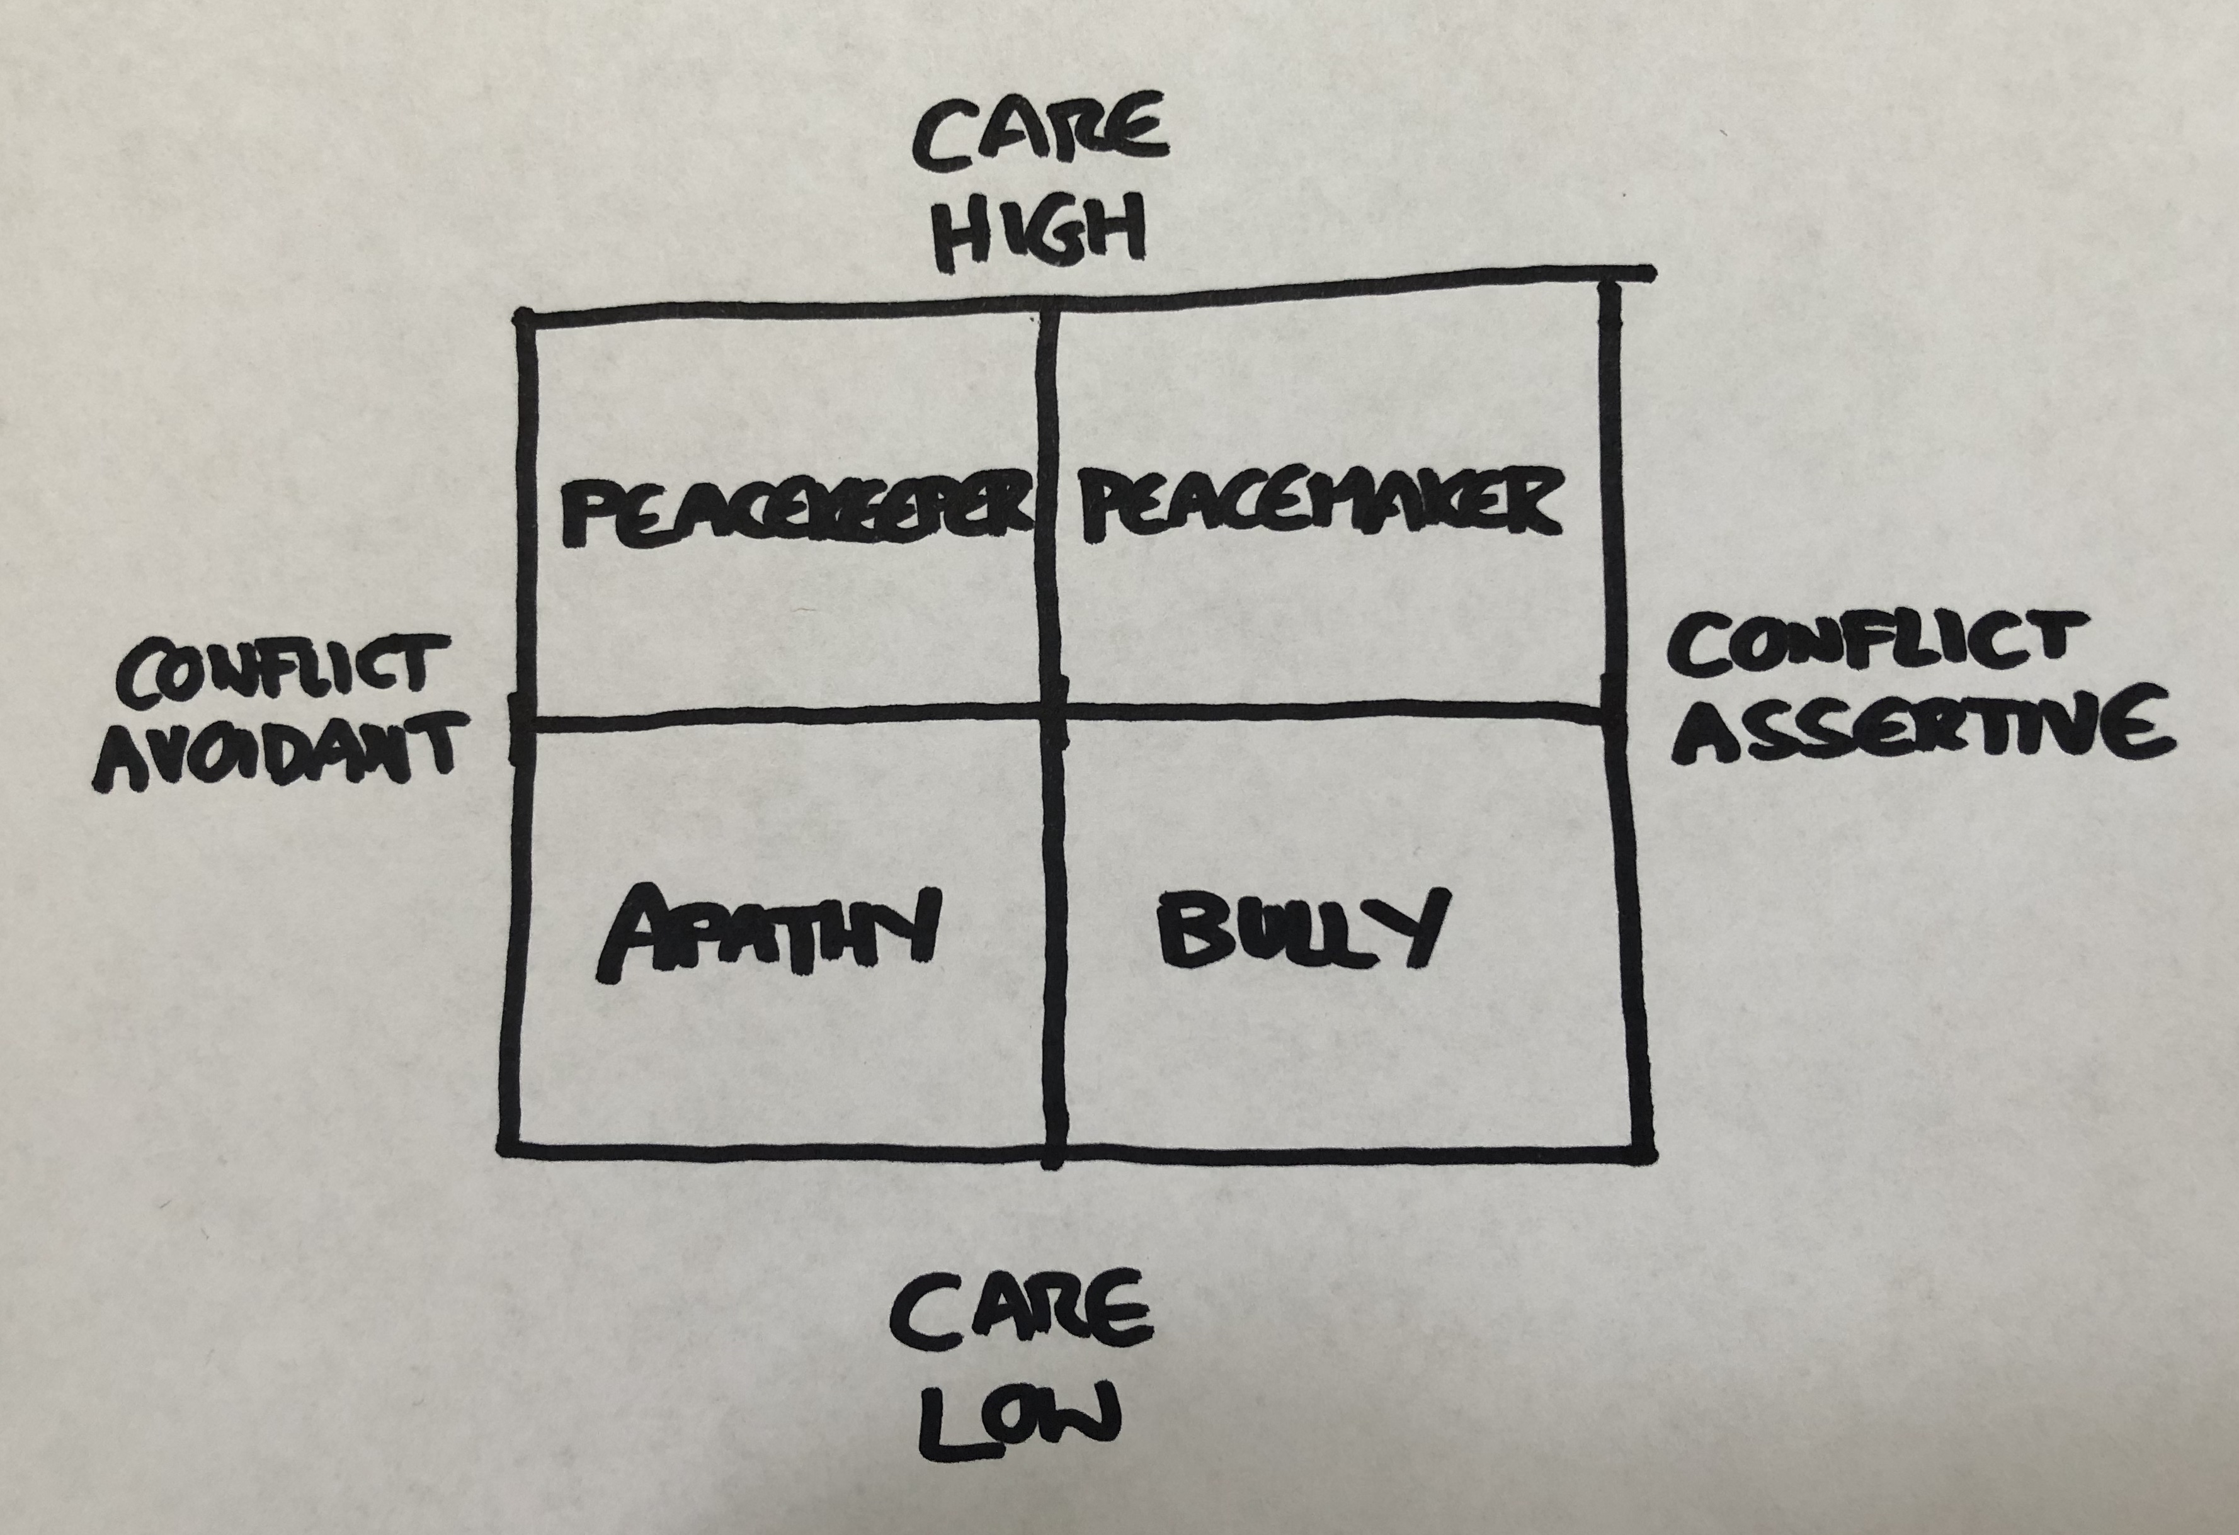
Remember, we don’t want to be all truth and no love, that’s being a bully. But we also don’t want to settle for all love and no truth and just be a peacekeeper. Our conflict goal is to move toward truth and love, toward healthy conflict, and this leads us back to Jesus’ words: (upper right) “Blessed are the Peacemakers.”

Our conflict goal is to be a peacemaker. Peacemakers have healthy conflict. They don’t run away from the truth that needs to be spoken, but they speak that truth with love.

So how do we move toward this goal of being a Peacemaker? How do we actually address conflict with love?

I want to give you three quick practical strategies that you can use to move toward healthy conflict. These strategies can be used in any relationship: Workplace, neighborhood, or home. With your spouse, children, or coworkers. Taking the time to frame your words in the following ways and speaking them with kindness can go a long way in addressing conflict. Here are three possible strategies:

For minor issues, kindly, clearly and respectfully use the following strategy for expressing a complaint with a possible solution. We call this strategy: “I notice and I prefer.”

For example: I noticed you left the towel on the bathroom floor. I prefer you hang it up on the hook. Fairly simple, but much better than, “Why did you leave the towel on the floor!?” You are speaking up and addressing the issue, but doing it kindly and respectfully.

A second strategy, one of my favorites, is called the Puzzled strategy. Instead of assuming you know what is going on in someone else’s head or making a story up about their motives in your own head, you calmly and respectfully say: “I am puzzled….” or “I am perplexed….”

For example: “I am puzzled as to why you didn’t return my call.” Or, “I am perplexed by the decision you made.”

Ok, I know this may seem simplistic to some of us. And if you grew up in a home that addressed conflict in a healthy way this may seem obvious too. But for the rest of us, we need practical steps and actual words that help us walk toward healthy conflict.

So one last one… When the issue is a bit more emotional than a towel on the floor or a missed phone call, the best strategy is to express what you’re feeling. It’s been my experience that most serious conflicts are more about emotions than the actual issue. Here are some words to help you address this with someone you are in conflict with: “I feel _________ when you _________.”

For example: “I feel unimportant when you look at your phone during dinner.” Or “I feel disrespected when you ignore my suggestions.”

(Put all of the above phrases on a slide) Notice how all of these strategies start with “I” statements. We do not want to blame. We don’t want to B-Lame. We want to address conflict in a healthy manner and these are a few strategies to do that.

What Now: One Person
Just this week I got a letter in the mail from someone I haven’t talked to in over three years. It was a very nice letter, kindly written where this person explained to me that they wanted to get together in person to apologize and resolve a conflict we had over three years ago. Actually, it is a great example of what we all need to do in response to what we’re talking about today. Address conflict. Not something I’m particularly good at. So I’ve been praying about that meeting for several weeks now. And I gotta tell you, the last thing I want to do is go to that meeting and deal with this conflict. I have tried to put it behind me for over three years.

But I’ve also done some heavy-duty wrestling, praying, and reflecting to determine where I may have contributed to this conflict, because up until now I have not felt that I did anything in this situation that would mean I need to go and ask for forgiveness. But now it’s happening. Were going to meet, and I am praying that God will bring peace by addressing this conflict. I am trusting that he will.

I share that example because it is fresh in my mind. There are plenty of other examples where I was clearly at fault. Those are also in my mind right now. And that’s what I want you to think of in the next few moments.

Who is it that you are in conflict with? (Matthew 5:23-24 The Message) Remember, Jesus calls us to action. To go to that person to make it right. Who is it? What would it look like for you to be a peacemaker in this relationship? What would it look like for you to take just one step toward making peace with that person?

Everyone should have received a Conflict Goal card. I want to challenge you to make a Conflict Goal.
During the next week, identify a conflict that is going on in a relationship and make a plan to address. Decide when over the next 7 days you will take action. And choose a strategy for the words you will use to address it.

Conflict is inevitable. Conflict is normal and necessary. And healthy conflict is the way to being a Peacemaker. Jesus says:

“Blessed are the peacemakers.” -Matthew 5:9

What blessings might be waiting for you and for me when we achieve our conflict goal of being a peacemaker?

Conclusion and Communion
Here is the deal: Without Jesus we are all in eternal conflict with our heavenly Father. From the beginning of time, ever since mankind chose to go his own way, there has been separation, and conflict between us and God.

The Apostle Paul wrote these words to Christ-followers in Rome. He said:

“All have sinned and fall short of the glory of God.” -Romans 3:23

That means every one of us have let our longings for love, purpose, and meaning take us to all sorts of places that put distance between us and our heavenly Father. And if it weren’t for the extravagant love of our Father, the result of that growing distance between us and God would be death – a life not knowing the love, grace, and forgiveness of God in Jesus.

But because God’s love is everlasting and unconditional, he chose to do something about this conflict and address it by sending his one and only son, Jesus to die and come back to life in order to give us the chance to find our way back to him. In that same letter to Christ-followers in Rome Paul writes these words:

“God demonstrates His own love toward us, in that while we were yet sinners, Christ died for us.” -Romans 5:8

When we receive this gift of God’s love and grace, his Holy Spirit comes to life inside of us helping us to do what we could never do on our own. (Romans 5:5) And because his Spirit is at work inside us we can tap into a love that God pours into our hearts so that we can in turn love those with whom we are in conflict with peacefully address it.

We’re going to celebrate communion now. It’s a celebration of the death and resurrection of Jesus. The bread reminds us of his body. And the juice reminds us of his blood. It’s a celebration because Jesus death and resurrection is what gives us the power to love and be make peace with those around us.

