Relationship Goals – Week 3 – Communication Goals

Message Big Idea: Because we are heard by God, we can grow as a listener.

Scripture: James 1:19, Proverbs 18:13, Luke 18:35-43
____________________

Introduction: Mother’s Day
(Cold open with the video)

Video: Mom Celebrity Translator – SNL
https://www.youtube.com/watch?v=JcviVDizlJ0&feature=youtu.be

(Happy Mother’s Day graphic) How many of you have ever had a miscommunication with your mom? (hands) Well, the Big Idea for today’s message is very simple, and here it is… no matter how they say it…MOMS ARE ALWAYS RIGHT!!! Everybody got it? OK, let’s close in prayer.

Seriously, though… Let me add my words of appreciation to all the moms out there. You deserve many days for all the love, support, and tireless energy you pour into your families. I hope you feel well celebrated today!

And let me also acknowledge that I know this day can be hard for a lot of women, too. For those who have lost your mom or long for a different relationship with your mom or perhaps long to be a mom yourself… I want you to know we celebrate you today, too. Mothering is about more than biology. Today we celebrate every nurturing, encouraging, strong woman in the room. In fact, men, let me ask you to show your appreciation for the women sitting around you (clap).

Series Recap
(Series Graphic) Today we are continuing in our series “Relationship Goals” with a topic that is relevant to every one of us in all of our most important relationships. Today I want to ask you, “What are your Communication Goals?”

Few things can wreak havoc in our relationships more than a breakdown in communication.

- In a recent poll of mental health professionals, poor communication was cited as the number one reason couples split up.
- If you’ve ever raised a teenager or been a teenager, miscommunication can feel like a daily habit.
- And chances are every one of us has experienced the loss of a friendship or an important working relationship over a break down in communication.

(Matthew 22:37-39) During this series we’re acknowledging that what Jesus taught is really true…that the most important things in life are relationships…loving God and loving each other…and good communication is essential to nurturing these relationships. Yet, not many of us think about setting communication goals. So today, we’re going to challenge one another to get better at communicating.

Slow to Listen
Now, of course, communication is a pretty broad topic.

- We communicate with our words.
- We communicate with our hands.
- We communicate through our silence.
- And, most moms out there are experts at communicating with (pictures) side eye. That’s like a basic mom skill, right? Moms, show the people sitting around you your best side eye.

Communication covers a lot of skills, but today I want to zero in on what is perhaps the most important communication skill of all: Listening.

James, the brother of Jesus, writes:

“My dear brothers and sisters, take note of this: Everyone should be quick to listen, slow to speak and slow to become angry…” -James 1:19

He’s saying listening should be our default response, what happens quickly and naturally, but so often that’s just not the case. I am so much faster at speaking. Anyone else willing to admit you are quick to speak and slow to listen?

Becoming a good listener can be difficult for a number of reasons. (Heading “Barriers to Listening” and build with following words)

First, because it’s much easier to be (add) Me-Focused, right? I like thinking about me and talking about me and having people listen to me…thanks for being here today, by the way. We have to be willing to let go of our own self-preoccupation to become good at listening. Author Adam McHugh says:

“Good listening starts with the scandalous premise that this conversation is not about you.” Adam S. McHugh, The Listening Life

That’s a new revelation for some of us, right? “What? You mean your life doesn’t revolve around me?” Our me-focus can keep us from listening.

Another barrier to listening is (add) Assumptions. We’re all prone to this. Rather than trying to understand what a person is saying, we assume we already know. It’s like trying to put together a piece of IKEA furniture without looking at the directions. You think you know, but you’re going to end up wrong.

A third barrier is (add) Validation. Let’s face it, in our culture, it’s the people who talk who are recognized and given authority. You never see someone on a cable news show trying to be a good listener.

And finally, it can be plain old (add) Busyness that keeps us from listening to one another. The calendar is full, our minds are full, we find it hard to slow down and pay attention.

Why Listening is So Important
However, What happens when we don’t listen? A couple of things… (Build a graphic for this equation)
First and perhaps it’s obvious… (Graphic) People feel Unheard. Sure, we may actually be hearing the words they are saying, but that doesn’t mean we’re listening. And that leaves people feeling unheard.

To show you what I mean, I want to try something. I want us to be silent for 20 seconds, and I want you to pay attention to what you hear. OK? 20 seconds of silence in this room where we all listen….go! (Wait 20 seconds). Alright, what did you hear? (Take audience responses) Here’s the thing… You were hearing all of those things before. The whole time we’ve been in this room you’ve been hearing (name the things the audience heard), but a lot of what you were hearing went unheard because you were paying attention to me (which in this case is OK…hopefully what I’m saying is more valuable than the sound of the HVAC system!). However, when it comes to the most important people in our lives, a lot of what we are hearing goes unheard when we aren’t really listening.

A common way we can make people feel unheard is something called “spotlight grabbing.” You know what that is, right? Some of us, myself included, are really good at this! It’s when someone else is sharing and rather than listening to their story, you’re thinking about your story and respond with, “Something like that just happened to me…” and off you go focusing on your own story instead of listening to the other person. It’s so easy to do! And yet, it can leave the people in our lives feeling unheard.

When we don’t listen, people feel unheard and also (add graphic) People feel Unknown.

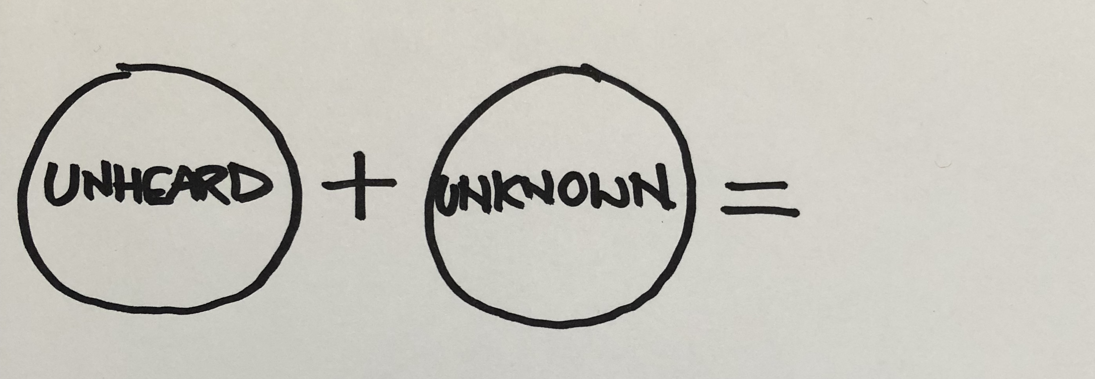
Let me ask you… have you ever called customer support for some kind of issue with a product or service and gotten one of those automated help lines where they say, “If you need help with blank, press 1, if your issue is with blank, press 2, and so on. Have any of you ever got stuck in one of those automated cycles where none of the offered options meets your needs? It’s like whomever put this thing together thinks they know you and the solution to your problem, but they don’t and none of their options are helpful. And then you get stuck on hold and some kind of computer voice says, (Improved Idea: audio clip) “Your call is important to us…” and I want to scream, “No it’s not!!!”

And yet, we often do this to each other in real life. When someone comes to us with an issue they want to talk about, rather than listening and trying to understand where they are coming from, we often go right into “fix-it” mode. We think we know how to solve their problem. This is important for us to recognize… Most people aren’t asking for your strategy for their problem; they are looking for support as they navigate their problem. The writer of Proverbs warns us…

To answer before listening—
that is folly and shame. –Proverbs 18:13

…and yet it’s so easy to do. We fail people when we try to heal them before we listen to them. We leave them feeling unknown.

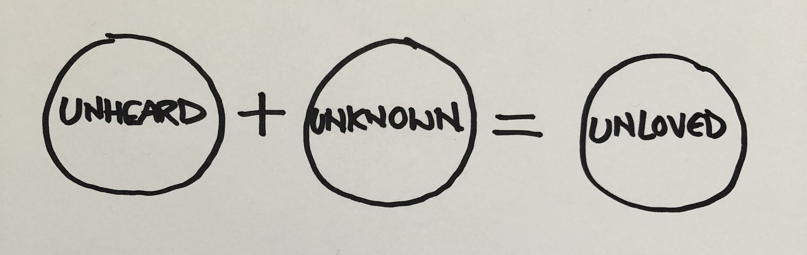
And here is the real issue, friends. When the people in our life feel unheard and unknown, ultimately it leaves them feeling (final graphic) unloved. Maybe that seems too extreme to you, but it’s true. Author David Ausburger writes:

“Being listened to is so close to being loved that the average person can not tell the difference.” –David Ausburger.

None of us want the most important people in our lives to feel unloved, so how do we make sure that doesn’t happen?

Word: Luke 18:35-43
Well, no person has ever (or will ever) live this out better than Jesus. He never misses an opportunity to love.

Sometimes we see that love on full display in big powerful moments like feeding a crowd of over 5,000 hungry people. We have a God who has the power to display love in big miraculous ways!

But there are other stories…stories that are less like a “mic-drop-moment” and more like a whisper. A whisper of love to someone might have felt unheard and unknown. It’s in these moments that we discover…

- A Jesus who sees every person.
- A Jesus who values every human life.
- A Jesus who loves those who are typically forgotten.

In these moments, God himself pulls up a chair up to listen to those who have often gone ignored. And one of these stories can be found in Luke 18.

As we pick up the story, Jesus is approaching a bustling town filled with people who are anxious to see him. In fact, we’re told that the crowds were so large that people couldn’t even get close enough to get a glimpse of him. Even powerful people, who could probably have pulled strings to connect with any other important visitor, were actually climbing trees just to get a glimpse of Jesus as he walked by!

I want you to imagine being surrounded by a huge crowd of people, covered in the dust from the road, some of them riding donkeys or horses, and none of them having any respect for personal space. Think “Taste of Chicago” on July 4th weekend. I know…it’s terrible.

If you have ever been in a situation like that, you know it can be overwhelming. You are pushed and pulled by the crowd. All you can hear is noise. And all you can think about is how great it would be to not breathe in someone else’s hot breath…nasty.

This is the scene I want you to picture as we look at this powerful story in Luke 18 starting in verse 35.

“As Jesus approached Jericho, a blind beggar was sitting beside the road. When he heard the noise of a crowd going past, he asked what was happening. They told him that Jesus the Nazarene was going by. So he began shouting, ‘Jesus, Son of David, have mercy on me!’
‘Be quiet!’ the people in front yelled at him.
But he only shouted louder, ‘Son of David, have mercy on me!’
When Jesus heard him, he stopped (pause) and ordered that the man be brought to him. As the man came near, Jesus asked him, ‘What do you want me to do for you?’
‘Lord,’ he said, ‘I want to see!’
And Jesus said, ‘All right, receive your sight! Your faith has healed you.’ Instantly the man could see, and he followed Jesus, praising God. And all who saw it praised God, too.” –Luke 18:35-43

This is so amazing to me… Not just the outrageous miracle of the man receiving sight, which of course is incredible, but I can’t help but be struck by how Jesus shows so much love in his response.

Jesus not only hears the man yelling, but he stops, resisting the current of the crowd. Then he asks for the man to be brought over to him, and he starts a conversation. He honors and respects this man enough to not make assumptions about him, but to actually listen to him.

Think about it… Everyone in this crowd is vying for a piece of Jesus, but Jesus chooses to get face to face with this blind beggar, a man everyone else was ignoring or telling to be quiet. Imagine how the blind man must have felt. I wonder how many years he had been sitting by the side of that road. I wonder how many thousands upon thousands of people had passed him by. I wonder how few had actually stopped and gotten to know him…not just tossed a few coins at him out of pity.

But here is Jesus, the most important person to ever walk the earth…and he (highlight “stopped”) stops (pause) so he can listen (point to ear) and then (add highlight “asked”) asks a question so he can know (point to chest) the man and what the man really desires.

This amazing scene concludes with Jesus, continuing to act out of love, healing the man right on the spot. And I can’t help but think about the beautiful irony of this moment: The first thing that this formally blind man sees is the only man who actually took the time to “see” him.

The man immediately begins to follow Jesus, praising God for what had happened! This is just one of many stories we see in scripture of Jesus displaying love in these simple but profound ways.

Jesus was a really good listener.

He didn’t ignore people, even when the chaos around him could have made walking right by justifiable.

He never interrupted people with a spotlight-grabbing story. When the blind man said, “I want to see,” Jesus didn’t say, “You know, this one time on the road to Jerusalem I got sand in my eye and boy, I couldn’t see for an hour!” I can’t even imagine Jesus ever doing that!

No, Jesus was an expert at identifying the cues of the individuals and inviting conversation. He drew people out so that they would feel heard and known.

And the secret-truth behind why Jesus is the world’s best listener is the fact that he fully understood the infinite value of every person he encountered. The not-so-attractive-truth about us, myself included, is that our value judgment of a person often determines whether or not we will stop and listen to them and whether we will actually seek to know them in any way.

As mere mortals, being a good listener can be really hard. But I believe Jesus set an example for us that we can learn to imitate.

Challenge: Imitate Jesus
So how do we do that? Well, first things first, before we can share the love of Jesus with others, we have to first receive it ourselves. John, one of Jesus’ closest friends and disciples reminds us:

“We love because He first loved us.” -1 John 4:19

Recognize that you and I are like the blind man in today’s story. We are all undeserving recipients of God’s love and attention. And yet, Jesus really sees us, and he really knows us, brokenness and all. He loves us so much that he was willing to do anything to heal us including laying down his own life. When we really come to understand that, everything changes! Like the blind man who can now see, when we receive Jesus’ love and healing forgiveness, we, too, can begin to follow in the way of Jesus with overwhelming joy in our hearts.
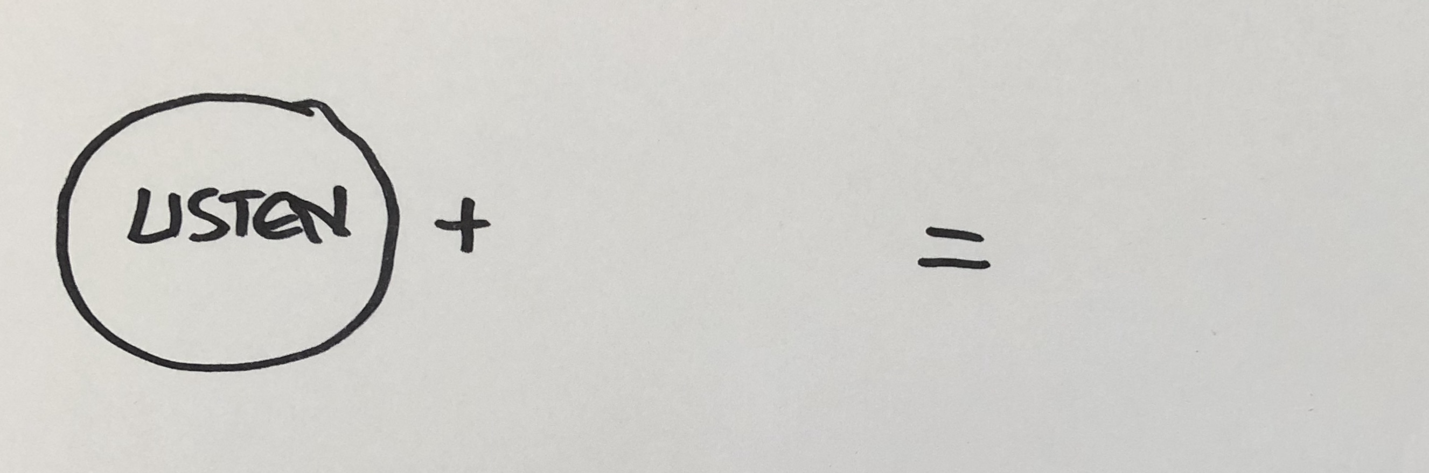
And so today I want to challenge us to imitate Jesus in the way we communicate with one another. It’s a challenge to (Graphic) Listen to the people in our lives – to not just hear the words they are saying, but to really listen. And we do that, just like Jesus did, by stopping. We decide that despite the swirl of activity and distractions that make up our lives, we’re going to stop to give somebody our full attention.

Little kids get this, right? Maybe if you are a parent or an aunt or an uncle you’ve experienced this. If a young kid is trying to talk to you and you’re not really listening, sometimes they will literally grab your face and turn it to look them in the face. Have you ever experienced that?

Let’s stop so we can listen to one another.

- Maybe set down our phones.
- Maybe turn off Netflix.

Let’s first imitate Jesus by stopping so we can listen, and second, let’s really come to (add graphic) Know the people in our lives. Let’s not make assumptions; let’s not just jump into “fix it” mode when a person tells us something. Like Jesus, let’s ask questions.

Remember, most people aren’t asking for your strategy for their problem; they are looking for support as they navigate their problem. They want to be known. Instead of responding with answers, we need to respond with affirmation. Words like:

- I’m so sorry.
- That must have been so hard.
- Or, tell me more about that.
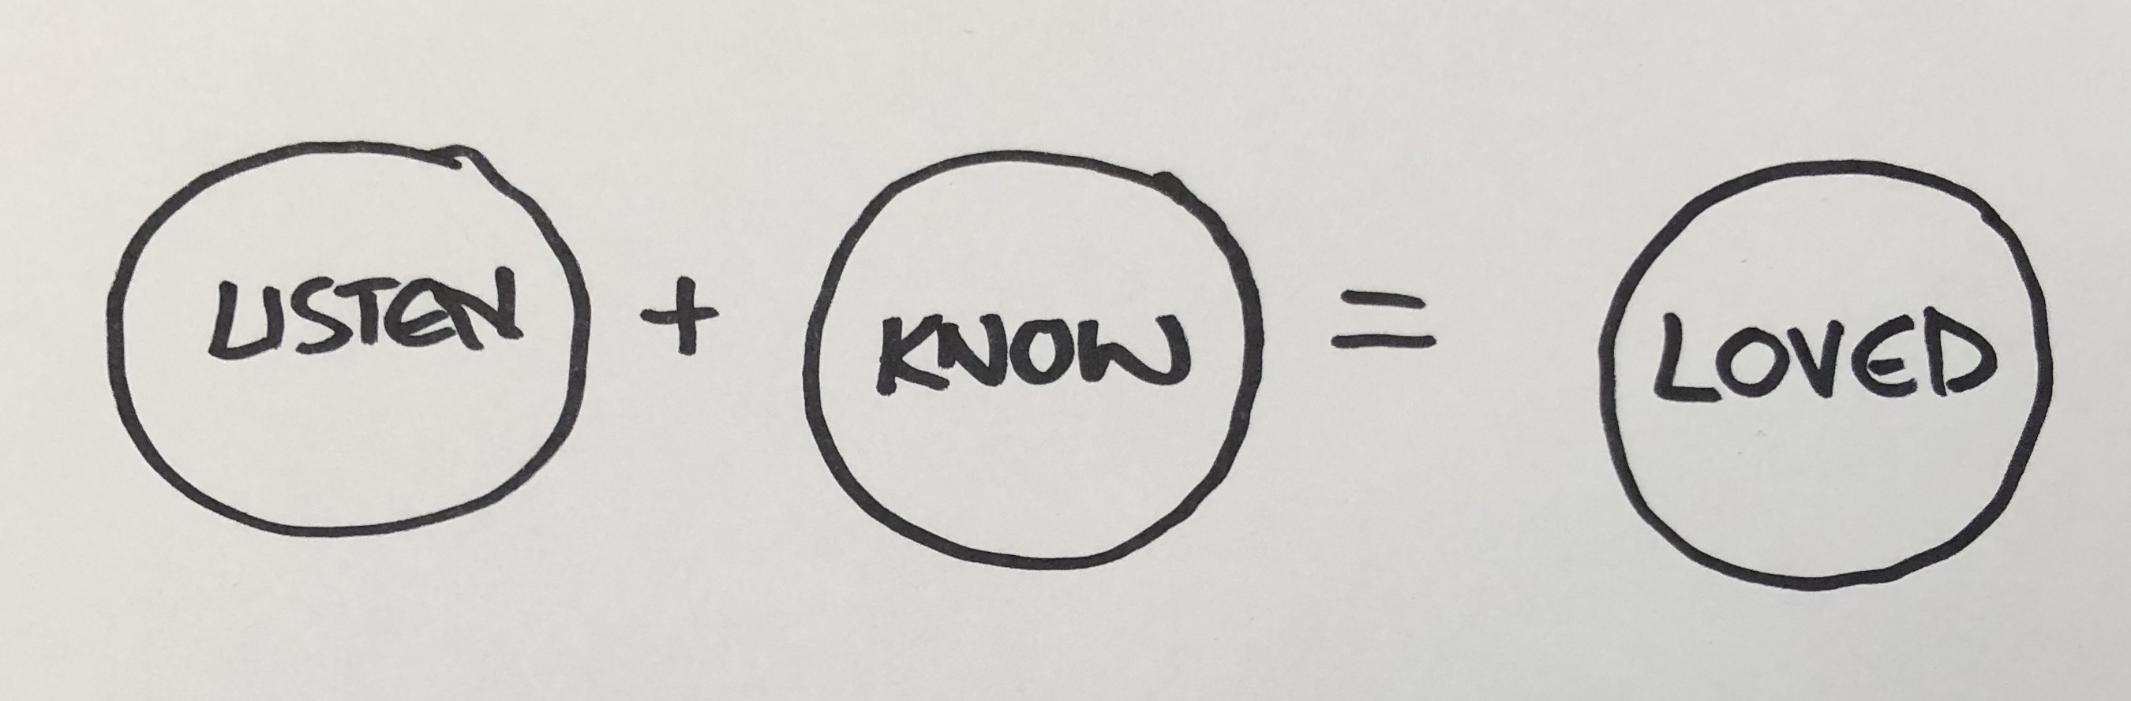
Ultimately, this is what love looks like. When we take the time to Listen and Know the people in our lives, especially those who are most important to us, (final graphic) they will feel Loved. And that is our Communication Goal as Jesus followers!

Conclusion
God loves us so much that he hears every thought that goes through our head and every word that comes out of our mouth.

I want to conclude today by reminding everyone of us that no matter what might be happening in the realm of our human relationships…

God listens to you. He knows you. And he loves you.

I really do believe there is a direct correlation between our communication with God and healthy communication with others. If I am not communicating with God so that I feel heard and known by him, then I will have to look to people for what I need.

Being heard and known by God equips us to do that for others. So let’s set a goal to receive what we need from God so that we in turn can love the people in our lives by listening. Remember…

“Being listened to is so close to being loved that the average person can not tell the difference.” –David Ausburger.

So let’s love each other well by listening.

Communion Idea
So, today as we close with communion today I want you to receive these symbols, the bread and the cup, as a reminder of God’s forever love that has been given to all who will accept it.

He came to all of us and each of us in Jesus so that we could receive the miraculous love of God so we could share that miraculous love with others.

Receive this cup and this bread as a reminder of the truth that “We love because He first loved us.” -1 John 4:1

https://www.huffpost.com/entry/divorce-causes_n_4304466

