Relationship Goals – Week 2 – Conflict Goals

Message Big Idea: Conflict is inevitable, how we respond is our choice. Conflict is not something to avoid; it’s an opportunity to follow Jesus the peacemaker.

Scripture: Matthew 5:9, Romans 12:18, Matthew 5:23-24, Ephesians 4:15
____________________

Introduction: Sitcom Conflicts

Video: Sitcom Conflict Montage (Run the video and go right into the following script.)

(Series Graphic) So funny! Quick show of hands:
- Who here has experienced some sort of relational conflict in the last 2 or 3 weeks? Maybe it was with a friend or co-worker or family member? Maybe with your husband or wife or signficant other? Big or small, who would say “Yes, I have had relational conflict in the last couple weeks?” (The rest of you – you know where liars go, right?)
- What about in the last 2-3 days?
- Anyone willing to admit you got into a conflict this morning before you arrived? Put your hands down. That’s a little too fresh!

The truth is, some of you walked in here today weighed down by something that has put distance between you and someone you love. And, unlike the conflicts we see in sitcoms, it is no laughing matter. Truth is, relational conflict can be some of the most stressful and difficult stuff we face.

Series Recap

We are in week 2 of our series - Relationship Goals. And I think we’d all agree that nothing matters more than relationships. We all long for strong, stable, solid relationships. And each week of this series we are examining an aspect of relationships that can help us achieve our relationship goals. And this week, we we’re talking about Conflict Goals.

Now, my conflict goal is about . . . oh . . . 7 or 8 a week (Pause). I’m kidding. That’s NOT what we mean by a conflict goal. Truth is conflict is inevitable – it’s not something to avoid or to ignore. BUT it’s also not something we should plow our way through without a goal or strategy.

So today, we’re going to establish a conflict goal! And let’s begin by looking at what Jesus had to say about conflict goals. Some of his most famous words are these:

“Blessed are the peacemakers.” (Matthew 5:9)

The apostle Paul echoed these words of Jesus when he wrote to Christ-followers in Rome saying:

(add) “If it is possible, as far as it depends on you, live at peace with everyone.” (Romans 12:18)

You can’t read the New Testament or look at the life of Jesus and come to any other conclusion – Followers of Jesus are to be peacemakers.

Now, we know that is way easier said than done! And how does that help us establish a conflict goal?
Conflict Scale

We’ll get to that, but first let’s be honest about our willingess to address conflict.

(Picture) Let me put this scale up on the screen, and I want you to think honestly about where you would place yourself.

All the way on the left is “Conflict Avoidant.” You might be on this side of the scale if about now you’re wishing you hadn’t come to church today! You might be thinking, “I wish they’d talk about tithing…anything but conflict!”

At the other end of the line, we’ll call these people “Conflict Assertive.” If you are over here - you’re thinking, “Conflict Goals? Bring. It. On.” – And . . . you need to calm down.

So, where on this line would you place yourself? Are you more assertive when it comes to conflict or to do you tend to avoid it? There are all sorts of reasons why we place ourselves where we place ourselves and often it has a lot to do with how conflict was handled in our families growing up.

For example, I (Jon) grew up in a house where conflict was certainly not appreciated and often avoided. I can hardly remember my parents ever in any sort of conflict at all -- So yes I learned a lot my first year of marriage. The first time Lisa and I got in to an argument I thought we were heaed for divorce court. – So my tendency is to avoid conflict.

But what about you? Where would you place yourself? We’re going to come back to this in a few minutes, but first, let’s take a closer look at the source of conflict. Why does it happen and where does it come from?

The Source of Conflict

Life brings all sorts of conflicts our way.

Some of it is trivial like…

- The obnoxious driver who cut you off in traffic, or worse yet - cuts you off, then drives in front of you WAY -- below -- the speed limit. So painful.

- Or that co-worker who has the most annoying-sounding voice on the planet. As soon as they talk it’s like fingernails on the chalkboard.

We can laugth at that kind of conflict, but there is more serious conflict that usually comes from a much deeper place.

Even those of us who were fortunate to grow up in a relatively stable home with parents who loved us very much, still grew up in flawed families. And every family has its own dysfunctions.

Combine that with the fact that even the most well intentioned parents still make mistakes, and the result is that we’ve all been wounded -- every single one of us. And so our past experiences color our interpretations of our current interactions. We enter into relationships with what some have called
Wound-based filters.

For example, in my home (JF), growing up we placed a very high value on working hard. I wouldn’t say my parents had unreasonable expectations; but they wanted us to work - and work hard. I remember a season where I was between part-time jobs in college, and whenever I mentioned that I couldn’t buy something because I didn’t have any money, my Mom or Dad would sing this jingle, “Get a job, sha-nah-nah-nah-nah-nah-nah-nah-na.” It was the most annoying thing ever.

I actually Googled that and discovered that there was a hit song in the 50’s by a group called The Silhouettes. The title of the song? You guessed it - “Get a Job.”

So if you want to push my button -- question how hard I work. -- That jingle comes to mind, I get super defensive, and it can quickly lead to conflict.

We also have (add) Expectations . . . all kinds of expectations . . . and they too can be a source of conflict.
- Unspoken expectations,
- Unreasonable expectations.
- And certainly Un-agreed upon expectations.
And when our expectations are not met, we have conflict.

So the next time you find yourself in conflict with someone, ask yourself:
- Am I reacting from a past wound?
- Could I have expectations that aren’t being met?
- Maybe I have expectations that have never even been expressed.

Unhealthy Conflict Strategies

Recognizing the source or reason for the conflict can better prepare us to start working through the conflict. And this is where the conflict goals come into play because there are healthy ways and unhealthy ways to respond to conflict.
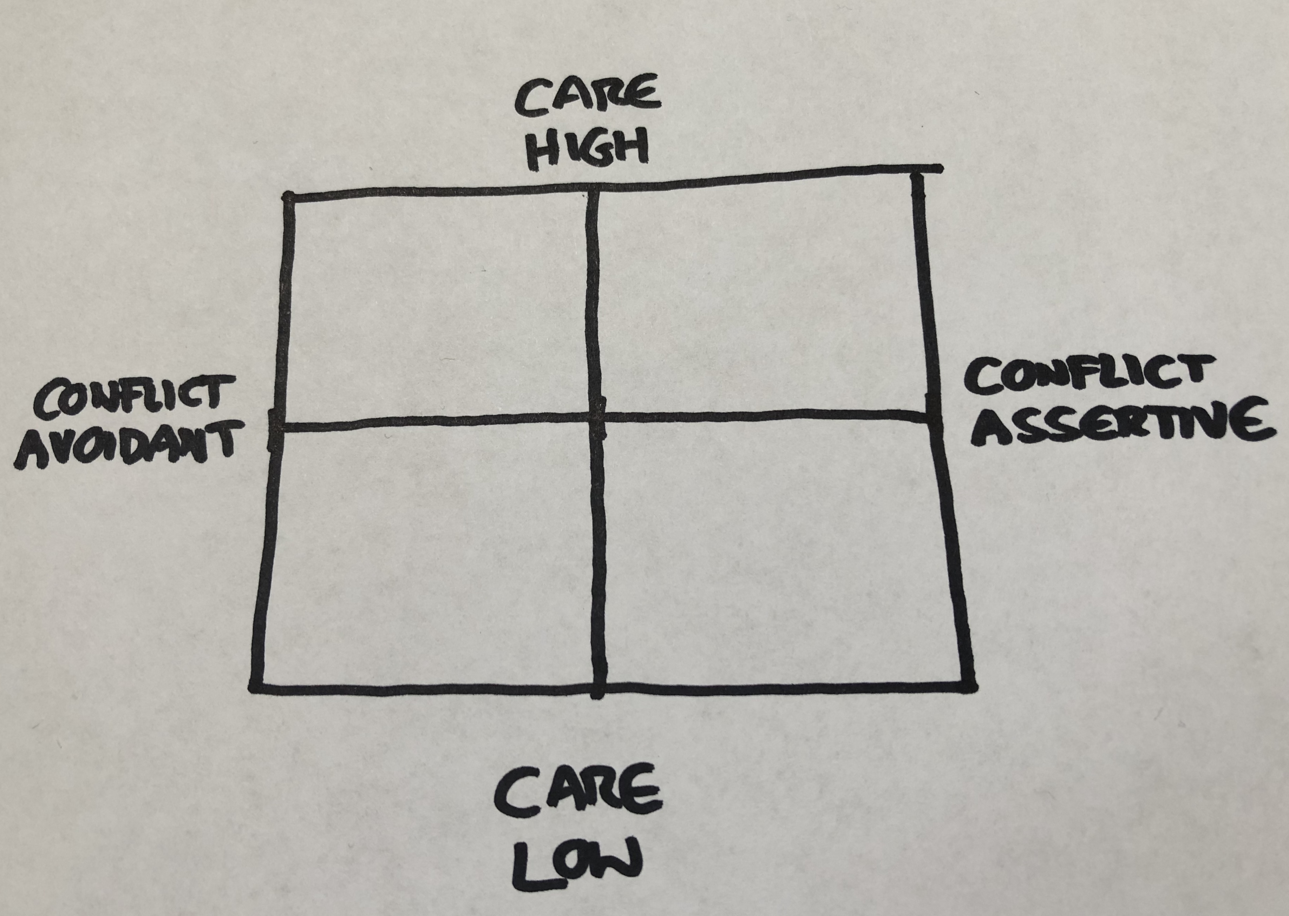
Let’s return to our (scale picture from before) conflict scale. Did everyone figure out where you land on this conflict scale, because I’m going to add another dimension to it. (4-quadrant picture)

The horizontal axis measures our willingness to address conflict. The new vertical axis measures how much we actually care.

So let’s talk about these quadrants for just a minute. (Build the diagram until all 4 Quadrants are filled in with names)

I would call the person in the upper left quadrant, the (upper left) Peacekeeper. Not the peacemaker, but the peacekeeper. The peacekeeper cares a lot, but they’re not willing to address the conflict.

Often the peacekeeper thinks he or she is doing the right thing by not rocking the boat, but the result isn’t peace at all. And often it looks like or sounds like…
- the silent treatment,
- living in denial,
- walking away,
- or even passive-aggressive comments.
And this is no way to address conflict.

If you are a peacekeeper, your heart is probably in the right place. You care about the relationship, but you need a better strategy for addressing the conflict.

Jesus is our best model when it comes to healthy conflict. He didn’t avoid conflict…
- He confronted the crowds,
- He confronted those who were out to bring him down,
- He even confronted his closest friends. .

In one of his most famous teachings, he said this about conflict:

“If you enter your place of worship and, about to make an offering, you suddenly remember a grudge a friend has against you, abandon your offering, leave immediately, go to this friend and make things right.” (Matthew 5:23-24 The Message)

I would prefer you leave your offering before you go, but Jesus is so serious about peacemaking over peacekeeping that he basically says if you come to church and remember there is something coming between you and someone else, you need to leave and go address that conflict!

So if you tend to keep the peace at all costs and someone is pushing your buttons to where you have an uneasiness in your gut, chances are you’ve got yourself a conflict! And it needs to be addressed.

Now, let me speak to anyone in this lower right quadrant. We’re going to call this person the (lower right) Bully.

Addresssing conflict is not the challenge for the bully. Addressing conflict with care is the challenge for the bully. Unfortunately, the bully often attacks the person instead of the problem.

The apostle Paul shares an important piece of wisdom for the bully when he writes: “…speak the truth in love…” (Ephesians 4:15)

If you think you might be a bully . . . ? You probably are . . . And it is good that you want to address conflict. But the challenge for you will almost always be to address that conflict with the right heart and the right words.

Finally, before I give you some practical strategies for dealing with conflict, let me talk to anyone who may find themselves in this lower left quadrant. I’m not going to give you a name like “peacekeeper” or “bully,” I’m just gonna describe what it feels like to be in this quadrant.

If you’re in this quadrant with anyone in particular, you likely find yourself low on love and low on any energy or desire to address conflict at all. For all sorts of reasons, you have little hope and may even feel like giving up on the relationship. The best word to describe how you feel is (lower left) Apathy. You feel beat up, worn down, or just plain over it.

This is a really hard and tough place to be, but I do want to encourage you today… relationships are literally worth fighting for.
- A marriage is worth fighting for.
- Family is worth fighting for.
- Friendships are worth fighting for.

If you find yourself in this quadrant, you might want to invite a third party such as a trusted spiritual advisor or counselor to help. And if you are in an abusive relationship, let us help you find help. Don’t settle for Apathy.

Healthy Conflict Strategies

No matter what your tendencies may be -- to bully or to keep peace at all costs, our goal is to move toward truth and love - toward healthy conflict. And this leads us back to Jesus’ words: (upper right) “Blessed are the Peacemakers” - peacemakers are people who speak the truth with love.

So how do we move toward this goal of being a Peacemaker? How do we actually address conflict in a caring and loving way?

I want to give you three quick practical strategies that can help us move toward healthy conflict. These strategies can be used in any relationship: Workplace, neighborhood, or home. With your spouse, children, or coworkers. And they are all about taking the time to frame your words and speak them with kindness.

For minor issues, try expressing a complaint with a possible solution. We call this strategy: “I notice and I prefer.”

It might sound like this: “I noticed you left the towel on the bathroom floor. I would prefer you hang it up on the hook.” (Just to be clear, none of these examles are from my personal life ) That is a fairly simple way to approach conflict, rigth? And so much better than, “Why did you leave the towel on the floor again!?” It’s better becaue you’re addressing the issue, but doing it kindly and respectfully.

A second strategy, one of my favorites, is called the Puzzled strategy. Instead of assuming you know what is going on in someone else’s head or making up some story in your own mind, calmly and respectfully say: “I am puzzled….” or “I am perplexed….”

It might sound like this: “I am really puzzled as to why you didn’t return my call.” Or, “I am just perplexed by the decision you made.” And you might follow up with, “Can you help me understand?”

Now I know this may all seem very simple, but I have found that the vast majority of us need practical steps and actual words that can help us walk through healthy conflict.

So one more… When the issue is a bit more emotional than a towel on the floor or a missed phone call, the best strategy is to express what you’re feeling. It’s been my experience that most serious conflicts are more about emotions than the actual issue itself. If your feelings have been hurt, try expressing yourself clearly and succinctly with these words: “I feel _________ when you _________.”

For example: “I feel unimportant when you look at your phone during dinner.” Or “I feel disrespected when you ignore my suggestions.”

(Put all of the above phrases on a slide) Notice that these strategies start with “I” statements. We do not want to blame. Or as someone once said, “We don’t want to B-Lame.” We want to address conflict in a healthy manner and these are a few strategies to help us do just that.

What Now: One Person

About a month ago I got a letter in the mail from someone I haven’t talked to in over three years. It was a very nice letter, kindly written where this person explained to me that he wanted to get together in person to apologize and resolve a conflict we had over three years ago.

I think it is a great example of what we all need to do in response to what we’re talking about today. Address conflict. -- Not something I’m particularly good at. And I gotta tell you, the last thing I wanted to do was go to that meeting and deal with this conflict. I tried to put this conflict behind me for over three years.

I also did some heavy-duty praying and reflecting to determine how I may have contributed to this conflict, because I never felt that I did anything that meant I needed to go and ask for forgiveness. – And so we met just a couple weeks ago, and going into it I was trusting God to make some peace between us by addressing the conflict. -- And I actually think he did. We’re not best friends. But I do believe that by addressing the conflict we have at least opened the door for God to bless us and do some healing he couldn’t otherwise do.

I share that example because it is fresh in my mind. There are plenty of other times when I was clearly at fault. Those are also in my mind right now. And that’s what I want you to think of in the next few moments.

Who is it that you are in conflict with? (Matthew 5:23-24 The Message) Remember, Jesus calls us to action. To go to that person to make it right. Who is it for you?
- What would it look like for you to be a peacemaker in that relationship?
- How could you take just one step toward making peace with that person?

Everyone should have received a Conflict Goal Card. I want to challenge you to make a Conflict Goal.
During the next week, identify a conflict that is going on in a relationship and make a plan to address it. Decide when over the next 7 days you will take action. And use this card to help you know what words you will use to address that conflict.

Conflict is inevitable. Conflict is normal and necessary. And healthy conflict is the path to being a Peacemaker. Remember, Jesus says:

“Blessed are the peacemakers.” -Matthew 5:9

It makes me wonder - What blessings might be waiting for us when we achieve our conflict goal of being a peacemaker? (Pause)

Conclusion and Communion

Here is the deal: Without Jesus we are all in forever conflict with our heavenly Father. Ever since mankind chose to go his own way instead of God’s way, there has been separation, and conflict between us and God and us and each other.

The Apostle Paul wrote these words to Christ-followers in Rome. He said:

“All have sinned and fall short of the glory of God.” (Romans 3:23)

That means every one of us have let our longings for love, purpose, and meaning take us to all sorts of places that put distance between us God. And if it weren’t for the extravagant love of our Heavenly Father, the result of that growing distance would be death – a lifetime of not knowing the love, grace, and forgiveness of God in Jesus.

(Romans 5:8 on screen) But because God’s love is everlasting and unconditional, he chose to address this conflict by sending his one and only son, Jesus to die and come back to life in order to give us the chance to find our way back to him.

And when we receive this gift of God’s love and grace, his Holy Spirit comes to life inside of us and helps us to make peace by addressing the conflict that so often keeps us apart.

We’re going to celebrate communion now. It’s a celebration of the death and resurrection of Jesus. The bread reminds us of his body. And the juice reminds us of his blood. It’s a celebration because Jesus death and resurrection is what gives us the power to love and make peace with those around us.

