Need to bring “bless” terminology into this more
Intro

Let’s start off this morning with a moment of honesty. How many of you would admit that you have a tendency to try and avoid small, annoying, everyday tasks that need to be done? Good to see we have some honest people in the room. I don’t know about the rest of you.

Most of us suffer from a chronic condition called “task avoidance.” It’s really a silly thing to live with when the cure often takes only about 10 seconds of effort. Let me give you a few examples.
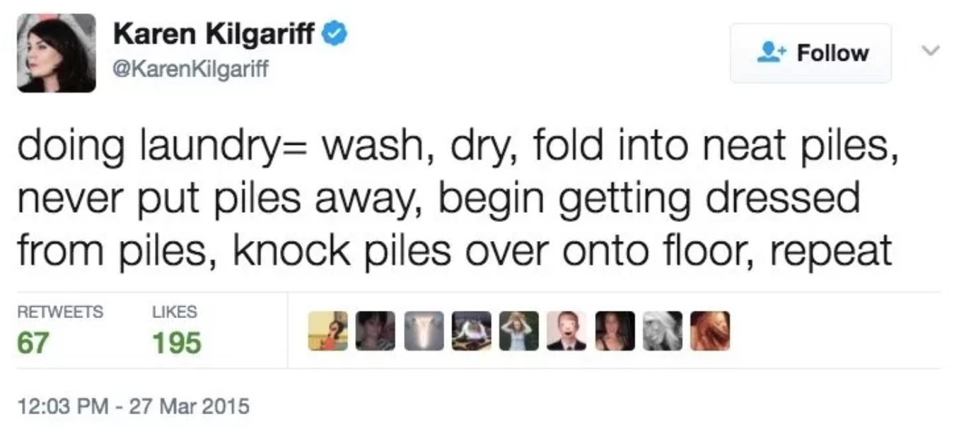
Like the twitter angle!
I saw a tweet the other day that fit me a little too well. “Doing laundry = wash, dry, fold into neat piles, never put piles away, begin getting dressed from piles, knock piles over onto floor, repeat.”

How about this one…”Just drank water out of a glass votive candle holder rather than clean a glass.”

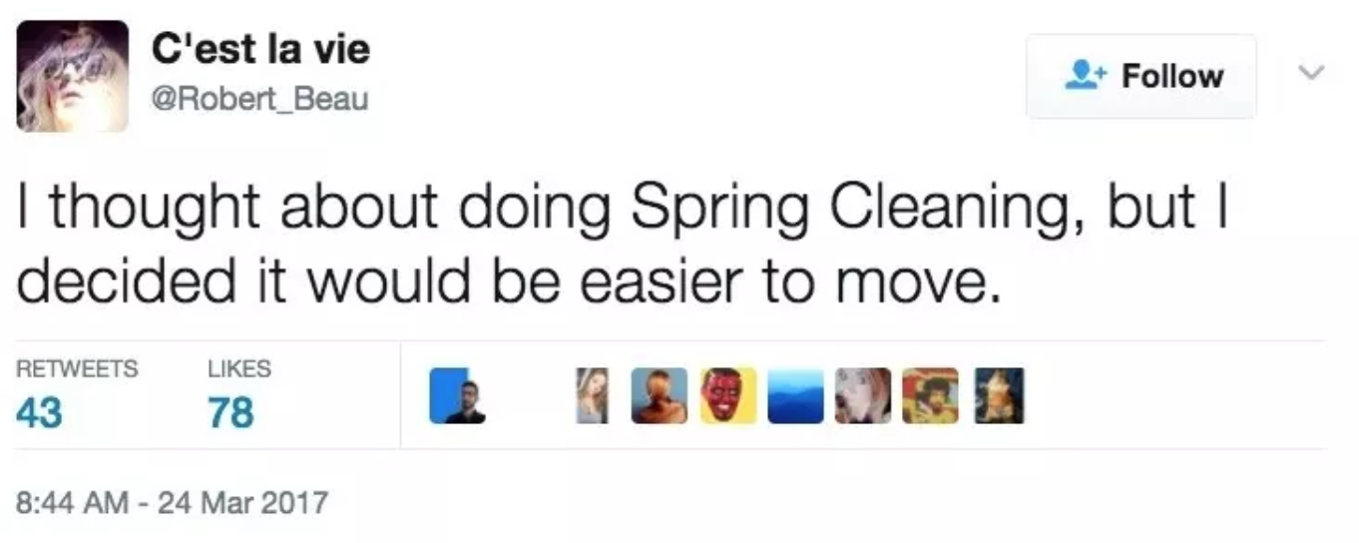
This one sounds about right too. “I thought about doing spring cleaning, but I decided it would be easier to move.”

As silly as these examples are, I think we all find ourselves avoiding tasks like this from time to time.
Need a better transition to series recap

Series Recap

(series slide)
We’re in a series called “How to BLESS Your Neighbor.” This series is about our mission: hpftwbtG. It’s not just the mission statement of our church. It’s your mission. It’s my mission.

Too often, though, we are people that “hope” people find their way back to God instead of being people who “help” people find their way back to God. So during this series we’re equipping and challenging one another to be people who actually “help.”

So how do we carry this mission out? Through the years we’ve discovered that one of the best ways to live out the mission is to simply be a BLESSing (Slide with acronym). Today, I want you to be thinking today about the people and places that God might be sending you to BLESS and how you might move moving from just hoping to actually helping.

This acronym “BLESS” stands for 5 missional practices. So far we’ve talked about the first three: Begin with prayer, Listen, and Eat. Today we’re talking about the fourth one: Serve.

Personal Story

Years ago, I (Jason) worked for a lawn mowing service and got to experience first hand the powerful impact we can have on others by serving them. My lawn mowing days were mostly filled with me chasing my boss around town with a trimmer in hand desperate to keep up with his insanely fast lawn mower [affectionately dubbed The Millennium Falcon].

However, there was one particular lawn that my boss adamantly demanded I hand the trimmer over to him. You see, this particular lawn had a dog pen that the mower couldn’t fit into, so the pen had to be trimmed. The problem with trimming the dog pen wasn’t the dogs…they were great…it was the dog POOP. Trimmers have a tendency to sling stuff back on the operator. And let me tell you…nothing humbles a man quite like getting hit in the face with tiny high speed particulates of dog feces.

My boss insisted that he should be the one to do this terrible job not me his employee. How’s that for serving someone? Dog poop to the face. My boss wouldn’t have it any other way, and the selfless way he led me still inspires me to this day.

However, knowing the impact that serving has had on me, you’d think I might be less prone to avoid serving others. But the truth is, I’m the guy who keeps the folded laundry on the floor. I often look the other way when there’s an opportunity to serve someone else. I imagine I’m not the only one in this room that can say that. But if we’re going to be a people that move from hoping to helping people find their way back to God, there’s got to be a major shift in our thinking when it comes to serving others.

Paradigm Shift

Here’s the kind of seismic shift I’m talking about.

By the year 1900 and the Field of Physics had taken incredible strides forward. In fact, they had made so much progress that there was a growing group of physicists that thought they had nearly exhausted its limits as a discipline.

(Picture of Lord Kelvin) Lord Kelvin was one of the keynote speakers at the annual assembly for the ‘British Association for the Advancement of Science.’ It wasn’t a very well dressed or sociable crowd but this was a gathering of some of the greatest physicists in the world…

So, Lord Kelvin gets up to the podium surrounded by a group of people so convinced of their own brilliance, that they believed they had dug as deeply into physics as was possible.

While he was addressing the group he made a statement that is now infamous…he said, “There is nothing new to be discovered in physics now. All that remains is more and more precise measurement.”

Now the reason this is such an infamous statement is that just 5 years later this guy (Funny picture of Einstein w/tongue out – the face of brilliance if I ever saw it!) Albert Einstein published a paper on “Special Relativity” that changed everything they thought they were sure of for the previous 200 years since the apple fell on Newton’s head.

Einstein’s work literally changed the way we understood our world.

It was a –
Par·a·digm shift - noun
A fundamental change in approach or underlying assumptions.

For 200 years everyone was walking this direction (Walk one direction >>>)
And BOOM. Einstein comes along, shifts the paradigm and sends us all moving the other direction. (Turn and walk in the other direction <<<)

Today we are going to look at another paradigm shift that is going to re-frame an even older problem…a problem that has been plaguing humanity since the Garden of Eden.

Say this more succinctly. Jesus is going to take the idea that the higher you are, the more power, wealth, prestige, influence and talent you have, the more resources you have to serve
yourself and the more leverage you have to get others to serve you.

He is going to take that paradigm and he is going to shift it, he is going to flip it on its head.

And through his low and humble example, he is going to show us how power, privilege, wealth, influence and talent are really to be used in this new Kingdom of God paradigm.

But Just like Einstein’s E=MC^2 is an easy formula to memorize but a difficult
formula to use…This paradigm shift is simple to understand but much harder to live
out.

It’s is a vision for a lifestyle of service for the Jesus follower.

It’s a paradigm shift from a crown to an apron…

Word: John 13:1-17

John records the stunning scene in his Gospel.

³ Jesus knew that the Father had put all things under his power, and that he had come from God and was returning to God; ⁴ so he got up from the meal, took off his outer clothing, and wrapped a towel around his waist. ⁵ After that, he poured water into a basin and began to wash his disciples’ feet, drying them with the towel that was wrapped around him.

-Jesus is the Exalted One-

To understand the magnitude of his service, it’s important to realize the height of his majesty. This is KING Jesus! God in the flesh…Maker and sustainer of everything. As high as we could possibly exalt him…he is HIGHER still.

Jesus knows His incredible power, He is aware of His limitless authority and divine privilege…So, what does he do as a result…how does he live and lead?

Well, Jesus does something shocking. He jumps head first from the highest heights of power, honor and privilege to the absolute lowest rung of the ladder to sacrificially serve his people…

And on top of that…Judas, the man who was about to betray him was one of the people he just served! even knowing Judas would betray him.

Jesus freely sets aside His rightful crown for a humble apron.

This is where we begin to see God, not just as the glorious King of Kings but as the humble and loving servant…

This is the paradigm shift of the Kingdom of God. In other words, this is how things should work when God is ruling the situation.

-Jesus washes feet-

Washing feet was a must before sharing a common meal like this in the ancient world…but it was only a job for the absolute lowest ranking person of the house.

Imagine the awkward silence in the room as the disciples gathered, realizing that no one was there to wash their feet. Yet none of them moved to lower himself.

But I am sure the awkwardness of the moment was turned up to 11 when Jesus…Their Leader, their Lord and Teacher… Takes his shirt off, ties on an apron and starts to prepare to wash their feet.

This was a Gross Job!

Now as most of you are aware…feet are nasty.

BUT 1st Century feet were … Much, much worse!
Think about it…No Nail clippers, no good soap, no pedicures, no socks, no shoes…you get the point.

I have a feeling we wouldn’t want to eat until that mess was taken care of either!

But also keep in mind this is was an honor and shame culture where your reputation, protecting your name and your dignity, where saving face was THE most important concern.

Avoiding Shame and Acquiring Honor was sort of like their cultural operating system

And people at the time were, and are in some places in the world, meticulous about keeping score in the honor and shame game…

Think of it this way…your Honor/Shame was like your social credit rating
- The higher the score the more privilege and prestige you had and the less you were expected to do and the more other people should serve you!

And washing feet was a great way to set your honor score to 0!

Jesus’ action was unprecedented. Foot washing was a job reserved for the lowest of the low.

It’s really hard for us in our time and in our culture to understand just how shocking this moment would have been…
I think the best example I’ve heard goes something like this…

Think of someone in power, someone well beyond you in wealth, status and in fame.

…Think about whoever you look up to. Whoever you have deep respect for and would be honored but also a little stressed to have them to your house.

He comes over to your house for dinner. After dinner is over, he just quietly gets up, takes off his jacket, goes to your bathroom and then begins to scrub around your toilet…Imagine how uncomfortable that would make you!

Now, think about what it would have been like to be there and have your feet washed by Jesus…Crazy!
When we think about that context, Peter’s response in these next verses starts to make a lot of sense…

⁶ He came to Simon Peter, who said to him, “Lord, are you going to wash my feet?”
⁷ Jesus replied, “You do not realize now what I am doing, but later you will understand.”
⁸ “No,” said Peter, “you shall never wash my feet.”
Jesus answered, “Unless I wash you, you have no part with me.”
⁹ “Then, Lord,” Simon Peter replied, “not just my feet but my hands and my head as well!”
¹⁰ Jesus answered, “Those who have had a bath need only to wash their feet; their whole body is clean. And you are clean, though not every one of you.”¹¹ For he knew who was going to betray him, and that was why he said not every one was clean.
Jesus has to twist Peter’s arm to see it but there is more happening here than meets the eye.

Peter didn’t realize what Jesus was doing…We know because we, like Jesus, know how this story ends.
This got really theological… not enough connecting to “me.” Need some levity. Could we add some practical examples. Maybe The Office Video.

All throughout the Bible God is working to remove shame and restore honor to his people
- Adam and Eve are restored through Abrahams Decedents
- The Israelite slaves restored into a great nation
- David, the youngest son doing the worst job was raised up to highest honor as King!

And in this story, as Jesus washes the disciple’s feet, he is pointing forward to the ultimate paradigm shifting moment.

In just a few short hours Jesus will again be stripped and humiliated…but this time through the violent force of others.

He will take on the full weight of our shame and wash us with the “once and for all gospel soap”. So that we could be eternally restored into right relationship with God and others…

In this act Jesus is providing a window into how this new paradigm, the Kingdom of God, works.

In Jesus, God is making right everything that went wrong…He takes on our shame and transforms it into an eternal honor.
Put this on list… A Slave becomes a Friend
The Sick are healed
The Blind - see
The lame - walk
The Oppressed are released
The weak become strong
An Orphan becomes Son or Daughter
An Alien becomes a Citizen
A Stranger becomes a Member
An enemy becomes an ally
The Dead are brought to Life!

And as we see here, the greatest among us become the least…The Powerful become like servants.

And the Crown is set aside for an Apron…even a cross.

-Jesus sets the example-

And here is what I want to drive home for us today…Jesus never intended his followers to just sit there and watch him wash feet. His example was to be followed.

¹² When he had finished washing their feet, he put on his clothes and returned to his place. “Do you understand what I have done for you?” he asked them.¹³ “You call me ‘Teacher’ and ‘Lord,’ and rightly so, for that is what I am. ¹⁴ Now that I, your Lord and Teacher, have washed your feet, you also should wash one another’s feet. ¹⁵ I have set you an example that you should do as I have done for you. ¹⁶ Very truly I tell you, no servant is greater than his master, nor is a messenger greater than the one who sent him. ¹⁷ Now that you know these things, you will be blessed if you do them.

The message here is simple…

Now it is our job to serve the world the way that we have been served by Jesus!

Shifting to a lifestyle of service doesn’t just mean we set aside time to serve as if it could live on our calendar…Tuesday 3:30 – Serve.

Scheduling service is a great place to start but the way of Jesus is an “as you go” kind of service. It is having eyes that see the needs around us and it is the willingness to move our hands and feet to meet them. It is serving others with humble hearts that are motivated by an enduring love for our neighbor.

A love we can only have because He first loved us …

It was love that moved Jesus to stoop low before his disciples…It was the love of Jesus that frames this entire story…Look how this scene begins in v. 1 & 2:

John 13:1-2
It was just before the Passover Festival. Jesus knew that the hour had come for him to leave this world and go to the Father. Having loved his own who were in the world, he loved them to the end.

Love…

Jesus was motivated by an Enduring and Infinite Love…

A pursuing love that will never give up and never be exhausted.

A redeeming love that is willing to do whatever it takes to make right what has gone wrong.

An all the way “to the end” love

Challenge

Jesus set aside his crown for an Apron…and ultimately a cross.

Now we are called to follow his example…Here is what Peter later wrote about how our lives are to lived in the footsteps of Jesus.

1 Peter 5:2-4
² Be shepherds of God’s flock that is under your care, watching over them—not because you must, but because you are willing, as God wants you to be; not pursuing dishonest gain, but eager to serve; ³ not lording it over those entrusted to you, but being examples to the flock. ⁴ And when the Chief Shepherd appears, you will receive the crown of glory that will never fade away.
Is there a way to make the crown – apron – cross – crown completion?
The disposition of the Christian life is to be the same as Jesus - humility, sacrifice and service.

We are to be people of the Apron

Not because we have to or because we are trying to earn something but because we have been radically served and forgiven…Radically loved and radically given grace.

Because we know (Like it said Jesus knew in V.3) That God has already given us everything we could ever want in Jesus…As a result of that we can freely serve.

As a result, we can be free from pride and competition…
- We can be free from trying to build our happiness around our accomplishments,
- We can be free from using our work or our goodness as the measure of our worth so that we can authentically serve those around us.

- We can be free from believing that our fulfillment can come from our individual efforts so that we can work on behalf of those in need.

When we receive the unmerited, uncomfortable and paradigm-shifting love of Jesus just like the disciples did while they were getting their feet washed around that table…We can be filled with Humility and Gratitude. Because Jesus, the King of Kings, set aside his Crown, Put on an apron, Got down on his knees and washed away our shame through his life, death and resurrection.

Because of his great love, Jesus set aside his crown and put on an apron…

And the challenge for us today is to put on our own apron.

So, lets drill this down…What does this look like practically in our day in and day out lives?
Come back to BLESS here… make me think about the people/places I’m called to serve.
Well, think through the different relationships and contexts you find yourself in…

Your relationship with your Spouse - Roommate – Closest Friend?
- ARE YOU WEARING A CROWN OR AN APRON?
How about your Children?
- ARE YOU WEARING A CROWN OR AN APRON?
Your Friends / Neighbors?
- ARE YOU WEARING A CROWN OR AN APRON?
Your Co-workers?
- ARE YOU WEARING A CROWN OR AN APRON?
Strangers or people you see throughout your day?
- ARE YOU WEARING A CROWN OR AN APRON?
Or how about here at church?
- ARE YOU WEARING A CROWN OR AN APRON?

Conclusion

Are you willing to stop “hoping” and start “helping?”

Jesus Set aside his crown for an apron…and a cross…FOR YOU!

So that you and I could do the same for others.

Will you receive His gift so you can follow his example?

Communion

A life of service and BLESSing the people around us starts with receiving the service and Blessing of Jesus.

Scripture tells us that we can love others because He, Jesus, first loved us.

We can take off our self-imposed crowns of entitlement and put on our God-ordained aprons of service because Jesus went first.

And Communion is a weekly reminder for us that a life of following Jesus begins with, and is sustained by, receiving His self-sacrificing love and service.

The Bread represents His body which was given for us
The Cup represents his blood which was shed for us

And as we receive communion together lets let these symbols of Jesus’ ultimate, paradigm-shifting love metabolize into acts of love and service in our own lives and communities.

