This Changes Everything - Week 2 – The Invitation

Scripture: Mark 1:14-20, Mark 2:13-14
Message Big Idea: Jesus invites us to an eternal life that starts right now.

____________________

Introduction: Word Association
(Series Graphic) I thought it’d be fun to start with a little word association game this morning. Here’s how it’ll work: I’m going to say a word, and I want you to pay attention to the images that come to your mind. Easy enough, right? Here we go.

(Note: Choose 2 of the first 3)
What do you picture when I say the word “NASCAR”? (Give moment to ponder).

Some of you might be picturing (picture) ...actual “NASCARS” going around the track.

While others of you perhaps picture NASCAR fans like this one… (picture). Now that’s impressive. Ok, enough of that on the big screen.

What about when I say the word “Crossfit”?

Maybe you picture someone enduring an intense workout… (picture) … I bet this picture was taken at 5am after she ate an egg-white omelete.
But, if you’re like me, you may have pictured something more like this… (picture) That’s me. I don’t want any part of that Crossfit nonsense!

Let’s try another one… What do you picture when I say the word “Vegan”?

Maybe you think of a healthy food option (picture)
Or maybe you picture something just as colorful, but in a different way. (picture)

Ok, last one. What about when I say the word “Christian”? What comes to mind?
Maybe this… (picture) or this… (add picture) or this… (add picture) .

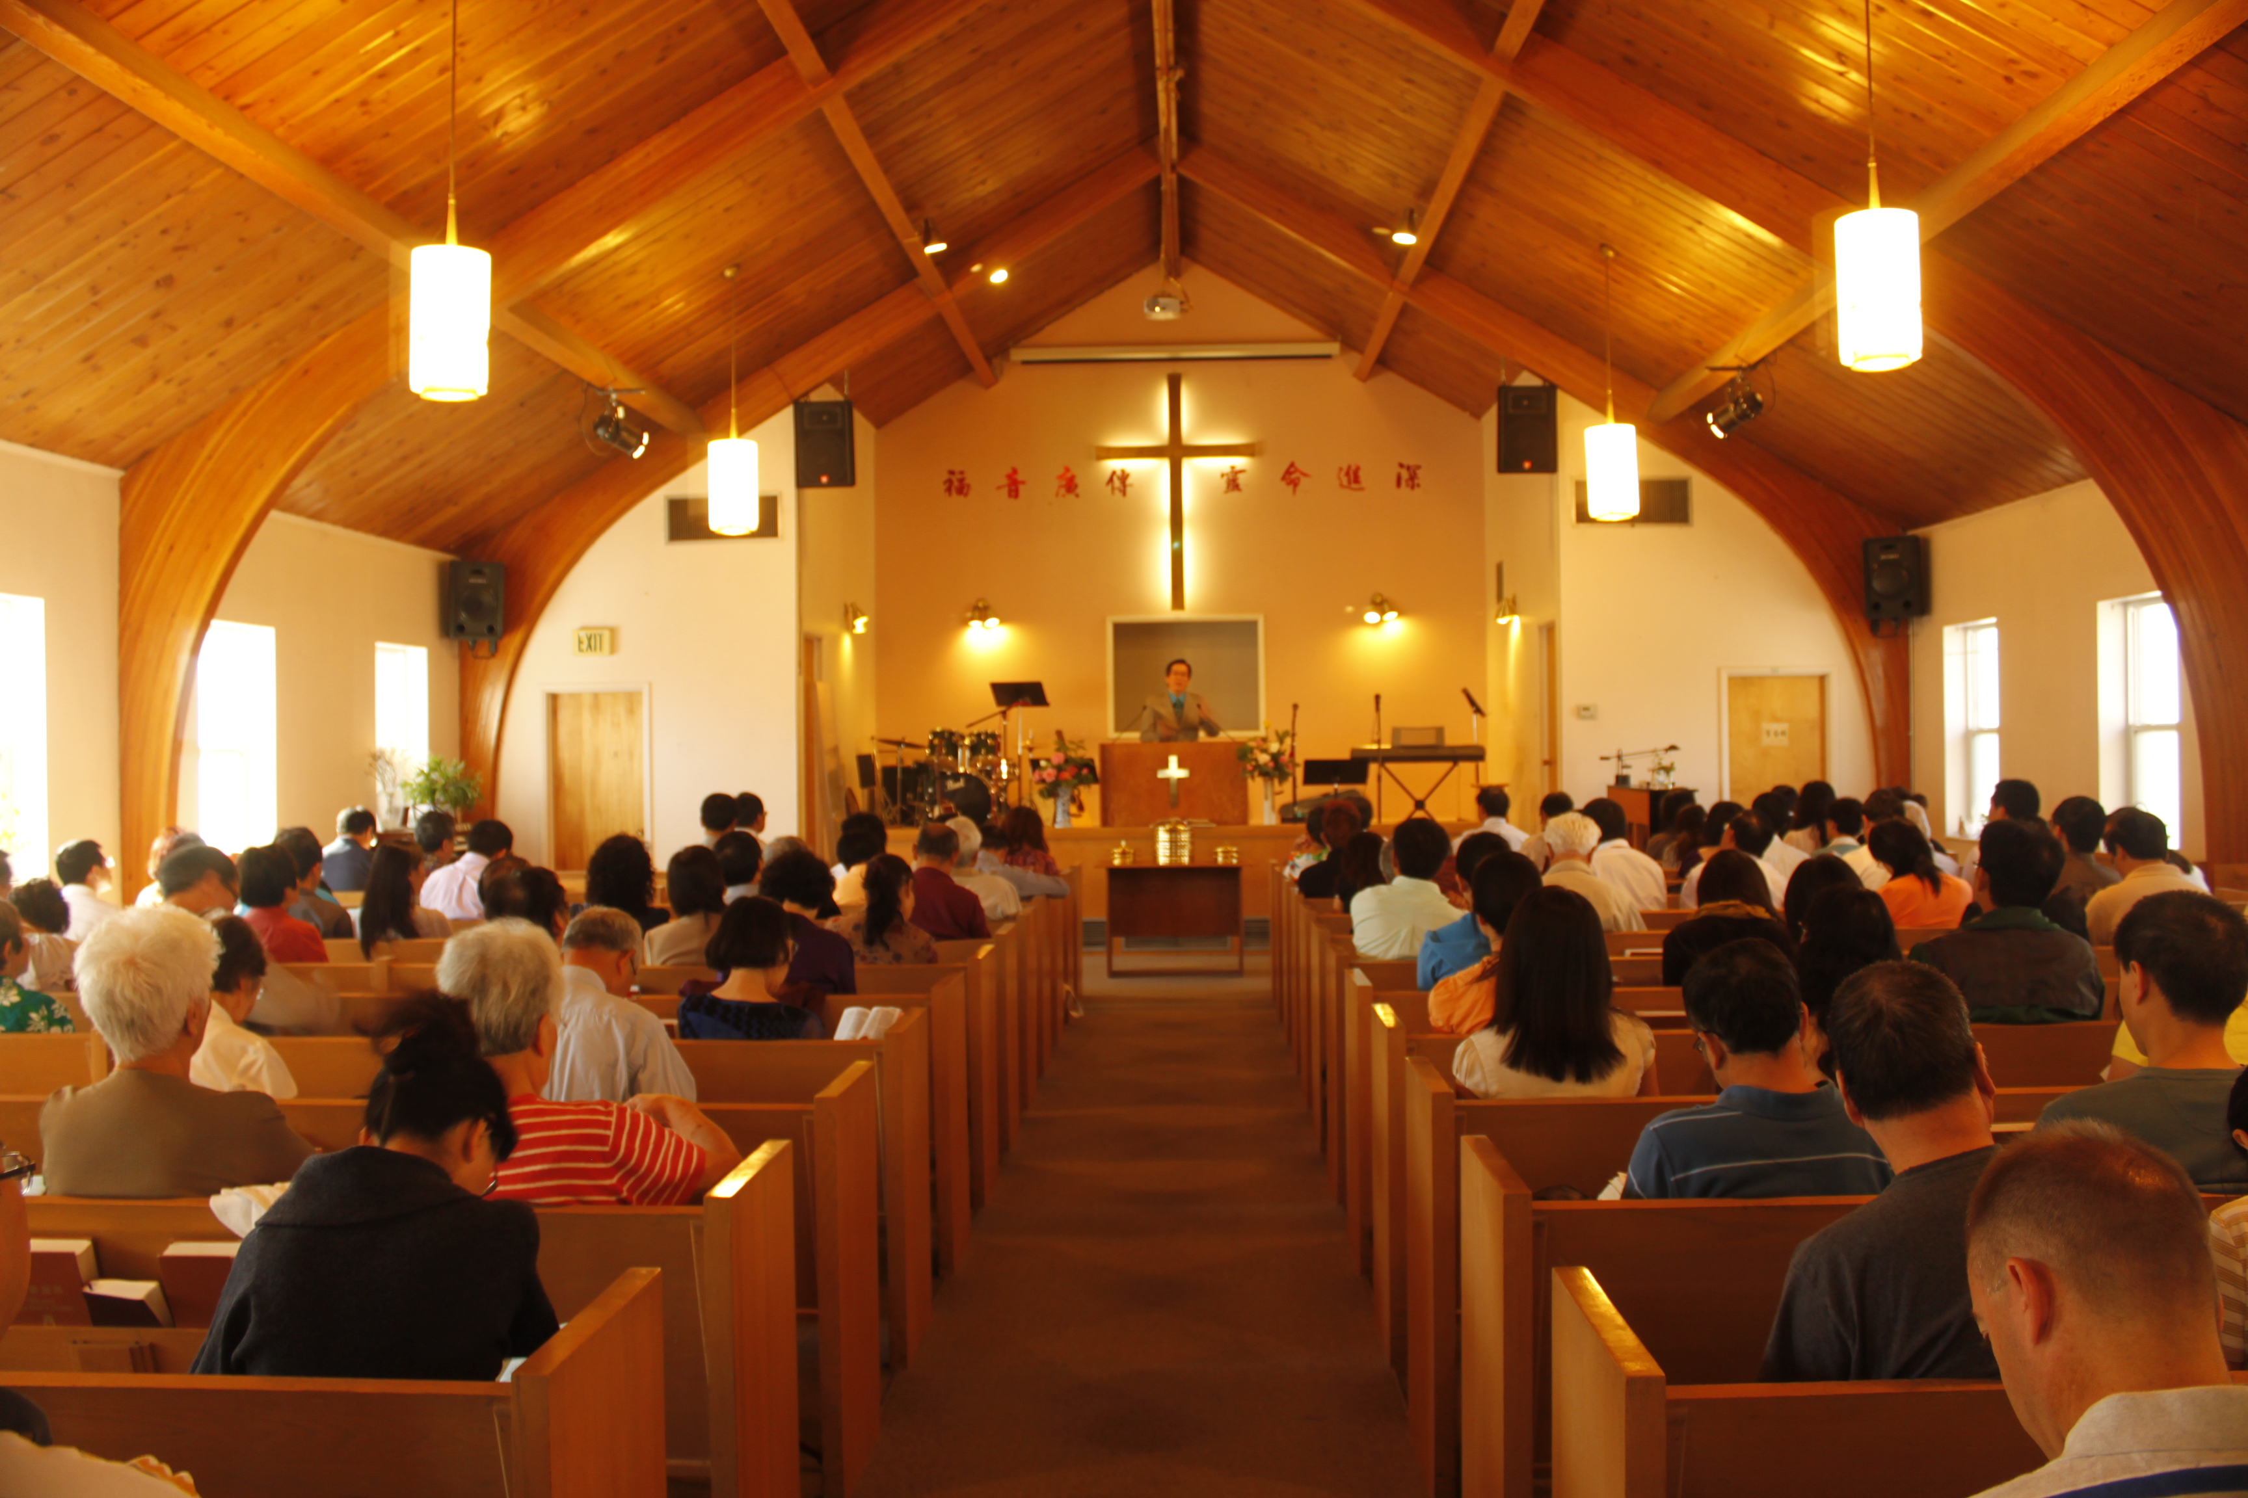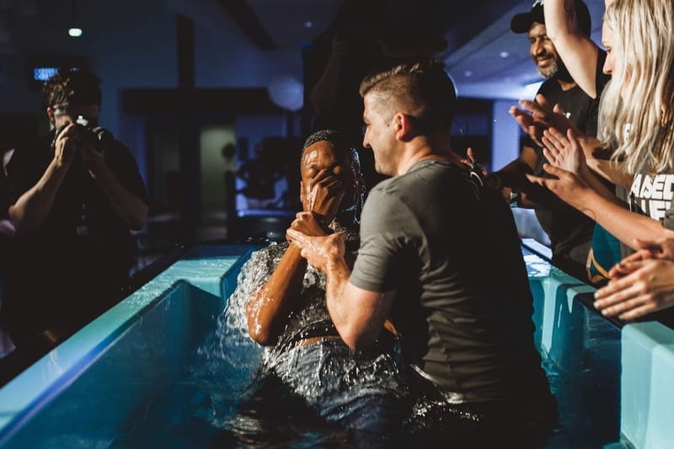

Which raises the question, exactly what is a “Christian?” Is it…

- Someone who holds certain beliefs?
- Someone who goes to church regularly?
- Someone who knows the Bible really well?
- Someone who has prayed a certain prayer?
- Someone who is going to heaven?

So often being a Christian is defined as believing the right things about Jesus so that you’ll get into heaven when you die. We’ve been calling this (graphic from Week 1) “In and Out Christianity.” It’s the idea that if you just believe the right things and jump through the right hoops, you’re in!

(Improved Option) This way of thinking reminds me of a scene in the movie Monty Python and the Holy Grail. When King Arthur and his knights come to “The Bridge of Death,” they face a test. If they can give the right answers, they are permitted to cross the bridge to reach the castle. If not, they are cast into the abyss. Maybe you remember this scene:

Video: “Monty Python” (Edited version of https://www.youtube.com/watch?v=dPOyOM7wxlE )

(In & Out Christianity) Is that really what being a Christian is all about? Knowing the right answers, believing the right things, and then you’re good to go? The problem with this “In and Out” version of Christianity is that Jesus doesn’t talk about being a Christian like this at all.

In fact, author and pastor John Ortberg writes;

“Do you know what never defines the word Christian? The Bible. Literally. It never calls anyone to become a Christian. Even Jesus never uses the word Christian. Jesus never says, ‘Here’s how to become a Christian.’ Jesus never describes what a Christian is. Jesus himself wasn’t even a Christian; he was Jewish. In fact, the word Christian is used only three times in the entire New Testament and then only because Jesus’ followers were becoming to ethnically diverse to be regarded as a sect within Judaism.” –John Ortberg

The truth is Jesus invites us to something far more revolutionary than being a “Christian!”

Series Recap
(Series Graphic) We are in the second week of our series, “This Changes Everything.” This series is all about the good news Jesus came to this world to proclaim. The Gospel writer Mark records Jesus’ sharing his news this way:

“The time has come,” he said. “The kingdom of God has come near. Repent and believe the good news!” Mark 1:15

Jesus doesn’t offer us merely an “In & Out Christianity” where you check the box, say the prayer, or do the “thing” and then you get a ticket to heaven when you die. No, Jesus said that with his coming, heaven was coming to earth. The Kingdom of God is here! There was and is now a new way of living in this world available to everyone! It’s an eternal kind of life that we can experience right now!

It’s a kind of life where we know God in what John Ortberg describes as…

“...an interactive relationship where I experience God’s presence and favor and power in my real life on earth.” –John Ortberg

So how do we experience this eternal kind of life? Well, Jesus says that he himself is the doorway to this life. And then he issues the most incredible invitation.

The Invitation
If we return to Mark’s account of Jesus’ life, after Jesus declares that the Kingdom of God has come near, this is what happens next:

“As Jesus walked beside the Sea of Galilee, he saw Simon and his brother Andrew casting a net into the lake, for they were fishermen. ‘Come, follow me,’ Jesus said, ‘and I will send you out to fish for people.’ At once they left their nets and followed him.” – Mark 1:16-18

Jesus’ invitation, one that he extended over and over again, was simply this: (highlight) “…follow me.”

Jesus never said, “Believe the right things about me and you’ll get to go to heaven after you die.” His invitation was to something far more life-changing, far more compelling, and, in truth, far more costly than that. It was an invitation to experience God’s presence and power. It was an invitation to experience an eternal kind of life that could be lived right now. It’s an invitation to become a talmidim, which is Hebrew for “disciple” but might be better translated with the word “apprentice.”

“Follow me” is an invitation to become an apprentice to Jesus.

And remember, the word “Christian” only shows up three times in the entire New Testament. But the word “disciple” appears 269 times! So what does it mean to be an apprentice? Dallas Willard described it this way:

“...a disciple, or apprentice, is simply someone who has decided to be with another person, under appropriate conditions, in order to become capable of doing what that person does or to become what that person is...as a disciple of Jesus I am with him, by choice and by grace, learning from him how to live in the kingdom of God...I am learning from Jesus to live my life as he would live my life if he were I.” –Dallas Willard

You and I are invited, not to just believe things about Jesus, not to just learn things about Jesus, but to be active participants in following Jesus.

It’s kind of like learning how to play a board game. Has anyone ever experienced someone trying to explain a complicated board game to you just by reading the directions? At some point, I don’t want to hear about the game anymore, I just want to play! Just show me and I’ll figure it out!

That’s a lot like how apprenticing Jesus is meant to work. We learn by doing, by experiencing, by stepping out in faith and allowing God to not only lead us but transform us in the process.

What does it look like to say “yes” to Jesus’ invitation to become his apprentice? Well, let’s think back to Mark’s account of Jesus invitation to his first apprentices. There are a number of things we see in their decision to follow Jesus that can guide us. First, we see…

#1 – Release (this heading with Mark 1:16-18)

These first Jesus-apprentices didn’t ask Jesus if they could bring ther nets with them. They didn’t even ask if they could have “just a quick second” to pack them all up nicely. Mark actually says, “At once they left their nets.” Did you catch that? At once! They dropped, not only what they were doing, but the very item that was inextricably connected to their well-being and identity.

And they released their old lives completely. They didn’t say, “Yeah, we’ll follow you part-time, Jesus, but on weekends we’ll go back to our fishing, if that’s okay.” No, they left everything that used to give them security in order to follow Jesus. They dropped their nets to pursue something and someone even greater.

Which I think is pretty beautiful, if you think about it. Nets are things that can ensnare us, tangle us up. So often I think we hold on to our nets thinking they’ll bring us security, purpose, or peace, when in truth they keep us tethered to our old life. Jesus is inviting us to loosen our white-knuckled grip on the idea of being in control and instead trust him, not merely with our Sunday mornings, but our entire lives, everything we are and hope to be.

In order to truly follow Jesus, an apprentice needs to let go of their life and the old ways they’ve lived. Releasing is the beginning of becoming an apprentice of Jesus.

And second…

#2 – Reorient

An apprentice of Jesus reorients their life around Jesus. It’s like how we often arrange rooms in our house around a focal point; in our lives, Jesus becomes the focal point and every other part of our lives is framed around and towards him. In the Gospel of Luke, Jesus makes this intense statement: (add)

“If you want to be my disciple, you must, by comparison, hate everyone else—your father and mother, wife and children, brothers and sisters—yes, even your own life. Otherwise, you cannot be my disciple. – Luke 14:26 NLT

What he’s getting at is our tendency to think that we can place God in the #2 or #3 seat and still get by. But Jesus has no intention of being a supporting actor or auxiliary instrument in our lives. He calls us to reorient everything we do and everything we are around following him. Jesus is Lord. He is King. Apprentices reorient everything in their lives around him.

And third, apprentices # 3- Respond

This is the piece we often miss. We can attend services like this, nod in agreement, and maybe even say a prayer to release and reorient, but what Jesus calls his apprentices to do is to actually respond in our daily lives – in every situation – as Jesus would respond.

Again, Dallas Willard hit the nail on the head when he said: (add)

“An apprentice is someone whose ultimate goal is to live their life the way Jesus would live if he were me.” –Dallas Willard

As an apprentice, by God’s grace, I’m learning to live my life the way Jesus would live it.

- I’m learning to do my job the way Jesus would do it.
- I’m learning to love the people in my life the way Jesus would love them.
- I’m learning to tackle the injustices I see the way Jesus would tackle them.

In every area of my life, I am learning to live my life the way Jesus would live it if he were me.
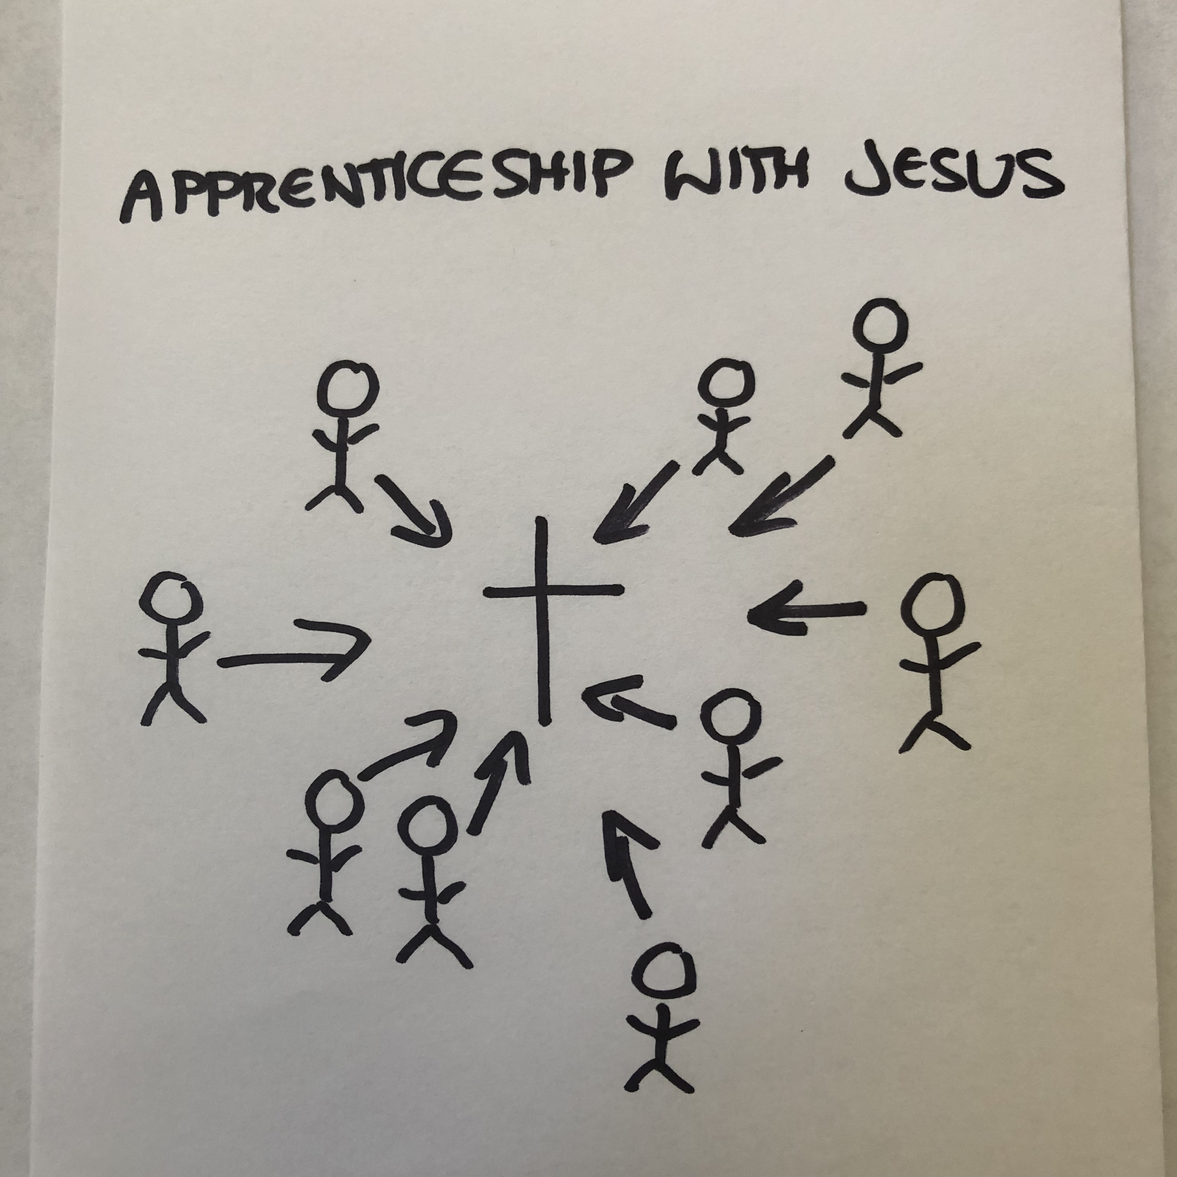
(Graphic from Week 1) And that’s why apprenticeship with Jesus is not like “In and Out Christianity.”

Apprenticeship with Jesus is about following Jesus. And it’s journey, not a destination. It’s a lifetime pursuit filled with successes and failures, victories and struggles, joys and sorrows. But all of it moves us closer and closer to Jesus and in him we find an eternal kind of life that changes everything!

Challenge: Accept the Invitation
Here is what I want you to understand today: Jesus is extending an invitation to you. Finding your way back to God isn’t merely about some philosophy or set of principles, it’s ultimately about saying “Yes!” to becoming an apprentice of Jesus, and then doing it.

Maybe you came here today, and honestly, weren’t expecting much. Maybe a friend or family member invited you, and you thought you’d come check this whole “church thing” out. Maybe you’ve been coming for awhile now and you still have your doubts. Guess what? We all do.

Maybe for one reason or another, you haven’t yet said “Yes” to Jesus. What if today, you choose to doubt your doubts, and Accept the invitation from Jesus. My challenge to you today is to say yes to him. Not just yes to trusting him, but following him.

For others of you, maybe you’ve realized that you’ve settled for “In and Out Christianity.” Maybe you’ve never really said yes to being an apprentice to Jesus. Would you do that today?

As Dallas Willard notes:

“Non-discipleship is the elephant in the church. It is not the much-discussed moral failures, financial abuses, or the amazing general similarity between Christians and non-Christians. These are only effects of the underlying problem. The fundamental negative reality among Christian believers now is their failure to be constantly learning how to live their lives in The Kingdom Among Us.” - Dallas Willard

So many of us aren’t experiencing an eternal kind of living because we’ve settled for something less than whole-life apprenticeship to Jesus. Friends, the Kingdom of God is here! We can experience it right now!

I want to take time right now to give you a chance to respond to Jesus in one of two ways.

(Communion graphic) The first is Communion. At Communion, when we eat the bread and drink the juice, we’re not merely remembering something Jesus did a couple thousand years ago. That’s part of it, but it’s not the whole picture. (1 Corinthians 10:16) In fact, the Apostle Paul says when we eat this bread and drink this cup, we are participating in the Body of Christ. We are, either again or for the first time, saying, “Jesus, I don’t want to merely know about you, I want to follow you. I want to be a part of what you’re doing in the world.”

In a moment, I’m going to invite you to come forward to receive the bread, his body, and the cup, his blood, as a way stepping out to become an apprentice of Jesus, for the first time or for the hundredth time. Following Jesus, really following him, is a journey that we’ll never fully arrive at in this life, and we encourage everyone to take whatever their next step might be.

So the first way to respond to Jesus is to receive Communion.

(Baptism graphic) The second what we call baptism. Baptism is not a ritual for those who are “in,” it is a birth into a new kind of life, an eternal kind of life. In baptism, we release our old way of life, reorient our whole selves to Jesus, and respond by following Jesus’ example of being baptized.

Through baptism we publicly declare that Jesus is Lord, and are choosing to follow him. When we go under the water, we identify with Jesus in his death and burial, but when we come out of the water, we identify with his ressurection and walk in the newness of this eternal kind of life with him!

Baptism Questions

Let me take a few moments here because for some of you, even as I’m talking, you are thinking, “I want to take this step to following Jesus…I should be baptized.” But then come all the questions that hold you back…

Question #1
You might be thinking: “I was baptized as a baby, should I be baptized again?”

When we read about baptism in the New Testament, we find two things that were true of every Christ-follower…

#1 - The person who was being baptized was always old enough to make that decision for his or herself. It was always that person’s choice.
#2 – We see each baptism as something that was done by immersion, or by completely going under the water.

If you’ve never made that choice for yourself, I want to challenge you to take this step today. The way I look at it is this - you are actually completing the commitment that your parents made for you all those years ago.

Question #2
Or you might be wondering: “What if I have family or friends who are not here today that I want to see this?”

Well, we have a professional photographer who is ready to capture this amazing moment for you so you can share it later with family and friends. If you sense God is prompting you, don’t put it off. You should be baptized TODAY!

Question #3
Or maybe today you’re thinking, “I want to get baptized, but do I have to do it in front of everyone?”

Let me just encourage you… that’s kind of the point. If you are willing to get soaking wet in front of a room of dry people to declare your commitment to Jesus, he will be able to use this moment of courage to strengthen you to live for him every day of your life. Don’t shy away. Be baptized TODAY!

Question #4
Or maybe you’re still holding out asking: “What if I don’t have clothes to change into or a towel to dry off with?”

· We’ve got an amazing baptism T-shirt to give you as a gift!
· We have shorts.
· We have towels.
· We have blow dryers to make your hair look perfect again!
· We have an entire team of people right by those doors ready to serve you in order to make this the best experience possible.

Question #5
Or perhaps you’re thinking, “Don’t I need to have my life all together before I get baptized?”

No! Baptism is NOT for those who have it all together, but for those of us who know we don’t! Baptism is actually a commitment by those who recognize: “I can’t save myself, I need Jesus!” If this is the question that you’re thinking today, don’t wait, you should be baptized TODAY!

Conclusion
Today can be the day that changes everything, This incredible invitation of Jesus to experience him and his kingdom is extended to everyone, not for some far-off distant future, but right here and now. Let’s not let this moment pass without accepting the invitation.

I invite you to accept Jesus’ invitation by receiving Communion.
I invite you to accept Jesus’ invitation by receiving Baptism.

Today can be the day that changes everything!
Let’s respond to his invitation.

