Week 1 - December 1, 2019 - Micah: A Promise of Peace

Scripture: Micah 5:1-5a, Luke 2:4-7, Romans 5:1-2 John 14:27, Matthew 5:9
Message Big Idea: Through Jesus we can now experience peace.
Bring out prophecy - Bethlehem
Introduction: Peace
Imagine for a moment that your world has just been turned upside down because your country has gone to war. And I’m not talking about fighting that’s happening somewhere else far away, but everything that you know is collapsing in your own country, right in front your eyes. How are you feeling? What’s in your heart? Now I want you to imagine that the war has ended and your life is actually slowly returning to normal. How would you then feel? This is exactly what people felt when War World II ended.

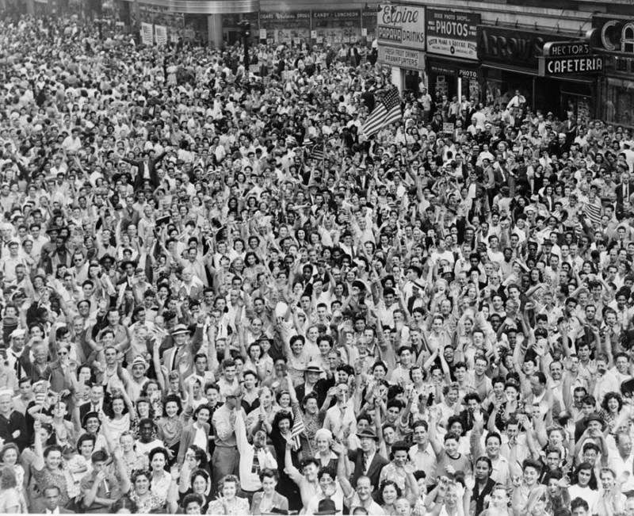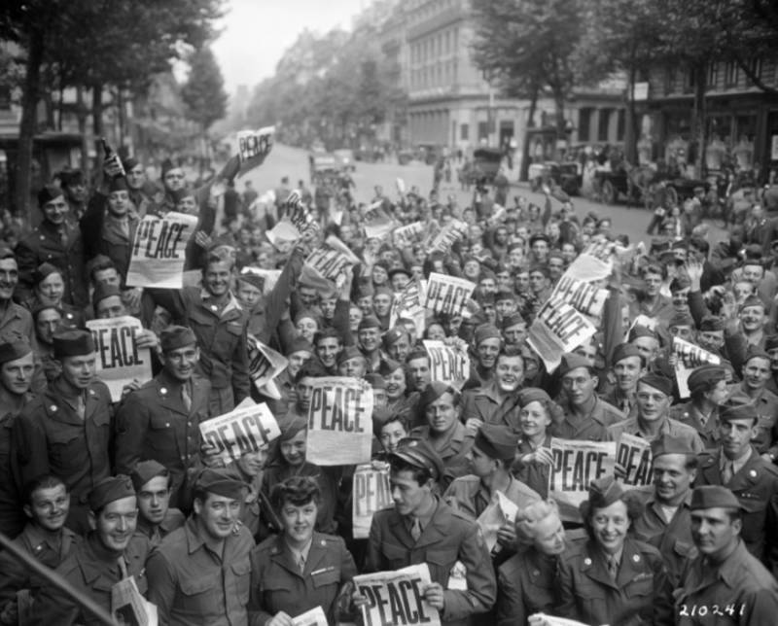

(Image 1) You open the newspaper and you read the fateful words: “War Ends” and “Peace.” (Image 2) In fact, the Daily Mirror reported that “people were so delirious with joy that they hardly knew what to do with themselves.” (Image 3) According to LIFE Magazine, Americans celebrated “as if joy had been rationed and saved up for the three years, eight months and seven days since Sunday, Dec. 7, 1941.” (Image 4)

Why would I bring any of this up? Why is this so important? Because we all hope for peace. If we take a look at the news, locally, nationally and around the world and we can immediately get a sense that something is wrong with our world. And the question we ask ourselves is: What do we do with that? How can we have peace in the midst of everything that is happening around the world? Well, the good news is that God offers us a different kind of peace, something that doesn’t depend on exterior circumstances. It’s a peace that is way beyond merely the absence of conflict. It’s something much, much better.
Does this “why” need to be brought to a personal level? Connect people to the emotion of these pictures. I want that day in my life! When you think of the conflicts in your life, don’t you wish you would have these moments.

Series Overview
(Series graphic) Today we’re starting a brand-new series that we have called B.C., which, for the pruposes of this series, stands for “Before Christmas.” The Old Testament is the story of God with his people before Christmas, before the birth of Jesus. During an era known as “the time of the kings”, God would send people called prophets to offer guidance and direction to their kings and nations. Now, the word prophet might sound a little strange to some of us and all kinds of thoughts come to mind. For example, I know that a number of you, when I say the word “prophet” you picture something like this: (Homer image)

In reality, a prophet was simply a messenger from God with, you guessed right, a message from God. Now, you would think that the kings would listen to a message of God, but time after time, we see kings doing the complete opposite of what the prophets would tell them. Will this be in the video? Yes. As a consequence, after the reign of King Solomon, the nation of Israel was divided into two, the Kingdom of the North, which is not a Game of Thrones reference, and that kingdom was called Israel. You then had the Kingdom of the South which was called Judah. Eventually, God allows both kingdoms to be defeated by their enemies. First, Israel is destroyed by the Assyrians in 722 B.C.. Later, Judah falls to the hands of the Babylonians and many of its people are carried off into exile around 586 B.C.. But, because we know God is a God of love and compassion, even in the midst of destruction, God would still send prophets that would bring words of hope and peace to these nations. One of them was a man named Micah, and here is his story:

Video: Kid’s Explain the Prophets

NOTES:

Micah was a prophet in Judaism who prophesied from approximately 737 to 696 BC in Judah and is the author of the Book of Micah. Micah was active in Judah from before the fall of Israel in 722 BC and experienced the devastation brought by Sennacherib’s invasion of Judah in 701 BC. He is considered one of the twelve minor prophets of the Tanakh (Hebrew Bible) and was a contemporary of the prophets Isaiah, Amos and Hosea. Micah was from Moresheth-Gath, in southwest Judah. He prophesied during the reigns of kings Jotham, Ahaz, and Hezekiah of Judah. Micah’s messages were directed chiefly toward Jerusalem. He prophesied the future destruction of Jerusalem and Samaria, the destruction and then future restoration of the Judean state, and he rebuked the people of Judah for dishonesty and idolatry. Micah 5:2 is a prophecy that Bethlehem, a small village just south of Jerusalem, would be the birthplace of the Messiah.

The Promise
I think it’s fair to say that the world at this time was a bit of a mess. These people are experiencing total chaos in but through the prophet Micah, God brings a word of hope for peace amidst the chaos:

Now muster your troops, O daughter of troops; siege is laid against us; with a rod they strike the judge of Israel on the cheek. But you, O Bethlehem Ephrathah, who are too little to be among the clans of Judah, from you shall come forth for me one who is to be ruler in Israel, whose coming forth is from of old, from ancient days.

Now, that’s an incredible statement. He’s saying, from some “no-name” town that’s not even big enough to be among the clans, is going to be home to the one who will be some sort of epic ruler! But Micah doesn’t stop there:

Therefore, he shall give them up until the time when she who is in labor has given birth; then the rest of his brothers shall return to the people of Israel. And he shall stand and shepherd his flock in the strength of the Lord, in the majesty of the name of the Lord his God. And they shall dwell secure, for now he shall be great to the ends of the earth. And he shall be their peace. - Micah 5:1-5a

I want you to imagine hearing to these words for the first time. There is hope for a better future. There is hope for something to come. Now, the Hebrew word used here for the word “peace” is the word “shalom.” And the shalom of God is way more than merely the absence of conflict. It has to do with a completeness, soundness, wholeness, and covenant with God. This what God is promising to his people here. This is what God will do for his people. This is confusing. Use quote to explain it. - See, peace is a pause in time, is a “but” in time. It is the sentence clause that reveals what has happened instead. “I once was blind, but now I see.” It is the fulfillment of a promise that things were once one way but are now a way much better.

Matt Woodley, a brilliant pastor and teacher, puts it this way: This is good!

“In the Bible, God’s peace—shalom—meant much more than simply the absence of war. Shalom meant not only inner peace or spiritual peace; it meant wholeness and completeness throughout all creation. It meant the end of injustice. It meant the rich would no longer devour the poor. It meant all brokenness would be set right and healed. It meant that people would love one another. For the Jews, the hope of shalom was wrapped up in a person. Someone is coming, they believed, who will open the door to peace.” (“A Look at Advent through the Old Testament” by Matt Woodley)

For Israel, the fact that this bringer of peace would be from Bethlehem was yet another reason to be hopeful. See, David, one of the most iconic kings of Israel, was from Bethlehem. His kingdom was known for a time of peace and prosperity. And God was saying to them, in the midst of chaos, destruction and agony, I will rise up again someone from the house of David, that will bring again the Shalom of God into your midst.

So who is this Messiah? Who is this bringer of peace?

Let’s take a look at Luke a historian that intensively researched the story of Jesus and he records:

And Joseph also went up from Galilee, from the town of Nazareth, to Judea, to the city of David, which is called Bethlehem, because he was of the house and lineage of David, to be registered with Mary, his betrothed, who was with child. And while they were there, the time came for her to give birth. And she gave birth to her firstborn son and wrapped him in swaddling cloths and laid him in a manger, because there was no place for them in the inn. - Luke 2:4-7

As we turn the page to the New Testament, we see Jesus fulfilling the promise of the Messiah. Here we see the fulfillment of what Micah, 700 years before had foretold about one that would be the prince of peace. Now the people of the time had a hard time believing that Jesus would be the Messiah. Why? Because conflict was still a very real part of their every day reality. There was no army, there was no earthly messianic reign. What the people of that moment forgot is that the peace God offers often goes way beyond the mere absence of war or conflict. He comes to offer a kind of peace that surpasses all understanding. In fact, in one of his first teachings known as the sermon of the mount, Jesus changes the paradigm entirely and said that sometimes the ones in the middle of difficulty are actually the most blessed. Put something personal here. How have you experienced that?

So, if the peace of Jesus is more than simply the absence of conflict, what does that actually look like? Well, I think there are four specific areas or direction that the peace of Jesus impacts.

(Illustrate each of these directions graphically)
Graphics for these. Put some humor in these so the video later isn’t so jarring.
The first direction is UP. I’ll call this one, (add) positional peace. Look at how the Apostle Paul explains this kind of peace to the church in Rome:

Since we have been acquitted and made right through faith, we are able to experience true and lasting peace with God through our Lord Jesus, the Anointed One, the Liberating King. Jesus leads us into a place of radical grace where we are able to celebrate the hope of experiencing God’s glory. – Romans 5:1-2

Because of Jesus, our record is utterly clean, blank, and we have true and complete peace with God. And it’s with that peace Paul says we’re able to fully celebrate the hope of experiencing God’s glory. That’s good news!

The second direction is IN. This one is all about (add) internal peace. Here’s how John, one of Jesus’ closest friends recorded it:

My peace is the legacy I leave to you. I don’t give gifts like those of this world. Do not let your heart be troubled or fearful. – John 14:27

Did you catch that? He’s linking this notion of the unique kind of peace that Jesus gives to the state and posture of our heart. He’s saying that, Jesus give a different kind of peace that doesn’t only have eternal implications, but that changes the state of our heart in the here and now.

The third direction this peace of Jesus impacts is ACROSS. I’m going to call this one (add) communal peace. This peace is about us, the church, and the peace that Jesus invites us to live into as the body of Christ. Here’s how the Apostle Paul explained it:

(add) Let the peace of Christ rule in your hearts, since as members of one body you were called to peace. And be thankful. – Colossians 3:15

Because we’re part of the same body, living at peace with one another is paramount. In fact, the point Paul is making here is subtle but massively important. The word “rule” that he uses here is actually the same word used to describe a sort of ancient umpire. He’s saying, “When life gets chaotic, when that person stomps on your last nerve, let this peace that Jesus gives you call the shots in whatever situation you find yourself in.” This idea of letting God’s peace actually “call the shots” in our life reminded me of an unforgettable encounter between coach Phil Wellman and an umpire. Take a look.

Video: Phil Wellman and Umpire (edited) https://www.youtube.com/watch?v=Ggy6WGUFaYs

Besides being hilarious, I think Phil’s reaction is actually a pretty great metaphor for how we sometimes feel toward one another, isn’t it? Don’t we sometimes, at least internally, feel like we’re coming a bit unhinged? But the umpire’s ruling stands and the same is true for us spiritually. When we’re inclined to lash out, to counter-punch, or to spiral out of control, Paul invites us to let the peace of Christ be the things that ultimately calls the shots in our life.

And lastly, the final direction it OUT. This one is about (add) missional peace. This is the peace that we’re now entrusted to bring to the world, wherever our “world” may be. The purpose of having this peace that surpasses understanding isn’t so that we can hoard it to ourselves but so that we can be agents of peace wherever we go. Here’s how Jesus says it:

Blessed are the peacemakers, for they will be called children of God. – Matthew 5:9
Maybe contrast “peacemaker” vs “peacemaker”
That’s the invitation of Jesus. Not to merely be “peacekeepers”, trying not to rock the boat or ruffle feathers, but to be active peacemaker in a world so desperate in need of that kind of peace.

Scholar and theologian N.T. Wright (AKA Tammy’s BFF) put it brilliantly:

…people who believe in the resurrection, in God making a whole new world in which everything will be set right at last, are unstoppably motivated to work for that new world in the present. – N.T. Wright

What Now? Four Challenges

How good is that? When we experience this “set rightness” the Holy Spirit does a work in us that makes us unstoppably motivated to bring that same peace into every area of our life and world. Which sounds all find and good, but how do we actually do that? Well, I’m so glad you asked hypothetical listener! Here are a few quick challenges for all of us to step into this week:
Could these fit in the “Across” section?
First, Deal with conflict early.

The writer of Proverbs hits the nail on the head:

(add) Starting a quarrel is like breaching a dam; so drop the matter before a dispute breaks out. – Proverbs 17:14

The second challenge is: Practice restraint

James, the brother of Jesus made this powerful observation.

(add) My dear brothers and sisters, take note of this: Everyone should be quick to listen, slow to speak and slow to become angry. – James 1:19

Could anyone here use a little more of that in their life? I know I could!

Fold that into the conclusion. The third challenge is: Prepare for a long journey.

Here’s how Peter, who notoriously struggled in this area, talks about it.

(add) They must turn from evil and do good; they must seek peace and pursue it. – 1 Peter 3:11

He understands that peace isn’t something that just magically happens but rather, it’s something we, together, have to actively pursue.

And my last challenge is this: Take a step towards peace.

Again, the Apostle Paul, quoting Proverbs 25 says:

(add) “If your enemy is hungry, give him something to eat. If he is thirsty, give him something to drink; because if you treat him kindly, it will be like heaping hot coals on top of his head.” – Romans 12:20

So, my question is this: what is one step you need to take toward bringing some peace into the world? What is one way this week, this month, that we together can embody this invitation? This could look a bunch of ways, but here are two quick suggestions:

1) Join a Team!
Where did this come from? Seems out of the blue.
This is a big part of the third “C” of our “3C’s” Contributing is ultimately about giving back, about joining God in bringing his peace to a world so desperately in need of it. If you’re interested, we’ve made it really easy to learn more. Simply attend the Contribute Party after the service or text the word CONTRIBUTE to 313131 to get started. This is one of the easiest ways to start saying yes to bringing the peace of Jesus to the world around us.

My second challenge is this:

2) Be a part of Gift Mart!
Could this be moved up into missional peace?
Gift Mart is one of my favorite things we do as a church. Since 2003, Giftmart has partnered with businesses and organizations to collect more than 100,000 new toys. Here’s how it works: in an effort to preserve dignity, parents from Giftmart’s partner schools in East Aurora and Joliet have been able to choose gifts for their children at a discounted price of $2 per toy. Giftmart seeks to reimagine the holiday charity model by harnessing the generosity of communities to do more than just place toys under the tree in under-resourced neighborhoods. You can provide the gift of community by joining our team to help plan, shop, set up and host the event at one of our many school sites. We plan this event all year, so its never too early to get involved!

You can visit the website or head to the table in the lobby after the service to learn more, but I can’t encourage you enough to take this opportunity to be the hands and feet of Jesus to others this Christmas season.

We: A vision of Peace

In light of all of this, I think Henri Nouwen encapsulates this whole idea wonderfully:

“The marvelous vision of the peaceable Kingdom, in which all violence has been overcome and all men, women, and children live in loving unity with nature, calls for its realization in our day-to-day lives.

In other words, he’s saying that this vision doesn’t only exist in the grandiose moments, but in the mundane space of the every day.

Instead of being an escapist dream, it challenges us to anticipate what it promises. Every time we forgive our neighbor, every time we make a child smile, every time we show compassion to a suffering person, every time we arrange a bouquet of flowers, offer care to tame or wild animals, prevent pollution, create beauty in our homes and gardens, and work for peace and justice among peoples and nations we are making the vision come true.” - Henri Nouwen

Remember what Jesus said: Is this earlier?

My peace is the legacy I leave to you. I don’t give gifts like those of this world. Do not let your heart be troubled or fearful. – John 14:27

Regardless of whatever chaos or trouble you find yourself in, remember that Jesus promises his gift of peace is unlike anything the world could ever give. It’s “shalom” – wholeness, completeness, fullness in every sense of the word. May we be a people you experience this and bring it into every corner of our lives. Let’s pray.

Communion Idea

Hours before Jesus’ crucifixion, he wasn’t performing another miracle or giving one more sermon. He was sharing a meal. At this meal, he was making it clear that his life was not going to be taken – he was giving it. He was giving his life for the purpose of peace.

When Jesus gave his life for us, it wasn’t merely so that we could have pace with God, as important as that element is. He always gave his life so that we could have peace with one another as well. When we eat this bread and drink this cup, we both remember, but also join the mission of Jesus to bring peace to every part of our lives.

