Breakthrough – Week 2 - People

Message Big Idea: The Spirit brings breakthrough in people… in individual lives, in groups, and in whole communities.
Scripture:
______________

Introduction: “I was today years old…”
(Series Graphic) Ever have an “Ah-hah” moment? Do you know what I mean? I’m talking about a breakthrough moment when you suddenly come to a realization you’ve never ever had before. You see something you didn’t see before; you know something you didn’t know before. Suddenly something that wasn’t a reality is now a reality!

Here’s what I mean… Have you seen the series of tweets and memes that start with “I was today years old when…”

For example… (Picture) “I was today years old when I found out the “L” in “Staples” is really a half open staple.” How many of you never realized that before?

Or this one: (Picture) “I was today years old when I found out the sides of juice boxes are for kids to hold it so they don’t squeeze out the juice.” I mean, come on! Juice boxes should come with these instructions!

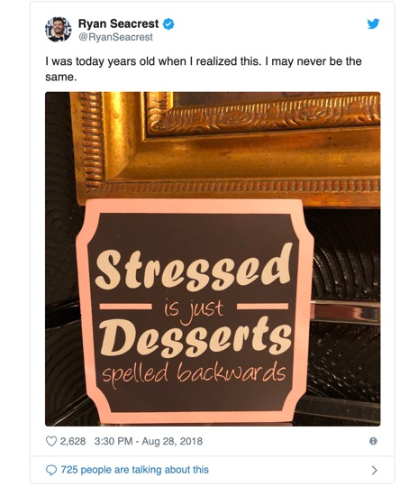
How about one more: (Picture) “I was today years old when I realized that “stressed” is just “desserts” spelled backwards.” No wonder why chocolate always helps, right?

As remarkable as these breakthrough moments are, I believe that if you lean in today and join us for the next 5 weeks of this series, you are going to experience a genuine spiritual breakthrough. And when God breaks through, it will not only change your life, it might change the lives of other people!

Series Recap
(Series Graphic) That’s why we are calling this series “Breakthrough.” The title of this series is based on a nickname that God got in the Old Testament. God was sometimes referred to as “The Lord of the Breakthrough.” The Psalmist writes:

“Your awe-inspiring acts of power have everyone talking! I’m telling people everywhere about your excellent greatness! …We shout with ecstatic joy over your breakthrough for us.” -Psalm 145:6-7 TPT

In the stories we read in Scripture, God had a way of suddenly showing up in time and space and making something that wasn’t a reality suddenly become a reality! He is the Lord of the Breakthrough!

And we believe that the same God who breaks through in the pages of Scripture wants to breakthrough in our lives today!

- God might breakthrough by answering a prayer that you’ve prayed!
- God might breakthrough by restoring a relationship in your life!
- God might breakthrough by healing a wound you’ve been carrying!

In fact, we believe as a church that we are entering into a new season of breakthrough. So, we’re launching into this new season with this series called “Breakthrough,” but we believe what God wants to do in our lives and our church is much bigger than a 6-week series.

During this series we are also launching a new 3-year initiative called “Breakthrough” that will be an important part of this season. We’ll have a special Commitment Sunday on November 17 when we’ll ask everyone who calls Community their church home to bring 1) a special gift 2) and a commitment of what they’re willing to give above and beyond their normal contribution to the church over the next 3 years. But again, we believe that what God wants to do in and through Community is much bigger than this initiative too.

We believe God wants to breakthrough into our lives, transforming us in ways we’ve never experienced before.

And as we try to open ourselves up to God’s Spirit, we decided the best place to start would be to study the book of Acts to learn how God’s Spirit worked in the very first church, breaking into the lives of the very first Christ-followers.

Story Context
The book of Acts begins with the very last thing Jesus says before he leaves planet earth to return to the Father:

“But you will receive power when the Holy Spirit comes on you; and you will be my witnesses in Jerusalem, and in all Judea and Samaria, and to the ends of the earth.” -Acts 1:8

Jesus promises that his followers will receive supernatural power when the Spirit breaks through that will allow them to carry out his mission forward from where they are in Jerusalem to the ends of the earth.

So what do these first Christ followers do? (pause) They wait and pray. Yes, they pray. And what emerges in the first few chapters of Acts is a pattern that we see over and over again.

When people pray, God breaks through.

The people pray and the Holy Spirit supernaturally breaks through. On the day of Pentecost, the Holy Spirit breaks through empowering these first followers of Jesus to speak other languages and to boldly share the good news of Jesus!

Over and over again this pattern of people praying and God breaking through happens, including in the story I want us to look at today. In today’s story, two people are praying, and it leads to a breakthrough not just for one individual, but for a whole community of people!

Breakthrough for Individuals
Now before we get into this, you should know just how key this story is. In fact, it’s so important that it’s recorded three different times in the book of Acts. It’s not even a mild stretch to say that the events of this breakthrough changed the course of history. You could even say that we are in this room right now in no small part because of what happened after these two guys prayed. So let’s start by reading about the first guy, Peter.

“About noon the following day as they were on their journey and approaching the city, Peter went up on the roof to pray. He became hungry and wanted something to eat, and while the meal was being prepared, he fell into a trance. He saw heaven opened and something like a large sheet being let down to earth by its four corners. It contained all kinds of four-footed animals, as well as reptiles and birds. Then a voice told him, ‘Get up, Peter. Kill and eat.’” – Acts 10:9-13

It’s a strange story already, right? They say you shouldn’t eat before you go to bed because you might have nightmares, maybe Peter shouldn’t pray when he’s hungry! What makes his vision so strange is that Peter, a devout Jew, is told to eat things that devout Jews would never eat. Peter has never broken the kosher laws, so when God essentially drops a slab of bacon in front of him, his response isn’t all that surprising:

“Surely not, Lord!” Peter replied. “I have never eaten anything impure or unclean.” –Acts 10:14

Peter’s response is so strong that God repeats the same message to him two more times, (Acts 10:15-16) telling him to “not call anything impure that God has made clean.” Peter hears from God, but in Peter’s mind there’s no way God could be saying what he’s saying. Basically, Peter’s response is: “No way!” God, “No way!”

I wish I could say I hear from God all the time like we read about here, but I can’t say that I’ve ever fallen into a trance while the pot pie heats up in the microwave. But what I can certainly identify with is Peter’s response. While the hearing part often seems difficult, the “No way!” part doesn’t seem too foreign to me at all. We’ve got all these areas in our lives where we’re desperate to see breakthrough, desperate to see God move. But in our minds, it’s impossible. As badly as I want it, deep down I’m convinced that nothing is actually going to happen. You might be sitting here this morning thinking the same thing.

Maybe you’re desperate to see breakthrough in your marriage. It’s practically all you pray about. You long for breakthrough, but it’s so bad right now you can’t imagine it. No way, God. No way.

Maybe you long for God to breakthrough in the life of someone you love. You long for them to find their way back to God, but nothing seems to be getting through. You pray, but you quietly think to yourself… No way, God. No way.

Maybe you feel desperate for God to breakthrough in your own life. Depression has a hold on you. Everyday feels like a prison. God wants to break through, but something holds you back from believing it. No way, God. No way.

It’s so easy to get stuck in the impossible, but I want you to know that God has a long history of working in the “No way!” areas of our lives.
In fact, let me share a story from right here in Chicago. (Picture) This is David Washington. David grew up in the South Side neighborhood of Roseland. By the time he was in fourth grade, he was “claimed” by one of the largest street gangs. In high school came the fighting and the drug dealing. By the time he was 19, he was spending $100 a day on a severe drug addiction. Worse yet, he was set to go to trial for armed robbery and unlawful use of a weapon. He faced a 15-year sentence.

The night before David was due in court, he looked himself in the mirror and realized he had thrown his life away for nothing. There was no way he was getting out of this one. No way! At the time, he described himself as an agnostic, but he still found himself turning to God in prayer. “God,” David prayed, “if you can’t get me out of there in 12 months, you don’t exist.”

Maybe not the way I’d recommend praying, but still… would God break through? (Pause)

As Peter prayed on the rooftop, all he could think was, “No way! God, no way!” He had no way of knowing a breakthrough he wasn’t expecting was about to knock at his door.

Breakthrough in Others
Remember, a while ago I said there was a second person praying? (Acts 10:1-2) His name is Cornelius. The chapter we’re reading today actually begins with Cornelius praying and seeking God. What’s significant about this is that he’s not a Jewish man. At this point in the story of Acts, it’s been a Jewish-people only thing. All the first Christ-followers were Jewish, but now Cornelius enters the story.

(Acts 10:3-5) At the beginning of the story, Cornelius is praying and an angel appears to him with a message to send men to a town called Joppa to find a man named Peter. Just as Peter was finished with his dream about the unclean meat, the men from Cornelius knock on his door. They tell Peter why they are there… that an angel of God spoke to Cornelius and told him to send for Peter.

(Acts 10:23b-24) So Peter agrees to go back with these men to Cornelius’s house. When he gets there, the house is jammed packed with Cornelius’ relatives and friends. As Peter looks on their faces, full of expectation, he finally realizes what his vision meant.

God had told him not to call “anything impure that God had made clean.” (Acts 10:34-35) Peter had, like everyone else at the time, believed that the breakthrough they were experiencing was only for the Jewish people. Now he began to understand that what God was doing in the world was for all people, Jews and Gentiles alike!

(Acts 10:44-46) As Peter begins to share the good news of Jesus, the whole room full of people begins speaking in languages they had never learned before. What’s crazy about this is that it’s the exact same miracle that Peter and the other disciples experienced back on the day of Pentecost! The Holy Spirit had come on them in power, and now it was happening to Cornelius and his Gentile friends and relatives. Astonished, Peter declares:

“’Surely no one can stand in the way of their being baptized with water. They have received the Holy Spirit just as we have.’ So he ordered that they be baptized in the name of Jesus Christ. ‘”– Acts 10:47-48a

Do you see what God is doing here? He takes Peter’s “No way!” and transforms it into “No way anyone could stop this!” This is breakthrough!

- A breakthrough for Peter as God tears down the walls of prejudice and helps him see the bigger picture of what God is doing in the world!
- A breakthrough for Cornelius and the community gathered in his home as they find their way back to God!

And a breakthrough for all of us as the mission of Jesus now expands out from its Jewish origins to reach all peoples of the world!

My Breakthrough
And here is the truth… God is still the God of breakthrough! God wants to move in our lives today!

So many of us have been stuck in the, “No way!”

- No way! for our marriages.
- No way! for our finances.
- No way! for our health.
- No way! for our families.
- No way! for our faith.

I believe God wants to move powerfully in this season of breakthrough! No matter what you’re facing today, God will breakthrough! It may not be the way you expected… Peter certainly didn’t expect he’d find himself hanging out in the home of a Gentile… but God will breakthrough! He will turn our “No ways!” into “No way anyone could stop this!”

When people pray, God breaks through.

Story: David Washington’s Breakthrough
The night before his court appearance, David Washington found himself on his knees praying, “God, if you can’t get me out of there in 12 months, you don’t exist.” Do you know what happened the next day? None of David’s accusers showed up to court. Though he was guilty, the judge lowered the charge and sentenced him to one year of house arrest probation.

“I was convinced God was real after that,” David said. “And once convinced, there was no turning back. I gave God everything I had.”

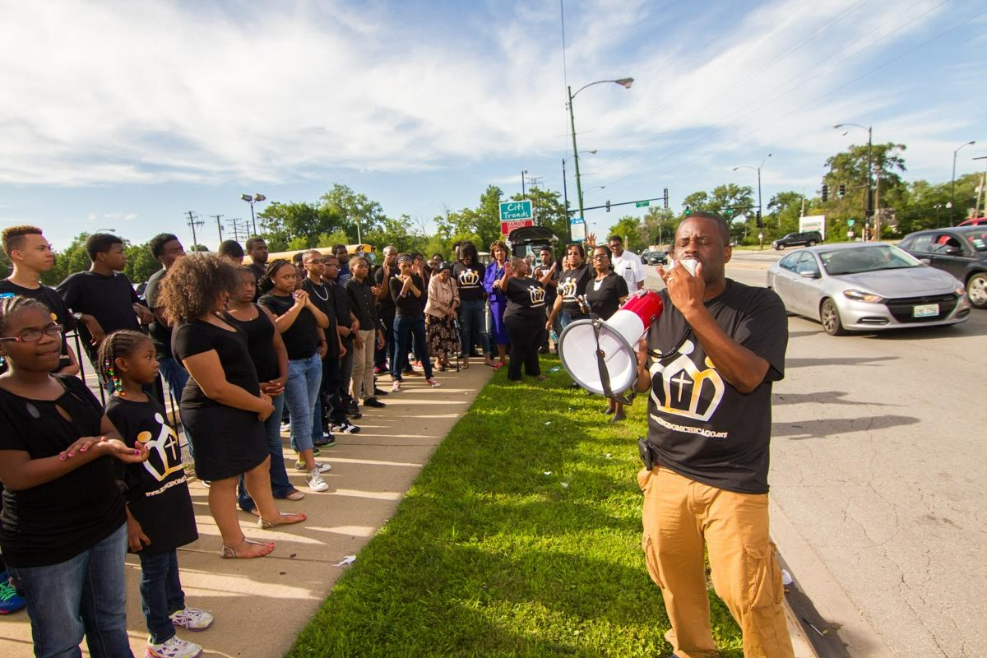
I wanted to share David’s story with you today because just as Peter’s breakthrough led to a breakthrough for a whole group of people in Cornelius’ house, our breakthroughs can lead to breakthroughs for others.

(Picture) When God broke through in David’s life, he became actively involved in a church on the South Side. He returned to the same streets that he had walked as a gang member to preach the good news of Jesus. He went on to Bible college and seminary.

We first met David when he decided God was calling him to plant a church in his hometown neighborhood of Roseland. (Picture – David and Dave or Jon) He came here to Community and went through our Lead Lab as a Leadership Resident. We helped train and equip him and in August of 2017, Kingdom Covenant Church officially opened its doors as a new church plant in Roseland. Now hundreds more people have the opportunity to find their way back to God in that neighborhood!

That is a breakthrough! Just like in the Old Testament and then later with first followers of Jesus – David Washington prayed and God broke through! He is the “The Lord of the Breakthrough.”

Breakthrough in People
Our (Graphic) Breakthrough Initiative gives us the opportunity to join God in bringing a breakthrough for people like David. Through this initiative, we are asking God for a breakthrough in people. Specifically, we want to invest in:

Leadership Residents (with pics): We are investing in the next wave of church planters through our Lead Lab. Leadership Residents spend anywhere from six months to one year in training and development before launching a new church or site.

We also want to invest in:

Community Music (with pics): We are investing in our song writers and musicians who are a part of Community Music. The platforms that Community Music has been given access to have led to new and powerful songs that are shaping the worship culture at our locations, at NewThing churches, and in church communities around the world.

Finally, the “people” part of this initiative is about:

Student Community (with pics): We are investing in our students. This year we saw 1400 students and leaders invade the BLAST Winter Conference. They came out of that and all of us could feel the spiritual intensity it brought our whole church. We will continue to invest in the BLAST Winter Conference and Summer Camp student events.

As I mentioned earlier, on November 17, we’re going to have a Commitment Sunday where we ask everyone who calls Community their church home to bring 1) a special gift 2) and a commitment of what they’re willing to give above and beyond their normal contribution to the church over the next 3 years in order to join God in bringing breakthrough.

We are asking “The Lord of the Breakthrough” to breakthrough in our own lives and to use us to bring breakthroughs in the lives of other people.

Conclusion: Prayer Time
And because we believe that…

When people pray, God breaks through.

…we are concluding each message in this series with a time of prayer. So here’s what we’re going to do: I am going to lead us in a time of prayer. I’m going to prompt us in several things to pray for right here, right now. For some of us, this will be new, but I want to challenge you to engage because when people pray, God breaks through.

So if you would bow your heads right where you are, let’s pray together.

Father, we acknowledge you as God and a “The Lord of the Breakthrough.” We come to you right now asking you to break through in our own lives. Go ahead right now and ask God to do the miraculous and for a specific breakthrough in your own life. (pause for 30 seconds)

Next, let’s ask for a breakthrough for someone we love. I know this will stretch many of us, but take a moment to pray out loud with one or two people sitting near you. Just pray this simple sentence, “God, I ask you for a breakthrough in _______’s life.” Just put the name of the person in that blank. (pause for 30 seconds)

As we close, let’s join together as one community of Christ-followers, and ask God for breakthrough in our church by praying this prayer on the screen together:

“Father, we ask you for breakthrough – in our lives and in the lives of other people. We open ourselves to the work of your Holy Spirit. Grow us. Transform us. Use us to further your mission in this world. We pray all of this in the name of Jesus and in the power of the Holy Spirit. Amen.”

Communion Idea
As we prepare for communion, I want us to go back to the very last statement Jesus made to his followers. Here is what he said:

“But you will receive power when the Holy Spirit comes on you; and you will be my witnesses in Jerusalem, and in all Judea and Samaria, and to the ends of the earth.” -Acts 1:8

This is Jesus describing a breakthrough. Let’s take two phrases:

1. “…you will receive power when the Holy Spirit comes on you.” The Spirit is something that you receive when you open yourself up to all that God has for you. Communion is an opportunity for you to fully open yourself to God and receive His Spirit.

2. “…and you will be my witnesses…” That means that God is going to do something so powerful in your life you will have a story to share. A story of how God broke through and changed your life.

So, during this communion time, the ushers will come and offer you the bread, a reminder of Jesus body. And also the cup, a reminder of Jesus blood. As you receive these, let this be a time that you fully open yourself up to all that God has for you and in so doing also receive a breakthrough.

