Breakthrough – Week 1 - Prayer

Message Big Idea: Breakthrough begins with the partnership between a praying people and a powerful Holy Spirit.

Scripture: Acts 1:8-9, Acts 1:12-14, Acts 2:1-4,14, Acts 2:42, Acts 3:1-10, Acts 4:23-31
______________

Introduction: Chicago Breakthroughs
(Series Graphic) Did you know that Chicago is a city of breakthroughs? So many “firsts” happened here. So many inventions can be traced back to our city.

For example, (picture) the first Ferris Wheel was built here in Chicago. It was the main attraction at the 1893 World’s Fair and people flocked from all over the country to ride it!
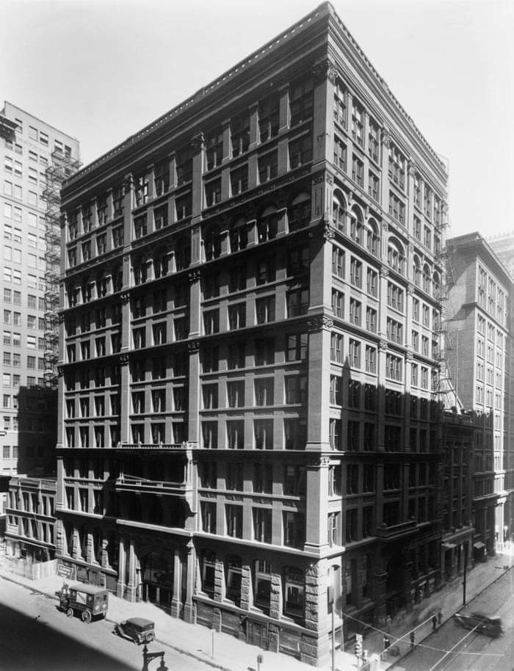
Chicago is also considered home to the very first skyscraper. (picture) The Home Insurance Building was built in 1884 and stood a whopping 10 stories high. OK, not tall by modern standards, but in its day it was a breakthrough!

But as significant as those breakthroughs may be, let’s not forget another Chicago breakthrough that is near and dear to everyone’s heart. I am speaking of what? Yes, the hot dog! (picture). Chicago-style dogs are some of the most well known delicacies anywhere. The iconic Chicago dog comes loaded with fresh tomatoes, a pickle spear, hot peppers, sweet onion, relish, and of course mustard, but absolutely no… (wait for it) that’s right no ketchup.

Who loves it when something new happens or someone invents something that has not yet been discovered? Yes, we love breakthroughs… especially Chicago breakthroughs!

Imagining Breakthrough
(Series Graphic) But I want to tell you about something way more significant than Ferris wheels, skyscrapers, and hot dogs. You ready? I am convinced that God, through his Holy Spirit, wants each of us to experience a breakthrough.

I believe God wants us to experience breakthroughs when it comes to our closest relationships. It might be with your husband or wife or with your parents or children. Or maybe you need a breakthrough with a close friend.

I believe God wants us to experience personal breakthroughs. Maybe there is a habit that you just can’t break or an addiction that has weighed you down for years. Or maybe it’s something physical, and more than anything you want healing. Or perhaps its spiritual and there is a closeness and confidence in your relationship with Jesus that seems to have eluded you?

Or maybe you long for breakthrough in your neighborhood, or in our city, or in our world where every injustice is made right and every person finds their way back to God. I believe that’s the kind of breakthrough God wants!

We all long for breakthrough!

And here is some good news - We believe that God, through the Holy Spirit, wants to breakthrough in all of these places. We believe he wants to see lives transformed, physical healings take place, and for relationships of all kinds to be restored.

In fact, we sense we are entering a new season together as a church. We believe God has been preparing us for this season for a while now. We’ve sensed the movement of his Spirit in our staff, in our prayer teams, and in our church as a whole. We believe God is wanting to do a new thing in us and through us, and we’re calling it breakthrough.

So we’re launching this new season with this series called “Breakthrough,” but we believe what God wants to do in Community is much bigger than a 6-week series. You might think of it this way: Baseball is one of the longest seasons in sports: 162 games that span from April to October, although only through September for Chicago teams. But that 162 game season is made up of many 2, 3, and 4 game series that teams play against each other. Those series make up the season. So, today we begin a new series that will last for six weeks, but we believe we are in the beginning of a longer season where God wants to break through in some new and amazing ways at Community.

During this series we are also launching a new 3-year initiative called “Breakthrough” that will be important to this season. We’ll have a special Commitment Sunday on November 17 when we’ll ask everyone who calls Community their church home to bring a special gift and a commitment of what they’re willing to give above and beyond their normal contribution to the church over the next 3 years. But again, we believe that what God wants to do in and through Community is much bigger than a 3-year initiative.

We believe during this season, God wants to breakthrough into our lives, transforming us in ways we’ve never experienced before.

So as we open ourselves up to the Holy Spirit, we decided the best place to start would be to dig into the book of Acts to better understand how the Holy Spirit broke through into the lives of the first Christ-followers. We want to learn from them about how God wants to breakthrough in our lives today.

(Turn the Page graphic) In fact, we believe there is so much for us to learn in this book that we have created a Monday thru Friday “Turn the Page Bible Experience” that includes daily readings and podcasts from Acts. You can find that through our app or our website, but I’ll tell you more about that later.

Jesus’ Ascension
For now, as we begin in Acts chapter 1, I want you to try to imagine what it would have been like to be one of Jesus’ first followers as Luke, the author of the book, tells the story. At this point, there are only 120 Christ-followers on the planet. You’ve just been through the most frenetic season of your life!

- Jesus, the one you’ve spent every waking moment with for the past three years, was arrested, beaten, and crucified.
- Then, to your utter amazement, three days later he rose from the dead!
- You still have a hard time wrapping your mind around it, but for the last 40 days he has been with you, eating with you, continuing to teach you, offering constant proof that he is alive!

Now, on this day, you gather around him wondering what will happen next with no clue that his next sentence will be the last one you hear from his lips. Jesus says:

“But you will receive power when the Holy Spirit comes on you; and you will be my witnesses in Jerusalem, and in all Judea and Samaria, and to the ends of the earth.” -Acts 1:8

In effect, Jesus tells you that you are going to be empowered by the Holy Spirit to change the world! You are still trying to grasp the meaning of this when right before your eyes, (Acts 1:9) Jesus suddenly and mysteriously disappears. Your head is spinning, yet somehow in your gut you know you’ve reached another key moment in this crazy story you’ve been living. Somehow you know this is not the end, in many ways, the story is just beginning.

What do you do in this moment? If you are one of few people left standing on the hillside looking up into the sky, what’s your next move?

- Would you be amped to get started on the mission?
- Would you be overwhelmed by what Jesus just said?
- Would you be freaked out over what you just saw?

I love how Luke records what happens. He says that while Jesus’ followers were standing there looking up into the sky, two angels appeared next to them and said:

“Men of Galilee, why do you stand here looking into the sky?” –Acts 1:11

I’d be like… What do you mean why am I looking up into the sky?! Did you see what just happened?! But then I’d realize that I was talking to two angels and probably start freaking out all over again!

So what did these first followers of Jesus do? Well, Luke tells us:

“Then the apostles returned to Jerusalem from the hill called the Mount of Olives, a Sabbath day’s walk from the city. When they arrived, they went upstairs to the room where they were staying… They all joined together constantly in prayer...” –Acts 1:12-14

“They all joined together constantly in prayer.” They waited and they prayed.

And I think that is important for us. A lot of us want breakthroughs. Breakthroughs in…

- Our lives.
- Our families and relationships.
- Our neighborhoods and cities.
- And in our church.

We want to see God break through with healing and wholeness and provision and renewal. And yet, how many of us are willing to wait and pray?

Word: A Pattern (Acts 1-4)
As we start this journey through Acts together, I want you to notice a pattern that emerges here in the first few chapters.

These first followers of Jesus joined together constantly in prayer, and what happens? As we turn the page to Acts chapter 2, the Holy Spirit breaks through!

“When the day of Pentecost came, they were all together in one place. Suddenly a sound like the blowing of a violent wind came from heaven and filled the whole house where they were sitting. They saw what seemed to be tongues of fire that separated and came to rest on each of them. All of them were filled with the Holy Spirit and began to speak in other tongues as the Spirit enabled them.” –Acts 2:1-4

The Holy Spirit, the one Jesus promised would come, breaks into the room in a supernatural way. The Spirit comes to rest, meaning he indwells, every person in the room and what happens? They begin to have abilities they didn’t have before! They start speaking in other languages!

(Acts 2:5-6) The commotion of this scene begins to draw a crowd as a diverse group of people hear the disciples speaking in their own native tongues. People can’t figure out what is going on. Some think it’s a giant frat party and accuse the disciples of being drunk. Can you imagine? (Acts 2:15) Peter has to get up and say, “Come on, it’s only 9 in the morning!” I wonder if they made Peter walk the centerline or take some kind of Breathalyzer test.

But once he has the crowd’s full attention, Peter has the opportunity to share the good news of Jesus. And the result? (Acts 2:41) 3000 people find their way back to God on this one day!

(Slow) The people pray and God breaks through!

As these new followers of Jesus become part of the community, (Acts 2:42) they devote themselves to the practices of the community. They meet together regularly for teaching, fellowship, the Lord’s Supper, and for prayer. Now, most English Bibles translate that last word “prayer” but in the original language it is plural, it actually says “to the prayers.” These first Christ-followers were devoted to regular times of prayer throughout the day. As we turn the page to Acts chapter 3, (Acts 3:1) Peter and John are on their way to the temple to participate in one of these regular times of prayer.

As they arrive at the temple, they encounter a man who had been lame from birth. The man asks them for money, but Peter has something far better to offer. He looks the man in the eye and empowered by the Holy Spirit declares:

“In the name of Jesus Christ of Nazareth, walk.” –Acts 3:6b

And the man leaps to his feet, miraculously healed! (Acts 3:8) This man who had never taken a step in his entire life is now jumping and praising God! Are you starting to see the pattern?

(Slow) The people pray and God breaks through!

Let’s look at one more. (Acts 4:1-3) Turning the page to Acts 4, the Jewish leaders are disturbed by what is happening. They thought they had gotten rid of Jesus, but now this man is miraculous healed and Jesus is getting the credit for it. They drag Peter and John to meet before their council and command them to stop teaching in the name of Jesus. But Peter and John refuse. The Jewish leaders can’t figure out how to punish them because they knew everyone was praising God for the miraculous healing, so they breathe out some vicious threats and then let Peter and John go. When the two men rejoin the other Christ-followers guess what they all do?

“When they heard this, they raised their voices together in prayer to God.” –Acts 4:24

Yep, they pray! They pray for boldness to continue to share the good news of Jesus despite the threats, and they pray for God to continue to break through in miraculous ways. The people pray and…

“After they prayed, the place where they were meeting was shaken. And they were all filled with the Holy Spirit and spoke the word of God boldly.” –Acts 4:31

Not only that, (Acts 4:32-35) Luke goes on to describe a supernatural movement of generosity that moves through the community. People willingly give of their resources to meet the needs of others and further the mission.

(Slow) The people pray and God breaks through!

Friends, as we enter into this new season as a church, we fervently believe that God wants to break through into our lives, our relationships, our neighborhoods and cities, our church, even the whole world.

We long to see…

- Addictions broken
- Marriages restored
- Sicknesses healed

We dream of the day…

- Divisions fall
- Poverty ends
- Justice wins

We will be relentless about moving the mission forward until every person finds his or her way back to God.

But as we start this new season, we have to understand: Breakthrough begins with the partnership between a praying people and a powerful Holy Spirit.

When people pray, God breaks through.

Say that after me… When people pray (When people pray), God breaks through (God breaks through).

Challenge: A Breakthrough in Prayer
So as we begin this next season as a church community, we are asking God for breakthroughs starting with a Breakthrough in Prayer. Understand, we don’t have all of this figured out. We aren’t quite sure how God will break through. But we do know this: When people pray, God breaks through. And so we are asking God to transform us into a praying people…into a praying church.

My guess is some of us aren’t even sure how to pray. That’s OK. I feel like I can confidently say that those first followers of Jesus didn’t have a clue what they were doing either. We have an advantage over them because we can learn from them. We can follow their example.

So in this new season, I want to leave you with two practical invitations to get started:

(Prayer Gathering graphic) First, this week we are going to gather together for prayer, much like those first Christ-followers did. If you are connected in a Small Group, your time together this week will be a prayer gathering. Don’t miss it! At this prayer gathering, you’ll have the opportunity to learn more about the 3-year Breakthrough Initiative we’re launching, and you’ll spend time with your group praying for breakthrough.

For those of you not yet in a Small Group, we want you to invite you to join us for a prayer gathering here at our Lincoln Square location. We will be gathering right here in this space on ____________.

And for any of you who want to join us, our staff and our Prayer Teams will be fasting on Wednesday, October 30 as we join together asking God for breakthrough. Anyone who wants to join us in that fast is welcome to participate!

When people pray, God breaks through. So everyone is invited to be a part of a prayer gathering this week.

(Turn the Page: Acts graphic) And I have a second invitation for you that I mentioned earlier. During this series, we want to invite you to join us for a Turn the Page Bible Experience through the book of Acts. I know many of you loved this when we did last year as an overview of the whole Bible. Over the next 6 weeks, Monday through Friday you have the opportunity to engage in a similar experience as we go through the book of Acts together.

There is both a podcast version and an email version. You can find both on our app or our communitychristian.org website. In fact, I’d encourage you to get on our app right now to sign up so you don’t miss out on Day 1 tomorrow! And you can also join a Lincoln Square Facebook group we’ve set up so we can connect with each other as we go through this experience.

Conclusion & Prayer Time
When people pray, God breaks through. So it only makes sense that each week of this series we join together in prayer. So here’s what we’re going to do: To close, I am going to lead us in a time of prayer. I’m going to prompt us in several things to pray for right here, right now. For some of us, this will be new, but I want to challenge you to engage because when people pray, God breaks through.

So if you would bow your heads right where you are, let’s pray together.

First, I want you to think about the breakthrough or breakthroughs you are longing for… something personal maybe in a relationship or in your health or in your career. Take a moment and silently talk to God about it. Ask him for a breakthrough. (Pause for 30 seconds)

Next, let’s ask for a breakthrough for someone you’d love to see find their way back to God. I know this will stretch many of us, but take a moment to pray out loud with one or two people sitting near you. Just pray this simple sentence, “God, I ask you for a breakthrough in blank’s life.” Just pray that one sentence putting the name of the person in that blank. “God, I ask you for a breakthrough in blank’s life. (pause for 30 seconds)

As we close, let’s join together as one community of Christ-followers, and ask God for breakthrough in our church by praying this prayer on the screen together:

“Father, we want to be a praying people. Please transform us into a praying church. Draw us closer to you and to each other during this season of Breakthrough. Give us an openness to your Holy Spirit. We pray all of this in the name of Jesus and in the power of the Holy Spirit. Amen.”

Communion Idea

“They devoted themselves to the apostles’ teaching and to fellowship, to the breaking of bread and to prayer.” –Acts 2:42

I am so grateful to be part of this community with all of you. I really do believe God is leading us into a series of breakthrough as we join together just like the first Christ-followers.

In this moment we get to imitate another of their practices, the breaking of bread or what we call Communion or the Lord’s Supper. It’s in this moment that they (and we) took time to remember Jesus’ life, death, burial, and resurrection. It’s in this moment that we remember his sacrifice that makes it possible for all of us to find our way back to God.

The bread that represents his broken body.
The cup that represents his shed blood.

Let’s receive it together.

