Breakthrough - Week 4 - Plants

Message Big Idea: The Spirit brings breakthrough by planting new churches.
Scripture: Acts 11:19-30, Acts 13:1-5, Acts 13-14 Paul’s First Missionary Journey, Acts 14:21-28
_________________

Introduction and Series Recap
(Following Breakthrough Video) (Series Graphic) Good Morning! I love those stories of life-change! We have so much good stuff to share with you today. I am going to jump right in to get us all up to speed in case some of you have missed any of the previous three weeks.

As a church we believe we are entering a season of BREAKTHROUGH. We believe God wants to break through into our lives, transforming us in ways we’ve never experienced before. We are asking God for breakthroughs in…

- Our relationships.
- Our finances.
- Our health.
- Our families.
- Our faith.

And not only do we believe God wants to break through in our own lives, we believe he wants to use us to help break through in the lives of others. Understand, breakthrough is something God can certainly do on his own! But because we have a relational God, he invites us to join him in the work he is doing.

During this series, we’ve been walking through the book of Acts which is a history of the very first Christ-followers. And we’ve seen this pattern over and over in the life of the early church:

When people pray, God breaks through. (Repeat)

- Our part is prayer
- God’s part is the breakthrough

When people pray, God breaks through so this entire season of breakthrough must begin with prayer and be sustained with prayer.

As we enter this season of breakthrough, we are also beginning with a 3-year initiative called (Graphic) “Breakthrough.” Through this Breakthrough initiative, we plan to invest in several groups of PEOPLE.

- This includes investing in the next wave of (Use slides from previous weeks) Leadership Residents through our Lead Lab.
- We are investing in our songwriters and musicians who are a part of Community Music. We want to empower our artists to write more new songs like “Make Room” and “When Heaven Breaks Through” that are creating an even more engaging worship culture here at Community.
- And we are investing in our Students. We have experienced firsthand the impact students can have on our church, and we want to ensure that every location moves closer to developing a strong Student Community where more and more middle and high school students can find their way back to God. In fact, I wanted to show you a short clip from the BLAST LAUNCH event we held a couple weeks ago - it is so encouraging to hear our students praying for breakthrough:

Video: Students and Breakthrough

Breakthrough happens in People. But Breakthrough also happens in PLACES. Through this Breakthrough initiative we will invest in every single Community location to further the mission in our local communities.

- One great example is our Downers Grove location. It is busting at the seams -- and fortunately God gave us the opportunity to acquire a church building right off Main Street, across from Good Samaritan Hospital in Downers. It is an outstanding location, but it needs renovation and remodeling. Breakthrough will help us do that.
- (Second example can be specific to each location) Here in Lincoln Park, we need a 24/7 weekday presence for our location. We know a visible presence in our key community would have a ripple all over the city. If we’re going to continue to impact the city of Chicago, this is a great place to start!

And yet there is more! The first 10% of BREAKTHROUGH will go to Celebration Generosity, making it the largest gift ever to our four teams.

Today we’re going to learn about the last part of the initiative… which is PLANTS. Now when I say “plants” I’m not talking about shrubs or ferns. Around Community when we talk about “plants” we mean new church plants.

Why Church Planting?
To understand why planting churches is so important, let’s go back to the very beginning of the book of Acts. Just before Jesus returned to his Father in heaven, the Christ-followers were in one place, Jerusalem, reaching one people, the Jewish people.

(Acts 1:8) Jesus commissioned his followers to take his message to Jerusalem, but then to spread out to Judea and Samaria, and eventually to the ends of the earth. The mission was to take the good news of Jesus to all places reaching all people. And God had a plan for how he would accomplish this. What was that plan? Church planting!

The Church at Antioch
In fact, God uses adverse circumstances to set his mission in motion. Fleeing persecution in Jerusalem, these first Christ-followers scatter across the region taking the good news of Jesus to new places. Luke, the writer of Acts describes it this way:

“Meanwhile, the believers who had been scattered during the persecution after Stephen’s death traveled as far as Phoenicia, Cyprus, and Antioch of Syria… some of the believers who went to Antioch from Cyprus and Cyrene began preaching to the Gentiles about the Lord Jesus. The power of the Lord was with them, and a large number of these Gentiles believed and turned to the Lord.” -Acts 11:19-21

The second half of the book of Acts turns its attention to how the good news of Jesus reaches those who were not Jewish, who were called “Gentiles.” And at the center of everything that happens from here on out is a new church that is planted in the city of Antioch.

The city of Antioch was significant in a number of ways. Josephus, a first century historian, notes that the it was the third most important city after Rome and Alexandria. Antioch was large, wealthy, and diverse; and God would use the church that was planted there to impact the rest of the world!

What made this church in Antioch a special type of church? Theologian Jack Levison points out a few key qualities of this church:

- First, the church at Antioch was A listening and learning community. (with Acts 11:26 starting at “So for a whole year…”) When Paul is brought to Antioch, he took a whole year to teach people about the good news of Jesus and about the mission Jesus had entrusted to them. The people were hungry to learn!

- The church at Antioch was A generous community. (with Acts 11:29-30) As they

- learned about another community of Christ followers struggling through a famine, they raised funds to provide relief for them. They were a church that learned to give generously above and beyond to further the mission.

- The church at Antioch was A multicultural community. (with Acts 13:1) Remember that the city of Antioch was large and diverse, and the church reflected its community. The people mentioned in the first verse of chapter 13 represent diverse cultures.

Now, at this point you might be thinking, wow this church was perfect! But it wasn’t. Like all churches, it had its fair share of challenges. In fact, because of its diversity, the church had some heated debates. But they stuck together because they knew their cultural differences were never as important as the mission of helping people find their way back to God. They knew the mission is what mattered most.

- Finally, the church at Antioch was A praying and fasting community. (Acts 13:2-3) They knew that the only way they were going to experience breakthrough was through these practices. So they put a high priority on prayer and fasting as they looked to God for guidance.

These key qualities of the church at Antioch tell us what was true about the “internal” work of the Holy Spirit in their lives; but the “external” result was that they not only grew in numbers, they became a multiplying church that started a whole movement of church planting.

Guided by God’s Spirit, they sent Paul and Barnabas to take the good news of Jesus to the ends of the earth! Paul ends up taking three missionary journeys, planting churches in every city he visits. And each and every one of those missionary trips starts from this church plant in Antioch. Antioch is a sending church!

Community: A Sending Church
And like the church in Antioch, here at COMMUNITY, we have always believed that God has called us to be a sending church. From the very beginning we had a three-fold vision: (Heading: Community’s Vision)

- To be an (add) Impact Church – A church that is reaching people who are far from God and making a difference in the local community. The kind of church, where if we suddenly disappeared, the neighborhood would miss us. Prayerfully, over the past 30 years, that’s who we’ve been.

- We also wanted to be a (add) Reproducing Church – And we thought that would happen as we planted new churches – and it did. But over the past 20 years it also came to mean that we would be one church in many locations in Chicagoland.

- And finally, our vision was that if God would so bless us, we would catalyze a (add) Movement of Multiplying Churches all over the world. And we are beginning to see the third part of this vision come to life! Through NewThing, we have been able to help plant over 1,500 churches worldwide!

Just as the church at Antioch was a sending church, we believe God has called us to be a sending church. That is what the PLANTS part of the Breakthrough Initiative is all about.

Over these next few years, we plan to invest in (with pictures) Chicago Church Plants, especially plants in under-resourced neighborhoods. Years ago, a friend of ours introduced us to an African Proverb:

"If you want to go fast, go alone. If you want to go far, go together." -African Proverb

We started NewThing to form partnerships that would help us go far together in planting churches around the world, but also right here in Chicago. We’re joining together with 30 other Chicago-area churches with a plan to start 50 new churches in Chicagoland over the next 3 years.
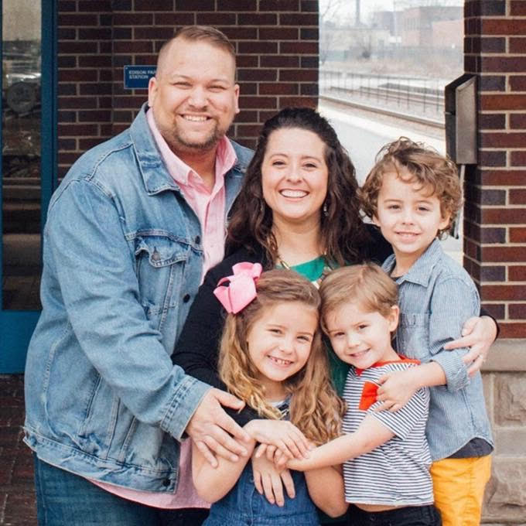
In fact, you may not know this, but as we speak we are helping to plant a new church in the Edison Park community of Chicago. (Bob Hedge and family) We are partnering with Park Community Church, Sow Church Chicago, and Kingdom Covenant Church to send out Bob Hedge and his family to start this new church on the far Northwest side. I love that! And we want to do it more and more and more!

The plants part of the Breakthrough Initiative also includes (with pictures) Community Freedom. Specifically, we are excited that this month we’ll be launching two new locations in the Joliet Treatment Center and the Aurora Transitional Center! The Breakthrough Initiative will help us get these new locations off and running to help people at these facilities find their way back to God.

Challenge: My Role in Church Planting
So you might be thinking – Wow, I had no idea we were doing all this stuff! But here’s the reality… it doesn’t happen without you. It doesn’t happen without me. Church planting does not happen unless people like you and me get involved!

I think it is easy to see church planting as something that others do. You know, leave that to the professionals. We applaud their efforts and think it is great for them, and great for our church, but not many of us think we have a role to play in church planting.

(TP – Tell your own story of why you are personally passionate about church planting.) I (Rodrigo) grew up in Mexico in a relatively poor church. But the pastor had a passion for even poorer neighborhoods. Every Saturday morning, we would go to these poor neighborhoods to bring breakfast to the children in these neighborhoods. We would serve hundreds of kids each Saturday in abandoned lots.

From there, there would grow a large enough group who wanted to meet and learn more about Jesus. So my pastor would encourage a family and say: “You are going to be the pastor of this church.” And they did it! It was amazing! He started 15 churches that way in just 20 years. I was just a teenager and I had no concept of church planting, but it had a profound impact on me. And in part it is why I am so passionate about church planting and why I gave my life to helping as many people as possible to find their way back to God.

We all have a part to play in church planting. I have a part, you have part, we have a part together. And to understand our role, I think we can look back at the example set by the church in Antioch. If we really want to see a breakthrough in church plants, we must become…

A listening and learning community. We can study Scripture together, like the book of Acts, to learn about how God used the first Christ-followers to plant churches. In fact, if you have not yet joined us for the Monday through Friday “Turn the Page Bible Experience” through Acts, jump in this week!

We can also learn more about church planting in our city and how we can support it. That’s what we’re doing today! Did you know that if every seat in every service in every church in Chicago was full, we still wouldn’t come close to having enough room for everyone in our city! We need more churches to reach more people! New churches see 4 to 5 times as many people finding their way back to God as compared to churches 10 years or older. The need and opportunity are tremendous!

Let’s not think of church planting as someone else’s responsibility, let’s listen and learn so that we can get involved.

Second, if we want to see a breakthrough in church planting like the church at Antioch, we need to be A generous community. Remember, you don’t have to be wealthy to be generous. Each of us just needs to be willing to do our part. The Christ-followers in Antioch banded together to meet a need and move the mission forward. Through the Breakthrough Initiative, we have the opportunity to do the same! (Hold envelope) That’s why I want to challenge every person who calls COMMUNITY their church to bring this envelope forward next week with 1) a special gift 2) and a commitment of what you are willing to give above and beyond your normal contribution to the church over the next 3 years. Or you can make your commitment on-line. That is the opportunity that is before us, every generous gift helps people find their way back to God.

But if we want to see a breakthrough in church planting, (A multicultural community.) we also have to become a church that includes others who are different than ourselves. Look around at the faces in this room. Do we reflect the demographics of our community or are there people missing? Think about your small group and the people you hang out with. Do most of them look like you and have experiences similar to yours? Who are we overlooking or leaving out? Everyone has a role to play in what God is doing here at Community! Let’s invite everyone to be a part of our church!

Finally, if we want to see a breakthrough in church planting we have to become A praying and fasting community. The church at Antioch prayed and fasted and then sent out Paul and Barnabas to plant churches. (Luke 10:2) Jesus urged us to pray for workers to be sent to reach people who are far from God. “The harvest is plentiful, but the workers are few,” he said. He told us to PRAY asking the “Lord of the harvest to send out workers.”

Let’s pray for the church planters in our city, and pray that God would raise up more men and women who will plant churches in every neighborhood until all people have the opportunity to find their way back to God!

Conclusion & Prayer Time
Friends, if you are a follower of Jesus, a church planter has directly impacted your spiritual journey.

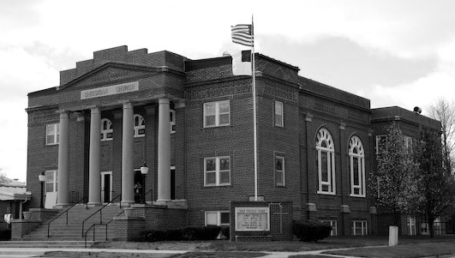
In the first century, a church was established at Antioch. The people in that church were passionate about the mission of Jesus so they sent people out to Turkey and Africa and Europe to start new churches in every city. Eventually, people from Europe came to the American colonies where more new churches were planted.

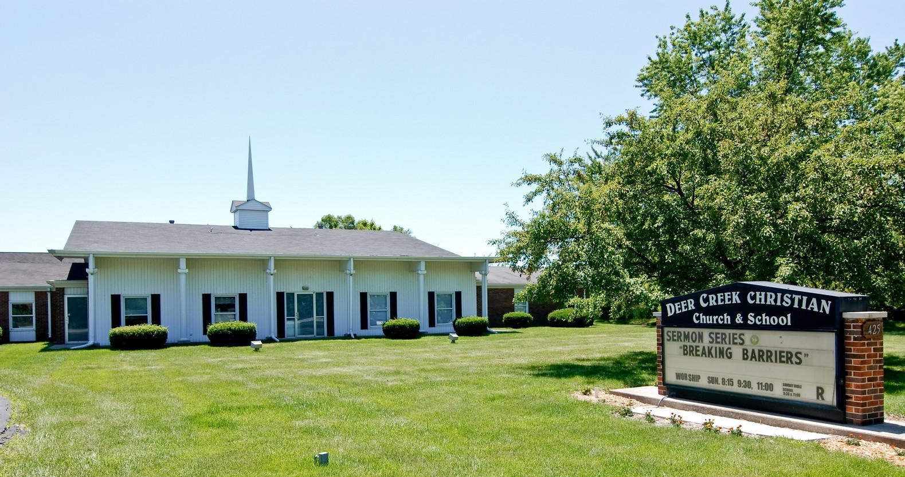
On April 26, 1879, a group of people started what would become (picture) First Christian Church in Vandalia, Missouri.

Years later, some members of that church invited a 10-year-old boy to attend. He found his way back to God and grew up and became a pastor who planted (picture) Deer Creek Christian Church in the south suburbs of Chicago.
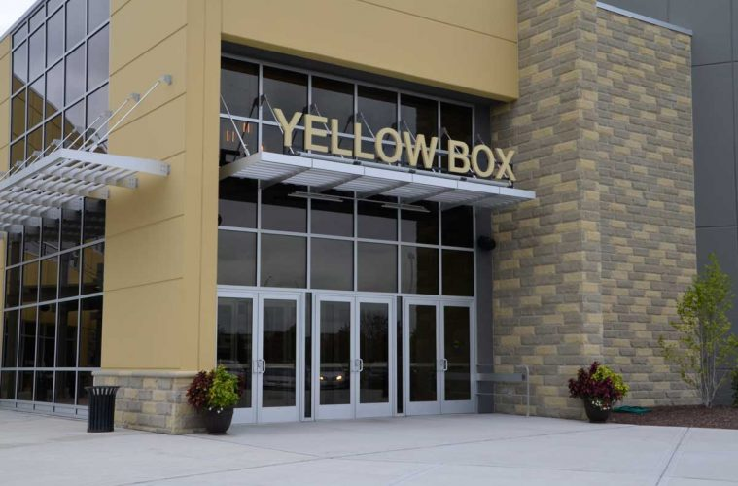
That man had two sons who also went on to plant a church. It’s a church called Community Christian Church in Naperville (picture) that went on to plant 9 more locations...including (location picture) the church you are attending right now!

We are here together today because people who came before us prayed that God would break through and help people in this community find their way back to God.

Together, you and I can play a role in planting someone else’s home church. So as we’ve done every week of this series, let me close by leading us in a time of prayer. When people pray, God breaks through, so would you bow your heads as I prompt you in a time of prayer.

First, I want to ask you to silently pray, right where you are, for God to show you the part he wants you to play in Breakthrough. How is God prompting you to help move the mission forward? (pause for 30 seconds)

Next, let’s join Jesus in his prayer for more workers for the harvest. Pray that God would raise up church planters, even from our own location here in ____ who will carry the good news of Jesus forward. (pause for 30 seconds)

As we close, let’s join together as one community of Christ-followers, and ask God for a breakthrough by praying this prayer on the screen together:

“Father, we ask you for breakthrough. May we be a community that is relentless about moving your mission forward. Use us to plant new churches in more places so that more people can find their way back to you. We pray all of this in the name of Jesus and in the power of the Holy Spirit. Amen.”

Communion Idea
The church is the instrument God uses to reach communities, restore relationships and reproduce apprentices to further the Jesus mission. The early church recognized that they needed the power of God’s Spirit in order to fulfill this mission. As a result Luke tells in Acts 16:5 that:

“…the churches were strengthened in their faith and grew larger every day.” -Acts 16:5

Here’s the beauty of this, God already gave us everything that we need in order to fulfill his mission. He gave us Jesus. In Jesus we have the certainty of breakthrough. And as we take communion we not only remember what Jesus did for his church, but we also remember that he is the one sustaining us today. We also proclaim his death and resurrection until the day he comes back. The bread represents his body given for us and the juice represents his blood shed for us.

