Make Room – Week 3 – Prayer

Message Big Idea: Prayer is communicating with God about ourselves and others.
Scripture: Luke 11:1, Luke 11:3, Ephesians 6:18, Luke 18:1-8
NOTE: Includes humorous moment involving raffle tickets. If you include this, you’ll need to have ushers hand out the tickets as people come in and allow an extra minute for the message.
_____________________

Introduction: Hail Mary Play
We are in the thick of the NFL playoffs, and this week I was reminded of how different last year was for us Bears fans. We actually had a chance to go to the Super Bowl this time last year! And in the midst of my reminiscing about better times, I was reminded of a game between the Bears and the Patriots last year that came down to the last play. Do you remember it?

The Bears were down 38-31with just a few seconds left. Mitch Trubisky steps back, he’s under pressure, and he heaves the ball with everything he’s got toward the goal line. A pack of Bears and Patriots players leap for the ball, and, well, this is what happens.

Video: Hail Mary https://www.youtube.com/watch?v=ZcGq8hiTzi0

#11 Kevin White miraculously catches the ball…but he was one yard short of a touch down and the Bears remain one touchdown short of a victory.

You know what they call these last-second plays, don’t you? That’s right “The Hail Mary Pass.” The phrase actually comes from the Catholic prayer that begins: “Hail Mary, full of grace . . .”

But I wonder… Why is that the only play in football named after a prayer?

- There are no “hail Mary kick-off returns” to start games.
- There are no “hail Mary” draw plays in the second quarter.

Why is that? Well, because you only run the “hail Mary” play if you have no other option. It’s your last hope. You only run that play if you are absolutely desperate.

And while most of us have never thrown a “hail Mary” pass, my hunch is that we’ve all tossed up a few “hail Mary” prayers at one time or another.

- When I see the red and blue lights in my rear-view mirror – that is time for a “hail Mary” prayer!
- Or when you are about to take a final exam and you know you haven’t studied nearly enough.
- And of course there are those moments when the situation truly is dire. (Pause) A loved one is sick, your finances are a wreck, a relationship seems doomed. And in desperation, you pray.

Desperate people pray. However, when life is good and we seem to be winning, what then? In those times, why do so many of us tend to neglect prayer?

Series Recap
We’re in the third week of our series “Make Room.” As we begin this New Year, we want to experience breakthrough, and we know the way that can happen is when we make room for God, through the Holy Spirit, to break through into our lives. Jesus taught his apprentices to engage in practices, like prayer, that make room for breakthrough. And yet, so many of us, myself included, struggle to have any sort of consistency in our prayer lives.

This week I came across this quote from author Richard Foster and it hit me square between the eyes:

“All who have walked with God have viewed prayer as the main business of their lives.” -Richard Foster

I have to confess, I’m not sure I’ve viewed prayer that way, and yet I see it reflected that way in the life of Jesus.

(Mark 1:35) Prayer is a practice Jesus modeled consistently, and you could argue that if anyone didn’t need to pray it was Jesus. I’ve often wondered how he started his prayers… “Dear…Me?”

Not only did Jesus pray himself, (Luke 11:1) he taught his followers to pray. One of the most well-known scriptures ever recorded is the “Our Father,” the “Lord’s Prayer,” where Jesus taught his disciples to pray.

Yet so many of us struggle to make room for a consistent, life-giving prayer life.

So I thought it would be good for us to pray today so here’s what I did. When you came in today, you were given one of these raffle tickets. (Hold ticket up) Go ahead and pull this out. I hold in my hand, the winning ticket! I’m going to call out the numbers, and whoever is the winner gets to come up here and lead us in prayer! Ready? (Start reading numbers then stop) Oh, stop panicking. I’m just kidding.

I just put you through that to illustrate that if prayer is one of the most significant ways we experience spiritual breakthrough, we should be jumping at the chance to pray! Yet so many of us find it difficult.

Why We Don’t Pray
TP should get personal in one of these that he/she struggles with.
(Heading: Why We Don’t Pray) Why is it that so many of us find it so challenging to make room for something that is supposed to be so central to what it means to follow Jesus?

I’ve talked to many people over the years who say, (add) “I really don’t know how to pray.” For some, prayer was something we memorized and recited before dinner or bedtime. Some of us feel like we never really got beyond “God is great. God is good.” or “Rub a dub dub, thanks for the grub. Yea God!”

I think others of us would simply say, (add) “I don’t have time.” I am on the go from the moment my smart phone wakes me up till the time I lay my head on my pillow once again. Prayer just isn’t something I’ve been able to work into my crazy schedule.

Or maybe you’re here today and when it comes to prayer you would say, “I’ve tried it. And while this may not sound very unspiritual, (add) “I just don’t enjoy it.” Maybe when you try to make room for prayer, you find yourself fighting one distraction over another and it just leaves you frustrated.

Or finally, I think some of us might honestly say, (add) “I don’t think prayer works.” And if you and I had the chance to sit down over a meal or a cup of coffee, you might tell me how you’ve prayed and prayed for God to come through for you or someone you love, and it just seems like nothing ever happens.

- Maybe you’ve prayed for physical healing, and the pain remains.
- It might be that you have prayed for a friend or family member to find their way back to God, and he or she still seems uninterested in spiritual matters.
- Maybe for years you’ve asked God to restore a relationship that is strained, and if anything, it seems to be getting worse.

And so you would say, “I’m just not sure prayer really works.”

Why We Do Pray
Maybe some of these reasons why we don’t pray have silenced our prayers, but I’m convinced that the reasons to pray are much more compelling than the reasons not to. Let’s talk about those.

First: Prayer is Powerful.

There’s an incredible scene in the book of Revelation that gives us a glimpse of just how powerful prayer really is. John, the author of Revelation, received a vision of heaven, and in the eighth chapter he says that there was silence in heaven for half an hour when this occurred: (add)

“Another angel, who had a golden censer, came and stood at the altar. He was given much incense to offer, with the prayers of all God’s people, on the golden altar in front of the throne. The smoke of the incense, together with the prayers of God’s people, went up before God from the angel’s hand.” –Revelation 8:3-4

The verses that follow describe a vision of fire, lightning, thunder, and earthquakes. What is so shocking about the scene is that these things happen in response to the prayers of people. You could say that their prayers literally interrupted heaven as they rose like the smoke of incense before God himself. It seems amazing enough that our voices in prayer would be heard at all in heaven, but to think that God pauses and moves in response to them is even more incredible! God notices. God hears. And God responds. We pray because prayer is powerful.

Here’s another reason we pray: Prayer is Practical

I (Jason) was in the car with my eight-year-old daughter a few weeks ago when she dropped this question on me: “Daddy, God creates our future, right?” “Of course!” I replied, thinking this was going to be an easy one, but she wasn’t done. “Well…ok…do we help? Do we help God create our future?” We do help create that future, and prayer is a massive part of how that happens. Prayer is practical. It’s how we fight and persist. In so many ways, it’s how we see change sparked in us and around us. Jesus tells a beautiful story about this very thing in Luke 18, and the purpose of this story is told right up front. (add)

“Then Jesus told his disciples a parable to show them that they should always pray and not give up.” -Luke 18:1

He goes on to tell of a widow who kept going to a judge again and again seeking justice against her adversary. For quite some time, the judge ignored her. He refused to listen. Though completely powerless to push through any results, the widow persisted. Again and again she came to the him until the judge said to himself: (switch)

“Even though I don’t fear God or care what people think, yet because this widow keeps bothering me, I will see that she gets justice, so that she won’t eventually come and attack me!” –Luke 18:4-5

At this point in the story, Jesus makes a compelling comparison. He says: (switch)

“Listen to what the unjust judge says. And will not God bring about justice for his chosen ones, who cry out to him day and night? Will he keep putting them off? I tell you, he will see that they get justice, and quickly.” –Luke 18:6-8a

What Jesus is saying is if the judge, who doesn’t care about people, does what the widow asks out of her sheer persistence, how much more will God our Father, who does care about us, listen and move with the prayers of his children?

God works in response to our prayers. Prayer is among the most supernaturally practical things we could ever do. Research even shows that it changes the way our brains work. Our brain’s ability to focus beyond ourselves is literally enhanced through prayer. Prayer is practical.

Here’s one more reason we pray: Prayer is Pleasing

Have you ever wondered if your prayers bothered God? Does he ever get sick of hearing you? Sometimes we’ve got this picture of God like he’s a grumpy dad reading the newspaper. “Don’t bother me kid!” Our prayers might start out as some timid version of, “Excuse me, sir, pardon the interruption.”

But here’s a beautiful truth. Just like the scene we got a glimpse of in Revelation, where the prayers of the people interrupted heaven, God doesn’t just tolerate the interruption, He INVITES it! He delights in our prayers. Prayer is pleasing to him. He’s not the judge who doesn’t care and is worn out by nagging. No…He’s the Father who can’t wait to have the attention of his children. He wants to hear from us. Our voice echoing in his ears isn’t racket to him…it’s music.

Dallas Willard describes prayer in a disarmingly simple way:

“Prayer is talking to God about what we are doing together.” -Dallas Willard

Have you ever realized that’s what God wants most? Just to do life with you? He loves when we walk through our days talking with him.

Prayer is powerful. Prayer is practical. Prayer is pleasing.

So in this season of breakthrough, let’s challenge one another to move beyond the reasons we don’t pray, and make room in our lives for prayer.

Ideas to Grow in Prayer
And I know most of us could use some help in this area of our spiritual growth so I’d love to offer you a simple model and a few resources. (Hold up handout) If you want to follow along, take out the handout you received when you come in. No matter where you are in your prayer life, you’ll find something useful here. So first the model:

We call this the A.C.T.S. prayer model. Let me take you through it. (add each letter below to the slide)

A – Adoration
Sometimes the hardest thing about praying is getting started. So start by praising him. It’s so important to realize who we’re talking to, and there’s no better way to do that than to lift him up high. You can name his attributes: “God you are awesome, faithful, powerful, gracious, and loving.” Or pray the words of a Psalm. Just start off praising him and you’ll find the conversation gets going. Next…

C – Confession
Come clean about the things that have pulled you away from God. If there are sins weighing on you, confess them before God and accept the freedom of his forgiveness. Remember: “The Lord is gracious and compassionate, slow to anger and rich in love.” Allow the joy of that truth to be a part of the way you pray. Third…

T – Thanksgiving
I once heard a person say that the key to conquering discouragement in his life was profuse and excessive thankfulness. It’s amazing how our perspective changes when we push ourselves to be thankful. I find that the more I look for God’s activity and commit to being thankful for it, the more I actually see it. It’s like looking for a particular kind of car on the road. How about it? Look for Volkswagen Beetles today…I bet you’ll see a dozen of them on the way home. Make noticing and thanking God for his goodness a part of your prayer life. And finally…

S - Supplication
Supplication is bringing your requests before God. Know this. God desires our interruptions. He wants to hear our voices calling out to him for his help. It doesn’t bother him. In fact, the Psalms say that he records our tears. Many times in my life, I’ve wanted to jump right to this step. But I have to tell you, the way I ask for God’s help changes a ton when I seek his help having already adored him, confessed my sins, and thanked him for his goodness.

A.C.T.S. – Adoration, confession, thanksgiving, supplication. It’s a pretty good model. But we’ve also included some resources on your handout.

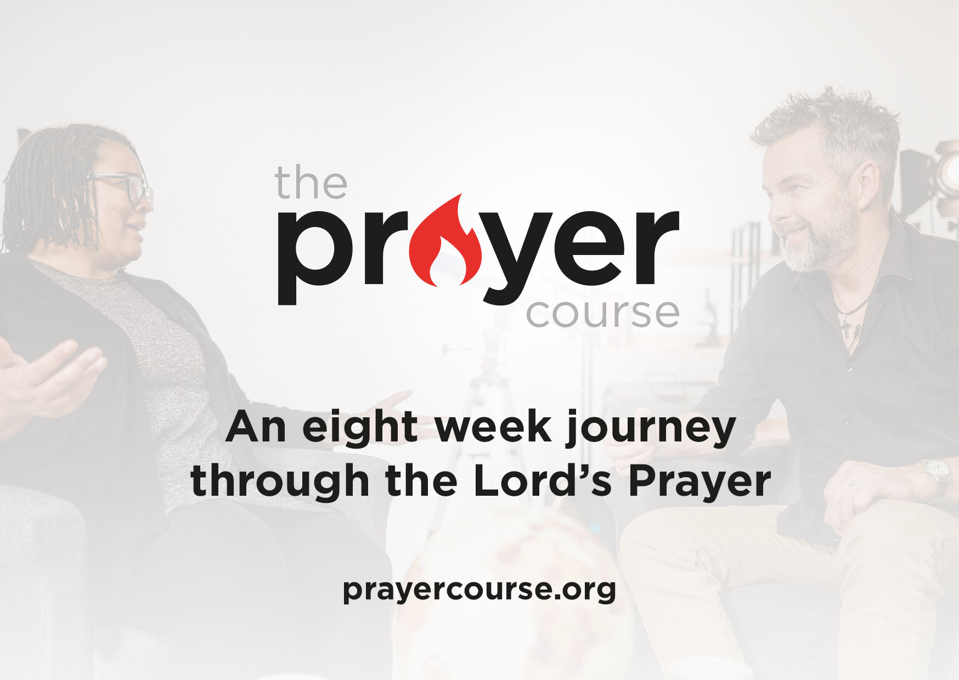
The Prayer Course (graphic)
The Prayer Course is an 8-week journey through the Lord’s Prayer that will help you learn how to pray. Ideally, the course is meant for you to go through with others so it might be something your Small Group wants to do together. (If you are offering the course at your location promote it here).

Inner Room Prayer App (graphic)
You might also check out the “The Inner Room Prayer App.” This app helps you keep track of prayer requests and leads you through time of praying for them.

21 Days of Prayer and Fasting (graphic)
And, of course, we’d love for you to join us for our 21 Days of Prayer and Fasting. We have 14 days left, and it’s not too late to jump in and get involved! You can find more information on our website.

Amazing things happen when our voices join together in prayer. These prayers are rising like incense before the Father. He’s listening to us. So don’t miss the opportunity to add your voice to a moment that is literally interrupting heaven.

Conclusion: Tony Campolo Story
To conclude, let me share one of my favorite prayer stories from author Tony Campolo. Tony was about to speak at a Pentecostal college chapel service, when eight men asked to pray for him. They had him kneel, laid their hands on his head, and began to pray. Tony said that was a good thing except they prayed a long time, and the longer they prayed, the more tired they got, and the more tired they got, the more they leaned on his head. He said, “I want to tell you that when eight guys are leaning on your head, it doesn’t feel so good.”

To make matters worse, one of the men wasn’t even paying for Tony. He started praying for someone named Charlie Stoltzfus: “Dear Lord, you know Charlie Stoltzfus. He lives in that silver trailer down the road. You know the trailer, Lord, the one on the right-hand side.” Tony felt irritated as he thought, “God doesn’t need your directions!” The guy continued: “Lord, Charlie told me this morning that he’s going to leave his wife and three kids. Step in and do something God. Bring that family back together.”

Tony says he finally got the Pentecostal preachers off his head, gave his talk, and got in his car to drive home. As he drove onto the Pennsylvania Turnpike, he noticed a hitchhiker and picked him up. He tells the rest of the story like this:

We drove a few minutes and I said, “Hi, my name is Tony. What’s yours?” He said, “My name is Charlie Stoltzfus.” I couldn’t believe it!

I got off the turnpike at the next exit and headed back. He got a bit uneasy with that and after a few minutes he said, “Hey mister, where are you taking me?” I said, “I’m taking you home.” He narrowed his eyes and asked, “Why?”

I said, “Because you just left your wife and three kids, right?” That blew him away. “Yeah! Yeah, that’s right.” With shock written all over his face, he plastered himself against the car door and never took his eyes off me.

Then I really did him in as I drove right to his silver trailer. When I pulled up, his eyes seemed to bulge as he asked, “How did you know that I lived here?” I said, “God told me.” (I believe God did tell me.)

When he opened the trailer door his wife exclaimed, “You’re back! You’re back!” He whispered in her ear and the more he talked, the bigger her eyes got.

Then I said with real authority, “The two of you sit down. I’m going to talk and you two are going listen.”

Man, did they listen! And that afternoon Tony helped that couple find their way back to God.

Now, God may not always answer our prayers in such a dramatic way, but I can tell you from personal experience that when I make room for prayer I find that it can be powerful and quite practical. But more than anything, I know that it is pleasing to my Heavenly Father. And that makes it worth it. Will you make room for prayer?

Communion Idea
(Luke 22:19-20 on screen) As we come to our time of communion, what we are doing right now is remembering the life, death, and resurrection of Jesus. He is the one who loved you so much and so wants you to talk with him about what you are doing that he gave up his life for you. And in his life, death, and resurrection we find forgiveness from our past, purpose to live for, and hope for our future.

So, take some time quietly, and talk to God about what we are doing right now (give a few moments of silent prayer). Then I will lead us in a prayer as we come to eat the bread that reminds us of his body that was broken and drink the juice the reminds us of his blood that was shed.

