Defying Gravity – Week 2 – Created to Climb

Message Big Idea: We are created to defy the gravitational pull of our culture by living generously.

Scripture: Genesis 1:26-30, John 3:16, Mark 10:45, 2 Corinthians 9:6-11

NOTE: We are planning to do GBTG near the end of this message.

Introduction: Acts of Defiance
(Series Graphic) Little kids have some strong wills, don’t they? Let me ask this… how many of you are currently living with a 2 or 3-year-old in your house? You can be honest, we see the bags under yours already anyway. Now let me ask you this: what happens when you want a 2 or 3-year-old to do something he or she doesn’t want to do? They ain’t gonna do it, right?! Toddlers can be pretty impressive at staging acts of defiance.

- Sometimes it’s a loud, “No!”
- Sometimes it’s a major tantrum.
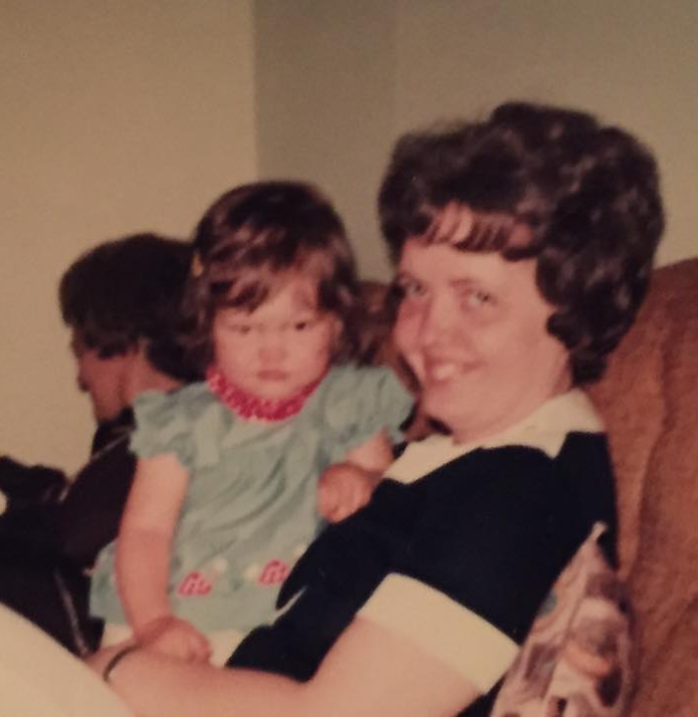
- Sometimes they just ignore you as if you aren’t even there.

(TP should tell a light-hearted story either about defiance either about their own childhood or as a parent)

When I was a toddler, so I’ve been told, when someone wanted me to do something I didn’t want to do, say, for instance, smile for a picture; my go to response was an ugly scowl. There is actually photographic evidence of it. (picture)

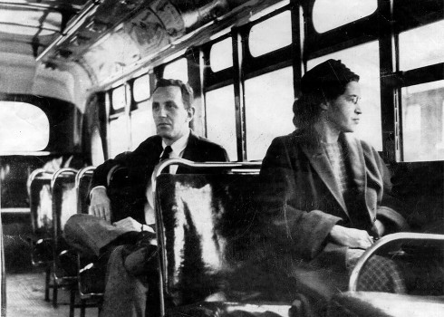
We laugh at strong-willed kids...when they belong to someone else! Defying your parents or some other authority figure when you are a kid really isn’t commendable, but there are other times when an act of defiance makes such a powerful statement it literally changes the world.

For example, what comes to mind when you see (Rosa Parks) this act of defiance? When Rosa Parks refused to surrender her seat to a white passenger on a segregated bus in Montgomery, Alabama; her act of defiance launched a nationwide effort to end racial segregation of public facilities.

Or this act of defiance… (2 Pictures of Malala) Malala took a stand for the right of girls to go to school in Pakistan and became a target of the Taliban because of it. Her miraculous recovery from a gunshot to the head only increased the platform for her message. This 15-year-old girl became a powerful symbol of defiance.

Or how about this photograph? (Tiananmen Square) It was June 5, 1989, a day after Chinese troops began violently cracking down on pro-democracy demonstrators in Tiananmen Square. The military had taken over the square, but one protestor fearlessly refused to back down. To this day, we don’t know who he is or what happened to him, but he remains a powerful symbol of defiance.

(All 3 Pictures) These acts of defiance are noble and inspiring. They took a tremendous amount of courage.

Today, I’m not going to ask you to stand in front of a tank, but I do want to challenge you to an act of defiance. My hope and prayer for today is that every one of us will be inspired to take a stand against the gravitational pull of our culture so that together we too can change the world.

Series Recap
(Series Graphic) We are in week 2 of our series “Defy Gravity” that is about money, finances, and generosity. Last week we talked about the gravitational pull of our culture when it comes to these things.

- Our culture is constantly putting pressure on us to Hurry, as our fast-paced lives keep us from stepping back and being intentional. We feel this rush to buy things NOW, and before we know what is happening, so many of us find ourselves living lifestyles we can’t really afford.
- Our culture is also always leading us to (add) Worry, as we see all that could go wrong in this world and wonder: Will I ever have enough? Will it continue to be enough? How much is enough?
- And our culture whispers to us constantly to (add) Consume, convincing us that life would be so much better if we could just have that next thing and the next and the next.

The gravitational pull of our culture when it comes to money and finances is to live with a “Me-first” orientation. And where has this left us? So many of us are stressed out, struggling, and stuck. We find ourselves with a pile of debt, broken relationships, and financial regrets.

However, Jesus came and taught us a counter-cultural way of life that can free us from a life of hurry, worry, and consume…a way that can free us from ourselves. He talked about it like this:

“…seek first his kingdom...” -Matthew 6:33

Jesus tells us the way to resist the gravitational pull of our culture is to “seek first the kingdom of God.” Instead of living “Me-first,” Jesus tells us to live “Kingdom-first.”

Understand, when Jesus said this, he wasn’t teaching something new. He was reminding us of who we have been created to be. In fact, I would go so far as to say we are created to defy the “Me-first” pull of our culture. How do I know that? Because we were created in the image of a generous God.

A Generous God
God is a generous being. The pictures that are painted of him all throughout Scripture reflect his generosity.

We see his generosity at Creation (with Genesis 1:29). Generosity flows from God in creation. He freely offers humankind everything we need to exist on this planet: he gives us life, he supplies us with provisions to sustain us, and he blesses us with relationships, both with himself and each other to make life enjoyable and full of meaning.

Even today, if we just go outside we come face to face with God’s generosity in a million ways. The Psalmist declares: (switch verse)

“The earth is the Lord’s, and everything in it, the world, and all who live in it; for he founded it on the seas and established it on the waters.” -Psalm 24:1-2

All of creation belongs to God. Yet incredibly, he chooses to be eternally generous with us, giving us his creation to meet our needs and bless our wants.

We see God’s generosity in creation, and we also see it at the Cradle (with John 3:16). The apostle John writes that God so loved the world that he….what? He gave! He generously gave his one and only Son.

(switch Philippians 2:5-7) In his letter to the Philippians, the apostle Paul quotes an early hymn reminding us that Jesus, being one with the Father, willingly left all the glory that was rightfully his to come to this earth, to be born as a baby, to take on the limitations of a human being. The cradle paints a picture of someone who was willing to live a “Kingdom-first” life. There was no “Me-first” in him!

Yes, we see God’s generosity in creation and at the cradle, but nowhere is God’s generosity displayed more clearly than on the Cross (with Mark 10:45).

Understand, when sin entered our world, those things God provided for us in the very beginning were broken. The purity of creation was marred. The intimacy of our relationship with God and each other was fractured.

In the midst of this fractured and broken world, we see the depths of God’s generosity. Jesus came to pour himself out in the most sacrificial act the world has ever seen. Through Jesus’ death, we experience the depths of God’s love. Paul writes in his letter to the Galatians: (switch verse)

“Grace and peace to you from God our Father and the Lord Jesus Christ, who gave himself for our sins to rescue us from the present evil age, according to the will of our God and Father.” -Galatians 1:3-4

Jesus generously gave himself for our sins to rescue us. Now, because of what he did on the cross, we don’t have to live according to the “Me-first” pull of this world. There is a better way! Through Jesus’ resurrection, he renews God’s offer of life, provision, and relationship. We can experience the freedom of a “Kingdom-first” life!

And how do we do that? By defying our culture and becoming who we were created to be… people made in the image of a generous God.

Image of a Generous God
But what does that actually mean? Well, the truth is, we’re all made in the image and likeness of a generous God, every single one of us. You’ve never met a person who wasn’t made in the image and likeness of God. In Christian theology, we call this the “imago Dei” and this is evident from the very beginning of the story, all the way back in Genesis:

“Then God said, ‘Let us make mankind in our image, in our likeness, so that they may rule over the fish in the sea and the birds in the sky, over the livestock and all the wild animals, and over all the creatures that move along the ground.’
So, God created mankind in his own image, in the image of God he created them; male and female he created them.” -Genesis 1:26-27

What are the real-life implications of being made in the image and likeness of generous, creative God? Well, here’s one way to think about it.

This is a mirror. Typically when I hold a mirror, I think of it as something I use to look at, well… me! (Grab mirror) That makes sense, right? We most often use mirrors to look at ourselves. (Looking in mirror) For example, looking in this mirror, I can see that my hair is particularly on point today…. Didn’t know that spinach in my teeth until this moment, though… Yikes. Either way, this is often how many of us think about being an image bearer of God; we simply reflect his image back to him.

But theologian N.T. Wright wonders if the best way to understand what it means that we are made in the image of God is to think of ourselves like an angled mirror. Wright says:

“It seems to me that God has put humans like an angled mirror in His world so that God can reflect His love and care and stewardship of the world through humans and so that the rest of the world can praise the creator through humans.” -N.T. Wright

The point of an angled mirror is that it makes it possible to see in both directions. (Point mirror toward audience) You see, as image bearers, when we reflect God to the world, we also help the world see God. We reflect who God truly is to the world and help the world see the one true God!

And generosity was one of the key attributes that made the early church stand out so vividly in a culture that was always busy looking out for number one. The Holy Spirit led these early Christ-followers to defiantly reject their “Me-first” pull of their culture and instead to reflect the love of a generous God to the world around them.

The book of Acts captures all sorts of ways the very first churches lived this out in the world. For example, we read this in Acts chapter 4:

“All the believers were one in heart and mind. No one claimed that any of their possessions was their own, but they shared everything they had. With great power the apostles continued to testify to the resurrection of the Lord Jesus. And God’s grace was so powerfully at work in them all that there were no needy persons among them. For from time to time those who owned land or houses sold them, brought the money from the sales and put it at the apostles’ feet, and it was distributed to anyone who had need.” –Acts 4:32-35

Can you imagine that? There was not a single needy person among them because they understood that everything they had was a gift on loan to them from a generous God and they were willing to share with others. What must it have been like to be a part of that first century church? In fact, in another place in Acts we read:

“All the believers were together and had everything in common. They sold property and possessions to give to anyone who had need. Every day they continued to meet together in the temple courts. They broke bread in their homes and ate together with glad and sincere hearts, praising God and enjoying the favor of all the people. And the Lord added to their number daily those who were being saved.” –Acts 2:44-47

I don’t know about you, but that sounds like a community reflecting the image of a gracious, generous God back to a world desperately in need of it.

Invitation to Defy Gravity
Here’s what I want us to understand today… we were created for this kind of generosity. We are made in the image of God so that we can reflect his gracious, generous nature to the world. But in order to do that, we have to defy the “Me-first” pull of our culture and choose to live with a “Kingdom-first” commitment.

Understand, every week when we Give Back to God as a part of our services, we are doing just that. We are defying the “Me-first” narrative that says what I have is for me, myself, and mine and instead, like that first community of Christ-followers in Acts, we’re choosing to share so that we can reflect our generous God to a world that is in desperate need of him.

I really do believe that when you and I stand together and defy the gravitational pull of our culture we can change the world.

In fact, I want to illustrate this in a practical, tangible way today. (Here is Plainfield’s Defy Gravity Challenge…you’ll need to insert your location’s challenge in its place… This should lead into the GBTG time.)

"How many times have you seen someone by the side of the road with a sign that reads "homeless"? Just this week I came across 4 people holding a sign like that. Now in my heart, I wanted to help and the reason I wanted to help is because I’m created in the image of a generous God. But in my mind, I wasn’t sure I wanted to roll down the window and give a complete stranger cash for fear it might not be used wisely. But because we’re created in the image of a generous God, several years ago one of our small groups established a partnership with a local homeless shelter in Joliet called Daybreak. Today, at least a half dozen of our small groups volunteer at the Shelter by making hot meals and serving the nearly 100 homeless men, women and children who are hoping to get back on their feet.

Now a few weeks ago I had this particular series and this particular message in mind and so we asked the staff at Daybreak about their most urgent need. Turns out their kitchen is in need of repair. Their primary sink needs to be replaced and their dish area needs to be brought up to code so that we can continue serving meals to people who would otherwise not have a meal. The estimated cost for the repairs is about $4,000. Well, $4,000 represents about 10% of our weekly budget here at Community and so what we’d like to do today is give Daybreak the first 10% of today’s offering so that 100 homeless men, women and children can continue receiving three meals a day until they are back on their feet.

Now keep in mind that every time we give back to God we’re defying gravity and meeting very real spiritual, emotional, relational and physical needs, but today we thought it would be helpful if our giving could meet a very specific and tangible need – a need that would in fact defy gravity – a need we could all get behind. So as the ushers come forward, it’s my hope that everyone of us will choose to defy gravity by giving back to God. The first 10% of our offering will be used to make the kitchen repairs at Daybreak, and the remaining 90% will be used to continue to meet very real spiritual, relational and emotional needs right here and around the world. So let’s defy the gravitational pull of our culture towards hurry, worry, and consumption; and instead give generously to reflect our generous God to the world. You can give right now through cash or check as the buckets are passed, or you can get on your phone on our app or at givenow.cc to join in this act of defiance. Let’s give generously to our reflect our generous God so that ultimately more and more people will find their way back to him.

Giving Back to God (with a song)

(After song, have everyone sit.)

Resources Available
We are created to defy the gravitational pull of our culture by living generously. Growing in generosity is a process and something most of us need some help with along the way. So as I wrap this up today, let me just mention some resources and opportunities that can help us defy the gravitational pull of hurry, worry, and consume and begin this “Kingdom-First” journey. In the coming weeks, we have a number of opportunities available to you… (Slide) (promote the resources and / or classes being offered – FPU, Thrivent, Together Conference, etc.).

To learn more you can either download the COMMUNITY App or simply go to communitychristian.org/defy for more information. Let’s not pass up this opportunity to defy the gravitational pull toward a “me-first” kind of life and step into something far great together.

Conclusion
The church in Acts didn’t have fancy websites or big stages. They didn’t have social media accounts, sound systems, or screens. But what they did have was the power of the Holy Spirit and an unprecedented, unrelenting commitment to radical generosity. They stood in defiant opposition of the “me-first” culture that tried so hard to pull them away from the mission and, as a result, the world has never been the same.

So, what about us? What if we lived with that same type of defiance? How might our world look differently if we all, like angled mirrors, reflected the love of a generous God into a world?

I think that’s something that God would smile at.

Let’s pray.

Communion
I think it’s fitting for us to celebrate communion together now. The reason I think it’s so fitting, is because communion, in many ways, is God’s ultimate demonstration of generosity. Hours before his crucifixion, Jesus isn’t giving one more sermon or performing one more miracle – he’s sharing a meal. And at this meal he’s saying, “In a world that takes, I invite you to receive. See this bread? This bread is my body, which isn’t being taken from me, I’m giving it freely. See this cup? This cup is my blood that I’m pouring out freely so you can have peace with God and peace with others.”

At communion, when we eat this bread and drink this cup, we’re not only remembering the radical kindness and generosity of Jesus, we’re also joining him in the work of reflecting his kindness to the world around us. So, as the ushers pass the trays, I invite you to hold on to the bread and cup. We’ll sing together and receive together as a family in just a minute.

Ushers, please come forward.

