Big Words – Week 3 – Atonement
Scripture: Hebrews 2:14-18, 1 John 3:7-8, Colossians 2:13-14, Romans 3:21-16, Romans 5:6-8
Message Big Idea: The atonement reminds us that Jesus would rather die than live without us.

________________

Introduction: That’s Not Right!
Have you ever had a moment when you came across something and you thought to yourself “Um… that’s not right…”? For instance, maybe you’re at your kid’s soccer game and you see this (image: socks): And you say, in your head of course, “Oh, that’s not right…on so many levels.”

Or maybe you’re at a BBQ and you’re eating some good food and everything is going fine until somebody walks by who clearly has no culinary sense and you know this because this (image: hotdog) is what they’re eating: Ketchup… on a hotdog? That’s just not right. In the immortal words of Dirty Harry, “Nobody, I mean nobody puts ketchup on a hotdog!” It’s just not right.

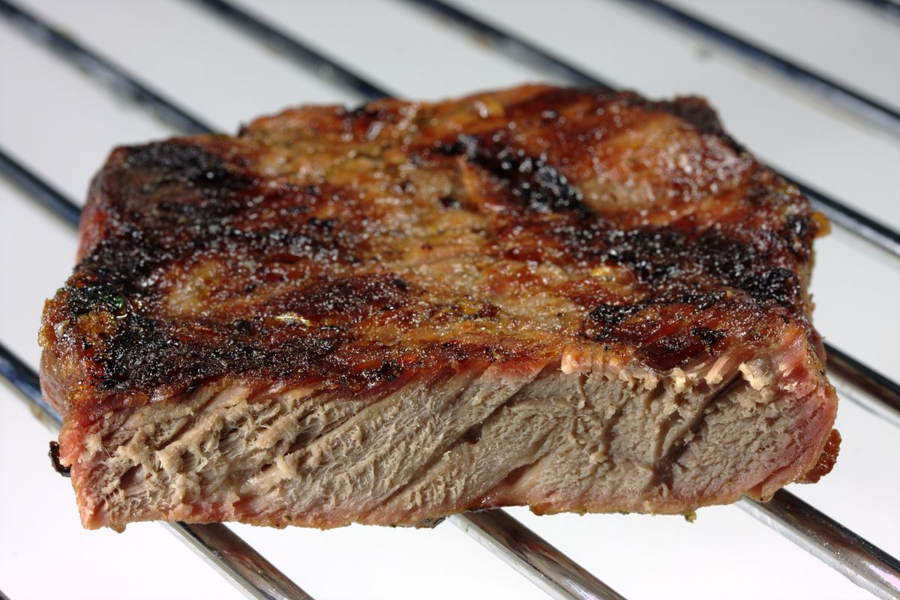
Or maybe you’re at a restaurant, enjoying the evening, and the waiter plops this (image: steak) in front of you. A well done steak, come on! Say it with me, “That’s just not right!”

As funny as those examples are, there are a lot of things in this world that just aren’t right. There is a lot of brokenness, hurt, and pain. One that we can point to in our own backyard is gun violence in Chicago. In 2016, Chicago had 756 homicides, the most in the last two decades.

The good news is that, in 2019, there was a third consecutive drop in homicides. That’s great, but I think we still would look at that and say, that’s not right. In fact, according to the Peace Corps a billion people can’t obtain nutritious food on a consistent basis.

And if those problems seem too big and abstract, let’s get a little more specific. Something is not right with me. Sometimes I can’t believe the things I think, say, or do. In one moment, I could tell you that my wife and kids are the most important people to me in all the world, and then in the next moment I lash out. I have taken them for granted. I have been selfish. Something is not right with me.

I’d be willing to say that we all have a fundamental sense that something is not right. Something is not right with me and something is not right with the world. But here’s the thing – the reason we meet here every week centers around the great statement of the Christian faith – that the death and resurrection of Jesus is God’s way of putting everything right again, and the big theological word we use to talk about that reality is: Atonement.

Series Recap
We’re in middle of a series here called, “Big Words.” As we engage with Scripture and learn more about the movement of Jesus followers for the last 2,000 there are some big words we come across used to describe the profound mysteries of God, and for some of us they might sound familiar, but we might struggle to truly understand what they actually mean.

- In week 1 we looked at Grace. Grace, simply put, is “unmerited favor.” It tells us that there is nothing we can do to make God love us more, and nothing we can do to make him love us less.
- Last week we dug into the word Holiness. We learned that we are declared holy as followers of Jesus but also that we are to pursue holiness in our day to day lives.

Today we’re going to talk about a word that really smart people have struggled with for centuries. It is the word Atonement, and that word is the word used by theologians for 2,000 years to describe “How did Jesus’ death on the cross make things right?”

This is a challenging question and can be hard to wrap our minds around.
So today, we’re going to jump in the deep end for a bit, so put your thinking hats on as we talk about the atonement, and how different atonement theories try to answer the question of “How did Jesus’ death on the cross make things right?” Now, some of you love heady stuff and you’re going to love these next twenty-five minutes. The rest of you… hang on for dear life.

Atonement Theories
From the earliest days of the Christian faith until now people have lived with this fundamental sense that something is wrong, and each atonement theory articulates the nature of the problem and how Jesus’ death on the cross solves it.

(Icon: Trophy)
Theory #1: Christus Victor (Victory)
What’s not right: We’re held captive
What atonement does: Sets us free

The first theory we will explore is the Christus Victor view of the atonement. The basic insight is that Christ has won a victory for us. The basic problem in this understanding is that you and I have turned away from God and in so doing we have surrendered our place as God’s rulers in the world. We’ve surrendered that rule to the Devil and all of the dark forces of evil, and since we’ve surrendered our rule we are now enslaved by evil. So, we are captives under the power of sin.

So what Jesus does, according to this theory, is he comes and identifies with us and he trades his life for us as a ransom paid to the devil, and the devil takes Jesus as his own. However, Jesus rises again from the dead and the devil can’t contain him and since all of us have already been set free, God wins, Jesus wins, we all win.

One passages that is often used in support of this particular atonement theory are:

Since the children are made of flesh and blood, it’s logical that the Savior took on flesh and blood in order to rescue them by his death. By embracing death, taking it into himself, he destroyed the Devil’s hold on death and freed all who cower through life, scared to death of death. - Hebrews 2:14-18

So, Jesus set us free from the power of sin and death, by dying under its power and conquering it in the resurrection.

(Icon: dollar sign)
(add) Theory #2: Satisfaction (Obedience)
What’s not right: We owe a debt we can’t pay
What atonement does: Pays our debt

So, people basically held some form of the Christus Victor view of the atonement for the first 1,000 years of the church until a guy named Anselm of Canterbury (1033-1109) comes along and he articulated and understanding of the cross that has been called the Satisfaction view of the Atonement.

He says the problem is that we have defrauded God of the honor he deserves and therefore we have a huge debt and we can’t pay God the honor he deserves. But Christ’s obedience pays our debt and satisfies God’s honor.

Anselm’s basic argument goes like this: God is a king and we are commoners. If I, a commoner, offend you neighbor, another commoner, by accidentally killing your lamb, I have offended your honor, and I am in your debt. However, I have a sheep, so I can pay my debt and satisfy the debt and give you the honor you deserve. Now imagine you’ve killed a King’s sheep and therefore, you have dishonored the King. You now have a debt, but you can’t rectify that with just one sheep. Maybe it’s five sheep. But I can still pay it, even though I have to trade in a few more animals to satisfy the debt and make sure the king is honored.

Now God is greater than any King. We have a debt before an infinite God. How many lambs do you think it would take to satisfy God? 50? 100? Anselm said an infinite number, because God is infinite. Only an infinite God can make an infinite payment. So why doesn’t God just write himself a check? Because, a person has to pay it for it to honor God. So, Jesus, the infinite Word, becomes a human and gives the ultimate gift, his obedience, which pays the debt of our sin – and he doesn’t just pay the minimum. There’s a surplus, enough for everyone’s deficit.

One passage where we see this idea is in Colossians 2:13-14

When you were dead in your sins and in the uncircumcision of your flesh, God made you alive with Christ. He forgave us all our sins, 14 having canceled the charge of our legal indebtedness, which stood against us and condemned us; he has taken it away, nailing it to the cross. - Colossians 2:13-14

Now, the third theory is:

(Icon: scales of justice)
(add) Theory #3: Penal Substitution (Penalty)
What’s not right: We deserve punishment for our sin
What atonement does: Jesus takes the punishment in our place

Then about 500 years later along comes a little thing we call the Protestant Reformation, and the protestants will take Anselm’s understanding and focus less on divine offense, and more on divine justice – that because of our sin, we have broken God’s law and therefore God’s righteousness demands punishment for human sin. That means every human deserves God’s punishment for their sins, for God is just and he would unjust if He didn’t punish injustice. So, God in his grace sends his son and exacts punishment on a sinful world and supplies the one to be punished.

Jesus doesn’t just pay the honor, he pays the penalty for sin. Paul put it this way:

Since we’ve compiled this long and sorry record as sinners (both us and them) and proved that we are utterly incapable of living the glorious lives God wills for us, God did it for us. Out of sheer generosity he put us in right standing with himself. A pure gift. He got us out of the mess we’re in and restored us to where he always wanted us to be. And he did it by means of Jesus Christ.

God sacrificed Jesus on the altar of the world to clear that world of sin. Having faith in him sets us in the clear. God decided on this course of action in full view of the public—to set the world in the clear with himself through the sacrifice of Jesus, finally taking care of the sins he had so patiently endured. This is not only clear, but it’s now—this is current history! God sets things right. He also makes it possible for us to live in his rightness. - Romans 3:22-26 (MSG)

In a lot of ways, this theory has become the predominant view here in the West. Well, we at COMMUNITY believe what actually happened on the cross is the sovereign act of love on behalf of the Father himself. The death of Jesus reveals, not the anger of God, but the love of God. The Apostle Paul said it like this to the church in Rome:

But God demonstrates his own love for us in this: While we were still sinners, Christ died for us. – Romans 5:8

There is a deeply intimate connection between the Father and Jesus and the Father and us. But the Father didn’t send someone else to do the dirty work. God says to us, ‘I love you so much, I’m coming to do it myself.’ It is God himself on that cross.

Pastor and author Brian Zahnd put it well:

“What is revealed on Good Friday is the depths of human depravity and the greater depths of God’s love… The crucifixion is not what God inflicts upon Jesus in order to forgive, the crucifixion is what God in Christ endures as he forgives… As long as we think Jesus died for God instead of dying for us, we will never see the sinfulness of human civilization and the beauty of the divine alternative: the kingdom of God.” –Brian Zahnd

The truth is, we serve a God who both created humanity and weeps at the parts that are broken. He not only sees this brokenness, however, but enters into humanity, became our humanity, and is actively at work to redeem broken humanity.

The Problem

So, the question on most of our minds now is: well, which one is it? Which theory fully encapsulates what’s actually true? And that’s a great question.

Theologian Scot McKnight’s in his book A Community Called Atonement actually answers that question with what I think is a helpful analogy:

(Bring out golf bag with various clubs in it)

Now, I’m not a golfer but I’m told some golfers have a favorite club. There are probably numerous reasons for this, but it makes sense that someone might have a favorite. But any serious golfer knows that, in order to play the game well, you need all of the clubs. You might use some clubs more than others but they all serve a purpose toward a common aim.

But when it comes to atonement theories, some atonement theories today are “one-club” theories that have to be adjusted each time one plays “the atonement game.” This is unfortunate because we have a big bag of images in our Bible and we need to pull each from the bag if we are to play out the fulsomeness of the redemptive work of God.
For example, sometimes we feel defeated, stuck in sin. When we’re there, the Christos Victor club declares us we have victory!

Sometimes we feel like we’ve fallen way short, that we’re not who we should be. Maybe we feel weighed down, buried. Satisfaction club declares us that because of Jesus our deficiencies have been paid for!

Perhaps sometimes we feel God is just angry with us and he’s going to come down hard on us. When we do, Penal Substitution club declares us that Jesus has paid the price, taken the punishment we deserved!

McKnight recognizes that atonement is difficult to explain because it has so many different dimensions, a lot like each of these clubs. Each of these clubs is useful in different ways but they’re all aimed at the same target. To only use one of these clubs for an entire game would be to miss out on the rich array of options given to us. Now, unfortunately, the “club” that tends to be the most popular in the West is the penal substitution theory, which has led many to see God as predominantly angry and vengeful. Maybe that’s been your experience. Theologian NT Wright responds to this particular posture this way:

“...the idea that there is this big, angry God who is cross with us all and is about to lash out, but fortunately someone gets in the way who happens to be his son, Jesus, and phew! We get off. In essence when atonement is explained this way, we have taken John 3:16–’For God so loved the world that he gave his only Son’–and what people have heard is: ‘God so hated the world that he killed his only Son.’ When you say that in a world where there is abuse, people think, ‘I know that kind of bully and I don’t want anything to do with him,’ and things go horribly wrong.

Some of you have said those same words yourself. I know I have. If God is truly this big, cosmic bully in the sky, why would I want anything to do with him? A former staff member actually wrote about an encounter he had with the student who had been handed an angry version of God and it led him to some incredibly dark places. Jason* was a freshman at a college in the city. His pastor from back home had called and asked if someone would meet with him because he needed a counselor but didn’t know anyone in the city. Here’s what that pastor had to say:

“Jason said things had really come to a head one day recently after he had been to church. He was taking the trash out of his dorm room to the end of the hall where they had some kind of chute that went down into the belly of the building below. And he said that that day after church he peered down into the darkness of wherever that chute went and felt that God must want to throw him down the spiritual equivalent of that trash chute. And if God really feels that way about me, what’s the point? Why should I go on living? I’ve been thinking if that’s the way it really is, I just ought to end it now and get it over with.”

This pastor decided to ask the student point-bank: “What makes you feel like God would throw you down the garbage chute?” This was his response:

“Well, when Jesus was on the cross, God turned His back on Him. And if God turned His back on His own Son, why wouldn’t He do the same with me?”

Has anyone else ever felt that way? I know I have. I’ve lost count of how many times over the years someone has come to me with this type of depiction in their mind and it leads to an almost inevitable place. But take heart, there is good news.

Atonement Invitation

Let’s be honest, though. We look around the world and so much is still not right. Not only in the world, but so much is not right in me (point to heart) either. But the atoning work of Jesus inaugurated the work of making all things right.

He makes me right, restoring all of the toxicity and brokenness in my heart.
He makes us right, healing the things that divide us against each other and keep us at a distance.
He makes the world right, repairing the systems and structures that contribute to evil and injustice.

This rightness of Jesus is both “now” and “not yet” and Jesus invites us to join him in the work of making all things right, both in here and out there. That is the invitation of the “already/not yet” Kingdom of God.

Conclusion

And, while we work, strive, and partner with God in restoring that which is broken in the world, God’s Word promises us that there will come a day when everything with be truly made right, restored to God’s original dream. Here’s how Revelation 21 puts it:

Then I saw “a new heaven and a new earth,” for the first heaven and the first earth had passed away, and there was no longer any sea. I saw the Holy City, the new Jerusalem, coming down out of heaven from God, prepared as a bride beautifully dressed for her husband. And I heard a loud voice from the throne saying, “Look! God’s dwelling place is now among the people, and he will dwell with them. They will be his people, and God himself will be with them and be their God. ‘He will wipe every tear from their eyes. There will be no more death’ or mourning or crying or pain, for the old order of things has passed away.” He who was seated on the throne said, “I am making everything new!” – Revelation 21:1-5

What an amazing image that is! That is the power of the cross of Jesus Christ That’s where it is leading us. Jesus steps down from eternity and enters broken humanity, not just to visit, but to re-ascend and bring the whole broken world with him. That’s very good news! May we be a people who live into that reality more and more every day. Let’s pray.

Communion

Hours before Jesus’ crucifixion, he wasn’t giving one more sermon our performing one more miracle. He’s sharing a meal. And I imagine there was even a shift in the room when he reached for the bread, broke it, looked each of the disciples in the eye and said, “This is my body. No one’s taking it from me, I’m giving it for you, so that you can be made whole again.”

Then he grabbed the cup and said, “This is no ordinary cup. It’s my blood, the cup of the new covenant.” In this brief but powerful moment, he was communicating what he came to do all along, make a way for us to be made whole again.

In a world that constantly takes, this Rabbi invites us to receive. Let’s receive together.

