Emotionally Healthy Relationships – Week 1 – Clarify Expectations

Message Big Idea: To have emotionally healthy relationships, stop mind reading and clarify expectations by talking to people–in person instead of in your head.

Scripture: Exodus 20:16, Matthew 7:1-5, Proverbs 18:2,13,15
__________________

Introduction: False Advertising
(Series Graphic) No one likes to be the victim of false advertising, and yet we’ve all probably experienced it in one way or another.

Pre-packaged food products are often the culprit of false advertising. Take for example…
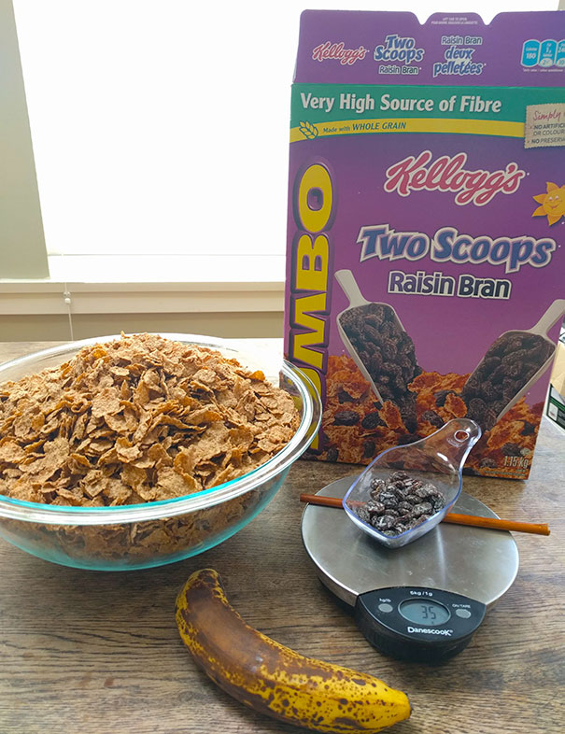
- (Picture) Opening a box of Raisin Bran to find that there are far less than two scoops of raisins.
- Or maybe you’ve heard people rave about Cincinnati’s Skyline Chili, but you don’t want to drive to Cincinnati. (Picture) Bad call.
- Or perhaps you decide to give your kids a Sponge Bob ice cream treat, (Picture) but instead you end up giving them nightmares!

However, food products are not the only place we find false advertising. According to a survey conducted by the job search firm Monsters.com, 85% of job applicants exaggerate skills and competencies on their resumes. 85%!

It makes me think of that Friend’s episode where Joey books an audition based on his claim of speaking French. Maybe you remember the scene where Phoebe, who does speak French, tries to help him.

Video: Joey Speaks French https://www.youtube.com/watch?v=kujMmdwGPoo (1-minute edited clip)

(Series Graphic) Whether it’s exaggerated resumes or fake hotel reviews or shady used car deals, no one likes false advertising because when reality doesn’t meet our expectations, we’re left disappointed.

And while we might get over those disappointments rather quickly, what happens when reality doesn’t meet expectations in our relationships? How do we navigate disappointment then?

All of us experience disappointments in relationships.

- Maybe there’s a friend you used to rely on, but now your connection seems distant and inaccessible.
- Maybe your relationship with a brother or a sister feels riddled with conflict and competition instead of closeness and connection.
- Maybe your marriage looks nothing like what you imagined it would be when you walked down the aisle years ago.

All of us long for close, meaningful relationships, and yet so often reality doesn’t meet our expectations. So what are we to do? How do we navigate our disappointment?

Series Introduction
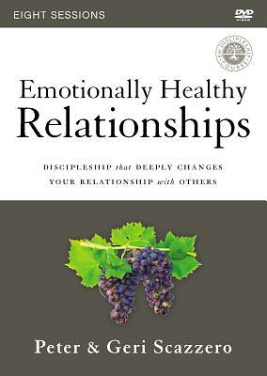
Well, today we are starting a 5-week series that I believe could revolutionize our relationships. It’s called (Book Cover) Emotionally Healthy Relationships, and it’s based on a book and course by the same name from authors Pete and Geri Scazzero. The goal of this series is to help us experience close, meaningful relationships by learning how to better love the people in our lives. After all, nothing is more important than growing in our ability to love!

When Jesus was asked to name the most important commandment, he answered:

“‘Love the Lord your God with all your heart and with all your soul and with all your mind.’ This is the first and greatest commandment.” -Matthew 22:37-38

But he didn’t stop with just that one command, he went on to say: (add)

“And the second is like it: ‘Love your neighbor as yourself.’” -Matthew 22:39

The mark of a growing Christ-follower is a deepening love for God and for people. In fact, Jesus said that every other commandment in Scripture hangs on these two commandments: Love God and Love people.

And these two commands are intricately connected. Love for God and love for people go hand in hand. Because of that, sometimes our greatest roadblock to spiritual maturity is our relational immaturity. Or as the Scazzero’s say it:

“It is impossible to be spiritually mature while remaining emotionally immature.” -Pete and Geri Scazzero

If we are truly going to follow Jesus as his apprentices, we need to take an honest look at our own emotional and relational tendencies. And so during this series, I want to challenge all of us to:

Be Brave. After all, relationships are not easy. Facing our struggles and disappointments is not easy. But we can do this together!

I also want to challenge us to (add) Be Open. Let’s invite God to reveal to us ways we might be contributing to the disappointments we feel.

And let’s also (add) Be Ready to act on what we learn. During this series, we’re going to learn 5 relational skills that can help us grow as Christ-followers who are learning to love well. Remember, nothing is more important than growing in our ability to love. During this series we have an opportunity to learn skills that could revolutionize our relationships!

So let’s be brave, let’s be open, let’s be ready, and let’s dive into the first skill: Clarify Expectations.

Unhealthy Expectations
Let’s start by admitting that, as Americans, we tend to have ridiculously high expectations. That’s not a secret, right?

For example, I recently came across a book excerpt from author Bill Bryson that discussed how products were sold in Britain and the United States. The gist of the excerpt was that the same product had to be marketed in different ways in the two countries.

For example, in Britain, an advertisement for a cold relief capsule would promise no more than it would make you feel a little bit better. Maybe it would show a person home from work in their pajamas with puffy eyes and a red nose, but a slight smile on their face indicating they are starting to feel better.

However, in the United States, a commercial for the same product would show total, instantaneous relief. Picture a person at work, running faster than ever, with no sign of even a sniffle! He’s closing deals! She’s leading presentations! And at the end of the night they feel so good they go bowling!

Bryson comments: “The British don’t expect over-the-counter drugs to change their lives, whereas we Americans will settle for nothing less.”

In his book, The Image, author Daniel Boorstin writes:

“We expect anything and everything. We expect the contradictory and the impossible. We expect compact cars which are spacious; luxurious cars which are economical…We expect to eat and stay thin, to be constantly on the move and ever more neighborly, to go to a ‘church of our choice’ and yet feel its guiding power over us, to revere God and to be God. Never have people been more the masters of their environment. Yet never has a people felt more deceived and disappointed. For never has a people expected so much more than the world could offer.” -Daniel Boorstin

As Americans, we have ridiculously high expectations, and we tend to carry those expectations into our relationships. And the real challenge is not only are those expectations high, many times they are downright unhealthy. So, what are unhealthy expectations?

(Build a chart with these 4 “Unhealthy Expectations” on the left side and leaving space on the right side for the “Healthy Expectations” later on.)

They can be expectations that are Unconscious, meaning we didn’t even know we had an expectation until it went unmet and we felt the sting of disappointment. For example:
- Maybe you expect your roommate to immediately wash the dishes after dinner because in the house you grew up in, that’s the way it was done.
- Or maybe you expect your kids to get straight “A’s” in school because you always got straight “A’s” in school.
Unconscious expectations are assumptions we make because of the way we think the world works.

Or maybe our expectations are Unreasonable. They aren’t grounded in reality.
- Maybe you expect a friend to be available whenever you want them to be available to do whatever you want them to do.
- I once received an angry letter from someone who was livid that I didn’t help her get into a Small Group during a week I was away on a mission trip in Ecuador. She even referenced the fact that I posted pictures on Facebook while in Ecuador as evidence that I had free time.
But I’ve had my fair share of unreasonable expectations too. And many times, it’s because those expectations were also…

Unspoken. We may be conscious of our expectations, but the other person isn’t. We haven’t voiced them, and yet we still get upset when people don’t meet them.
- Maybe you expect that your extended family will chip in for a gift, but no one does, and now you’re angry.
- Sometimes I get my feelings hurt when my friends don’t show up at an event I want them to be at… but the truth is I’ve never asked them to come! I just expected that they would.

But sometimes the reason our expectations are unhealthy is simply because they are Un-agreed Upon.
- Just because you invited someone to a party doesn’t mean they will come.
- Just because you asked someone for a ride to the airport doesn’t mean they have to give it.
- Just because you put the hamper in the bedroom, doesn’t mean he’ll fill it with dirty clothes.

What ends up happening is eventually our Unconscious, Unreasonable, Unspoken, or Un-agreed Upon expectations will go unmet, and if we don’t take a step back to examine our expectations, we’ll likely start making judgments and assumptions about the other person.

Unhealthy expectations become landmines in our relationships.
Pain, confusion, and disappointment begin to grow.
Resentment builds.
We begin to put up walls.

Ever been there? (pause) Are you there now? (pause)

When unhealthy expectations go unexamined and unresolved, eventually…
- Friendships fall apart.
- Small Groups disintegrate.
- Working relationships sour.
- Families blow up.
- Marriages collapse.

So what can we do? How can we move toward emotionally healthy relationships?

Well, to start, we need to look at some of the wisdom of the Bible to help us stop some things and start some things.

The Bible has so much to say about this but I want to start the conversation today by looking at two things we need to stop doing and two things we need to start doing.

Stops and Starts (Word / What Now)
Shorten this section?

First, we need to Stop Mind Reading.

I think we are often unaware of the fact that we are constantly making assumptions about the people around us. It’s our minds way of filling in the gaps of our expereince to try to make sense of our story and the stories of those around us.

I (Ted) can’t tell you how many times I have done this with my kids. I am really trying to get better at this, but I often find myself assuming I know why my kids are behaving in a particular way. For example, I remember one recent evening where one of our boys seemed a little quiet at dinner and I made the assumption that he was just tired from the long day at school but thankfully my wife did not make an assumption and asked him what was going on and they ended up having a really important conversation about a hard thing that happened with a friend at school that day…While the story I wrote in my mind about him made sense…It was wrong. my assumption was wrong and had I not had Melissa right there to ask instead of assume we would have missed that really important opportunity to love our son through a hard moment.

We think we know the thoughts and motives behind what people say or do and we make assumptions about the other person or your relationship based on how we connect the dots between what happened and our best guess as to why…But often we treat our guess like a fact which has a nasty habit of getting us into trouble and erroding the most importatn relationships in our life.

Scritpure gives a clear warning about focusing on our own opinions and assumptions rather thanactally seeking to understand the people in our lives. Proverbs 18:2 warns us that when we do that we may be the one playing the fool. “Fools find no pleasure in understanding but delight in airing their own opinions.” -Proverbs 18:2

When we act as if we have the ablity to read people’s minds we are in essence operating as if we are like God…as if we are all knowing. The truth is, only God knows everything. Only He knows what is going on in the minds and hearts of other people.

We need to stop trying to play God and assuming we know too…Otherwise we may be unknowingly putting our relationships at risk to falling victum to unhealthy expectations.

Second, we need to Stop Making Judgments.

Exodus 20:16 puts it this way, “You shall not give false testimony against your neighbor.” (Exodus 20:16)

Now, I know some of you might be wondering, what exactly does that verse have to do with making judements? Well, that is an excellent question…Let me explain. I know we tend not to think of our judgements this way but the truth is that whenever we make an assumption about someone without confirming it, it is very possible that we are believing a lie about this person in our head. We are creating and holdng on to our own false testimony about another person…And what’s worse…We very often pass that false assumption on to others. We spread the unintentional lie to others who assume it to be true…Just because we believe it does not change the fact that it is false and it doesn’t change the ill effects.

Giving false testimony based on assumption, even if it was well meaning or made sense to you, can destroy reputations and relationships…It’s essentially character assassination and it qualifies as false witness and would be a violation of this commandment.

There is something called Fundamental Attribution Error or (FAE). FAE states that when we judge “bad” behavior in other people we attribute their actions to their “bad” character, and we don’t consider environmental factors in our assessment of their choices. HOWEVER, when we engage in the same “bad” behavior, we don’t attribute our own “bad” choices to our “bad” character, we attribute it to environmental factors.

For example…When someone cuts us off on the road, our first thought is “What a jerk!” instead of thinking that they are probably trying to rush someone to the airport or an important meeting. BUT, when we cut someone off we convince ourselves that we had to do it for some greater good…like getting to lunch 30 seconds sooner…When is comes to our behavior we pay attention to the situaltional factors that explain or excuse what we do but we ignore those same factors when we try to explain the actions of others. That is Fundamental Attribution Error…and unfortunatley, we all do it…all of us.

We need to stop mind reading and stop making judgements…However, we do need to Start Having Conversations.

Proverbs 18:15 says it this way, (Add) “The heart of the discerning acquires knowledge, for the ears of the wise seek it out.” -Proverbs 18:15

Simply put, the only way to discover what a person is really thinking is to ask questions.

Let me illistrate it this way, (TP pull out a small gift wrapped present) I would be willing to bet that each of us would be able to come up with at least one guess about what is in this little package here…right? But the obvious truth is…the only way to know whats inside the box is to open it or to ask me whats inside.

Asking questions and having a real conversation is how we see whats actually going on inside of other people.

(Hold box) It would be crazy to start making judgements about me or decsions about your future based on your ill-informed assumption of what is inside this little box…BUT…when it comes to our relationships (when so much more is at stake!) we tend to make these kinds of judgements and decsions all the time.

The only way to know whats going on inside of another person is to ask them whats in the box (Point to your heart). (Pause)

The best way to start is to simply ask questions and listen…ask questions like:

  - “Can you tell me more about that?”
  - “Can you explain what you mean by that?”
  - “I think you think _____, is that true?”
  - “Can I check an assumption I’m making?”

Communication leads to understanding…And understanding leads to meaningful community.

We When neeed need to start having a descerning heart that aquires knowledge through conversation AND we need to Start Clarifying Expectations
- (Here complete the chart introduced earlier with “Healthy Expectations.” Build list in second colomun compared to the unhelthy expectations from earlier)

Healthy Expectations are:
- Conscious:
  - It requires that we are aware of our expectations. That means we take the time to recognize what our expectations are in a given situation or relatiosnhip.
- Realistic:
  - We need to descern whether or not our expectations are flying pigs and unicorns OR is there real evidence to support that our expectations are reasonable. Either it has been done in the past or we know the person has the capacity and willingness to do it.
- Spoken:
  - We need to be certain…I have we clearly expressed the expectation.
- Agreed Upon:
  - Not only has the expectation been communicated and understood but has the other person agreed to the expectation?

All of these insights together will help to shape healthy expectations in our life and relationships.

Conclusion: Jesus Exceeds Expectations (Ted) Move this section before Stop/Start?
But in the end, it is critically important for all of us to remember that each of us are messed up and broken people… messed up and broken people who are always going to mess up and break the expectations of others and struggle with people who have messed up and broken our own expectations.

This is also the reality of our relationship with God as well…we are constantly breaking and messing up our relationship with Him…

(Add all of these on screen) Romans 3:23 says it this way, “For everyone has sinned; we all fall short of God’s glorious standard.”

Even though Jesus sums up all the expectations of the law and the prophets…basically the entire first half of the Bible…into two simple commandments...”Love God and Love your Neighbor” (put Matthew 22:37-39 on screen with Love God and Love your Neighbor highlighted.) We all fall short.

But this is why Jesus is our only hope…

(Put on screen) Jesus is the only one who can fully meet God’s perfect expectations….His glorious standard. AND he is the only one that can meet all of our expectations… In fact, he exceeds them. He will always love us and He will never turn His back on us or leave us.

Jesus proved that he will love us to the end and beyond through His life, death and resurrection…
Romans 5:8 says. “But God showed his great love for us by sending Christ to die for us while we were still sinners.” - Romans 5:8

In other words, even though you messed it all up, even though you fell short of His right and true expectations that were set for our own benefit…despite all of that…Jesus came and gave his life for you…He paid the price for our sin…so that you could be reconciled with God.

2 Corinthains 5:21 says, “For God made Christ (Jesus), who never sinned, to be the offering for our Sin, so that we could be made right with God through Christ.” 2 Corinthians 5:21

When you find your way back to God, it changes everything…It starts by being made right with God through Jesus and then it overflows into all the relatiosnhips in our life.

As we let Jesus pour His love into our hearts, he will empower and equip us to love one another.

(Go right into communion, pray after.)

Communion Idea

Jesus clarifies the expectations…. they are simple.

(Put three R’s on screen)

Recognize your brokenness.
Receive the love of God through faith in Jesus
Release that love to the world around you through the power of the Holy Spirit.
In the midst of broken lives and broken expectations Jesus comes to say… “I love you”

And we celebrate His love for us every week through communion as we receive the Bread and the Cup as reminders of His death and resurrection…Reminders that he will never let us down.

So receive the love of God…and let it be released into your life and relationships.

https://www.monster.com/career-advice/article/the-truth-about-resume-lies-hot-jobs

